

CAPSTONE PROJECT REPORT
Report 3 – Software Requirement Specification

AI-POWERED EXAMINATION AND PROGRAMMING PRACTICE PLATFORM FOR FPT UNIVERSITY
(APE)

Group: SEP490-G26
Lecturer: Nguyễn Mạnh Hiển

– Hanoi, June 2026 –

Table of Contents
I. Record of Changes 7
II. Software Requirement Specification 8
1. Overall Requirements 8
1.1 Context Diagram 8
1.2 Main Workflows 10
1.2.1 User Authentication 11
1.2.2 AI Wallet Top-up 12
1.2.3 System Document Ingestion (Super Admin) 13
1.2.4 BYOS Document Ingestion (Student) 14
1.2.5 AI Question Generation & Review 15
1.2.6 MCQ & Flashcard Practice 16
1.2.7 Coding Practice & Grading 17
1.2.8 AI Code Mentor 18
1.3 User Requirements 19
1.3.1 Actors 19
1.3.2 Use Cases (UC) 20
1.3.3 Use Case Diagrams 27
1.3.3.1.1 Question Bank Browsing & Practice Setup 27
1.3.3.1.2 MCQ & Flashcard Practice 28
1.3.3.1.3 Coding Practice & AI Mentor 28
1.3.3.1.4 BYOS Ingestion 29
1.3.3.1.5 BYOS Generation & Publish 30
1.3.3.2.1 System Document Management 31
1.3.3.2.2 Ingest Pipeline Detail (System Document) 32
1.3.3.2.3 Question Generation & Moderation 33
1.3.3.2.4 Generation Pipeline Detail (System Content) 34
1.4 System Functionalities 34
1.4.1 Screens Flow 34
1.4.2 Screen Authorization 36
1.4.3 Non-UI Functions 38
1.5 Entity Relationship Diagram 40
2. Use Case Specifications 42
2.1 Authentication & Account 42
2.1.1 UC-01: Login with Google 42
2.2 AI Wallet & Payment 43
2.2.1 UC-07: Top-up AI Wallet 43
2.2.2 UC-08: Process Payment Callback 44
2.3 Document Management & AI Ingest 45
2.3.1 UC-24: Upload System Document 45
2.3.2 UC-25: Upload Personal Document (BYOS) 46
2.3.3 UC-32: Delete Document 47
2.4 AI Question Generation 48
2.4.1 UC-47: Configure Generation Request 48
2.5 Question Bank Management 50
2.5.1 UC-71: Publish Question 50
2.5.2 UC-72: Reject Draft Question 51
2.5.3 UC-73: Publish All Draft Questions 52
2.6 Practice Setup 53
2.6.1 UC-80: Configure Practice from System Bank 53
2.6.2 UC-81: Configure Practice from Personal Bank 54
2.6.3 UC-82: Manually Select Coding Problems 55
2.7 MCQ & Flashcard Practice 56
2.7.1 UC-84: Start MCQ Practice Session 56
2.7.2 UC-85: Submit MCQ Answers 56
2.7.3 UC-89: Resume In-Progress Session 57
2.7.4 UC-90: Start Flashcard Session 58
2.8 Coding Practice 58
2.8.1 UC-92: Start Coding Practice Session 58
2.8.2 UC-95: Submit Coding Solution 59
2.8.3 UC-98: Start New Coding Attempt 60
2.9 AI Code Mentor 60
2.9.1 UC-99: Request AI Mentor Feedback 60
2.10 Progress & Analytics 62
2.10.1 UC-105: View Personal Dashboard 62
2.10.2 UC-109: View Practice History 62
2.10.3 UC-110: View Practice Session Detail 63
2.11 Course Management 63
2.11.1 UC-14: Create Course 63
2.12 User Management 64
2.12.1 UC-147: Moderate User Access Status 64
2.13 Wallet Package Management 65
2.13.1 UC-148: Create Wallet Package 65
2.14 AI Configuration & Operations 66
2.14.1 UC-119: Create AI Agent 66
2.14.2 UC-122: Configure Agent Model Settings 66
2.14.3 UC-132: Activate Prompt Version 67
2.14.4 UC-141: View AI Usage Logs 68
2.14.5 UC-144: Run AI Smoke Test 69
3. Functional Requirements 69
3.1 Authentication & Account 69
3.1.1 Login (Google OAuth) — Roles: Student, Super Admin 70
3.1.2 Profile — Roles: Student, Super Admin 71
3.1.3 User Management (Admin) — Role: Super Admin 72
3.2 AI Wallet & Payment 73
3.2.1 AI Wallet — Role: Student 74
3.2.2 Top-up — Role: Student 76
3.2.3 Top-up History — Role: Student 78
3.2.4 Wallet Packages Management (Admin) — Role: Super Admin 79
3.3 Course Management 80
3.3.1 Course Management (Admin) — Role: Super Admin 81
3.4 Document Management 82
3.4.2 Personal Documents (My Documents) — Role: Student 85
3.4.3 Personal Document Preview — Role: Student 87
3.4.4 Extraction Draft Review — Role: Student 89
3.5 AI Question Generation 91
3.5.1 Generate from BYOS (Personal Doc) — Role: Student 92
3.5.2 Generate System Bank (Admin) — Role: Super Admin 94
3.6 Question Bank 95
3.6.1 Question Bank Browse (Student) — Role: Student 96
3.6.2 Question Detail (Student) — Role: Student 98
3.6.3 System Question Bank & Moderation (Admin) — Role: Super Admin 100
3.6.4 Question Import (Admin) — Role: Super Admin 102
3.7 Practice Setup 102
3.7.1 Practice Configuration - Role: Student 103
3.7.2 Personal Practice Library — Role: Student 105
3.7.3 System Exam Library — Role: Student 106
3.7.4 Admin Practice Setup — Role: Super Admin 107
3.8 MCQ & Flashcard Practice 109
3.8.1 MCQ Session — Role: Student 110
3.8.2 Flashcard Session — Role: Student 112
3.9 Coding Practice 113
3.9.1 Coding Session — Role: Student 113
3.9.2 Submission Result — Role: Student 115
3.10 AI Code Mentor 116
3.10.1 AI Mentor Feedback — Role: Student 117
3.11 Progress & Analytics 118
3.11.1 Student Home — Role: Student 119
3.11.2 Knowledge Analytics — Role: Student 121
3.11.3 Practice History — Role: Student 124
3.11.4 Setup Guide — Role: Student 125
3.11.5 Admin Dashboard — Role: Super Admin 126
3.12 AI Configuration 127
3.12.1 Provider Credentials — Role: Super Admin 128
3.12.2 AI Agents — Role: Super Admin 129
3.12.3 Rule Artifacts (Policy / Rubric / GroundTruth / Prompt / Taxonomy) — Role: Super Admin 130
3.12.4 AI Billing Configuration — Role: Super Admin 132
3.12.5 AI Usage Logs — Role: Super Admin 133
3.12.6 Smoke Test Suite — Role: Super Admin 134
4. Non-Functional Requirements 138
4.1 External Interfaces 138
4.2 Quality Attributes 140
4.2.1 Usability 140
4.2.2 Performance 140
4.2.3 Security 141
4.2.4 Scalability 143
4.2.5 Reliability 143
5. Requirement Appendix 144
5.1 Business Rules 144
Authentication & Account (BR-AUTH) 144
AI Wallet & Payment (BR-PAY) 145
Course (BR-CRS) 145
Topic Tag (BR-TAG) 145
Document & Ingest (BR-DOC) 146
Question Generation (BR-GEN) 146
Question Bank & Draft (BR-QBK) 147
Practice Setup (BR-SET) 147
MCQ & Flashcard Practice (BR-PRC) 148
Coding Practice (BR-COD) 148
AI Code Mentor (BR-MTR) 148
Progress & Analytics (BR-PRG) 149
AI Configuration (BR-CFG) 149
Data Retention (BR-RET) 149
5.2 System Messages 149
5.3 Other Requirements 153
5.3.1 Glossary 153
5.3.2 Abbreviations & Acronyms 155
5.3.3 Assumptions & Open Items 156

I. Record of Changes
Date | A*  M, D | In charge | Change Description
10/06/2026 | A | Nguyễn Việt Đức | 1. Overall Requirements (1.1)
12/06/2026 | A | Nguyễn Viết Sang,  Phạm Quốc Minh | 1. Overall Requirements (1.5)
*A - Added M - Modified D - Deleted

II. Software Requirement Specification

1. Overall Requirements

1.1 Context Diagram
The APE (AI-Powered Examination and Programming Practice Platform) is a web application designed for FPT University IT students. The context diagram below illustrates the system boundary, external entities (terminators), and all data/control flows between them.
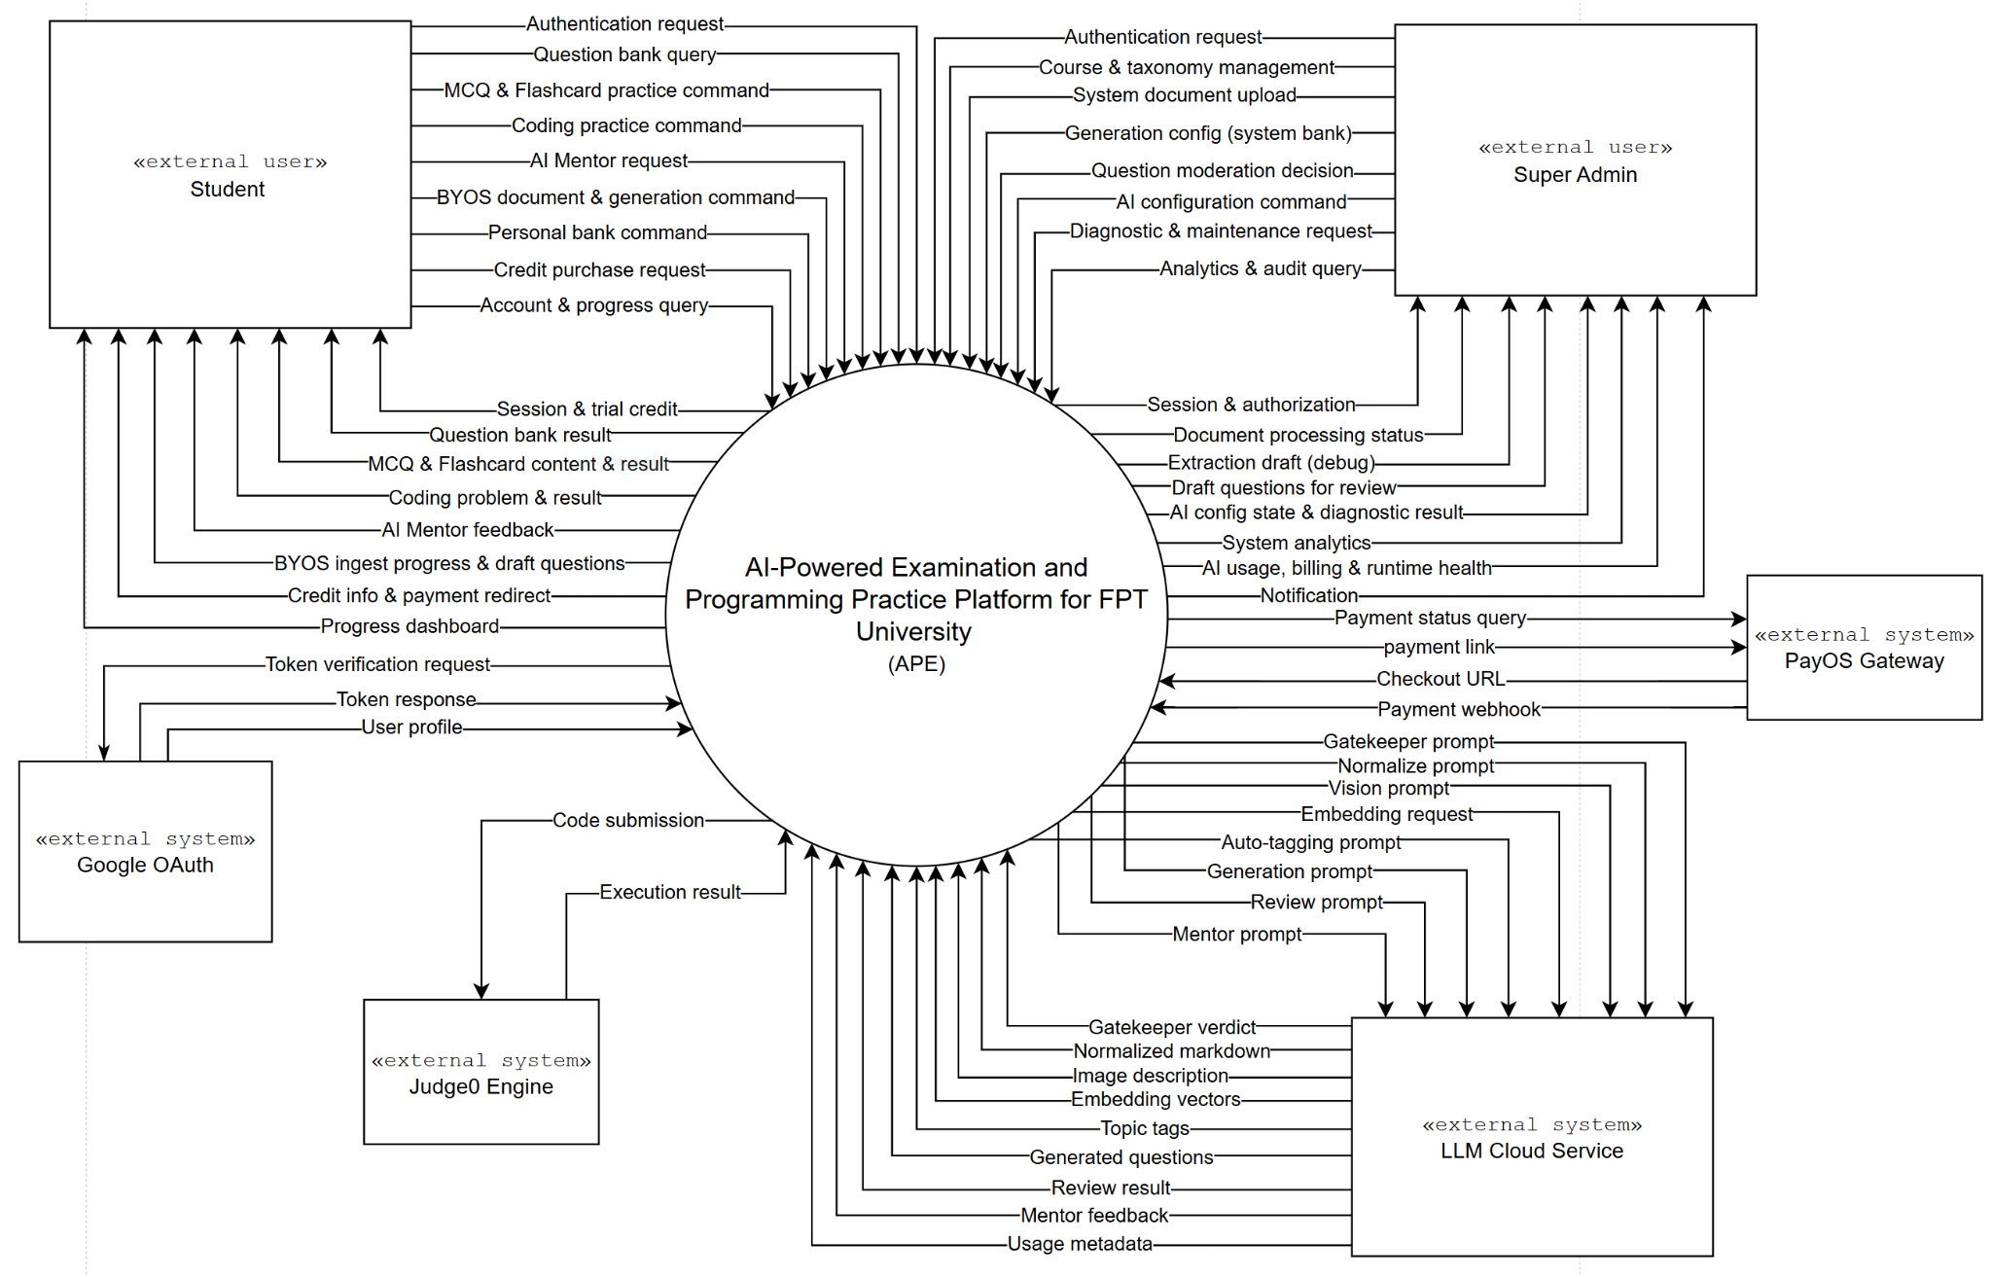
Figure 1-1. Context Diagram

External Entities:
Student: The primary end-user. Students authenticate via Google, upload personal study materials (BYOS), configure and take practice sessions in both Multiple Choice (FE) and Coding (PE) formats, view results with explanations, request post-submission AI Mentor feedback on their code, track learning analytics, and manage their profile and AI wallet (VND top-up).
Super Admin: The administrative user who manages courses and topic-tag taxonomies, uploads system-wide course materials, moderates AI-generated question banks (publish/reject drafts), configures the AI runtime (provider credentials, agents, model presets, prompts, and rule artifacts), manages user accounts, and monitors system dashboards (usage traffic, AI billing, and absorbed cost).
Google SSO System: Handles user authentication via OAuth 2.0. APE sends Login Initiation Requests and Token Verification Requests; receives Authentication Responses carrying the user's identity and profile.
Judge0 API: The self-hosted external code execution engine. APE sends Executable Source Code, Test Case Inputs, and Execution Constraints (time and memory limits); receives Standard Outputs, Compilation & Error Logs, and Runtime Metrics (execution time and memory usage).
LLM Cloud Service (OpenAI / Google Gemini): Provides the AI capabilities across the ingest and generation pipelines. APE sends Clean Text Chunks, Contextual Prompts, and Generation / Review / Mentor Requests; receives Generated Practice Contents, Review Verdicts, AI Mentor Feedback, Auto-Tags, and Vector Embeddings.
Payment API (PayOS): Handles financial transactions for AI wallet top-up in VND. APE sends Payment Link / QR Generation Requests; receives Payment Status Confirmations, delivered both as a synchronous response and an asynchronous webhook callback.

1.2 Main Workflows
The APE system operates through five (5) core business workflows. Each workflow is described with a PlantUML swim-lane activity diagram.

1.2.1 User Authentication
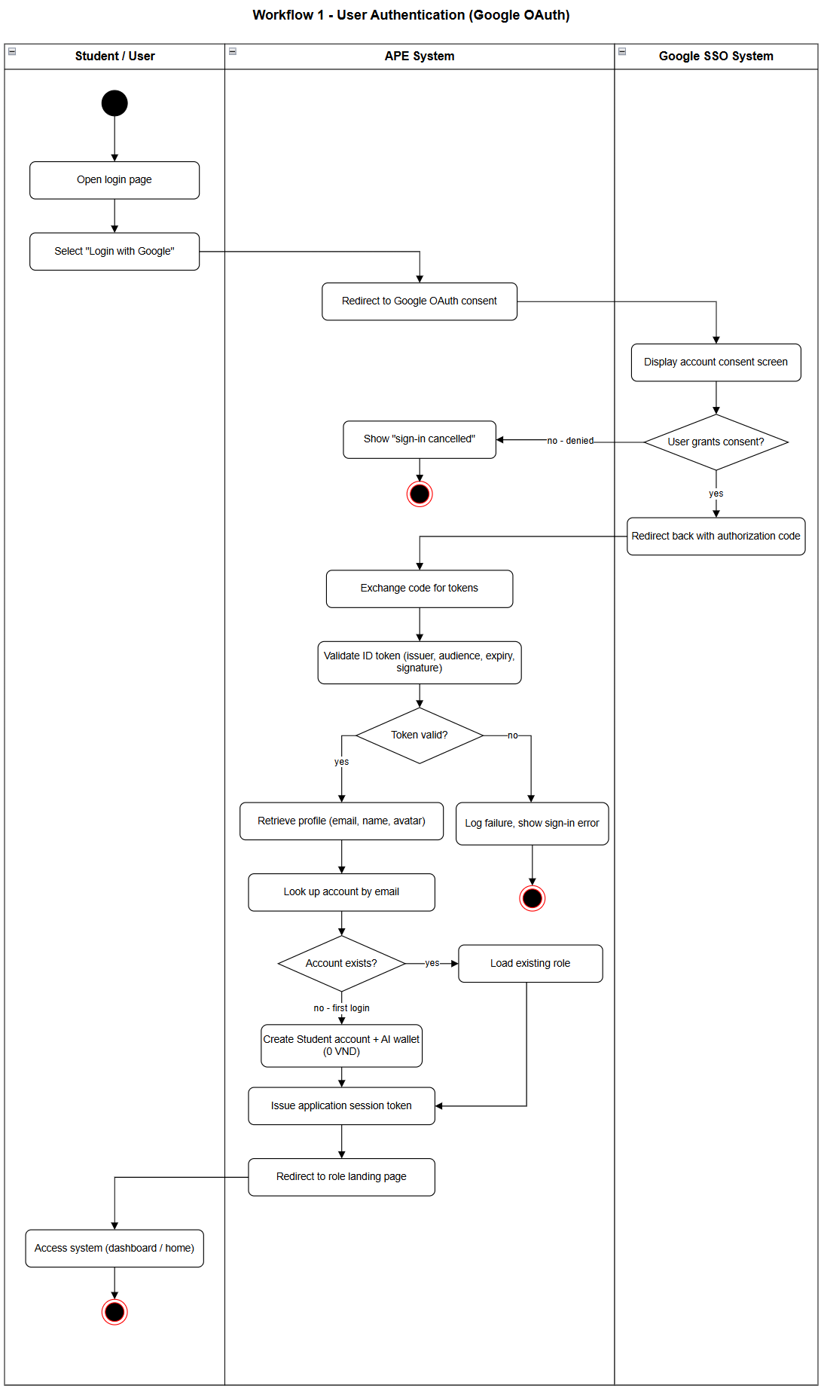
Figure 1-2-1 Swimlane-diagram User Authentication

1.2.2 AI Wallet Top-up
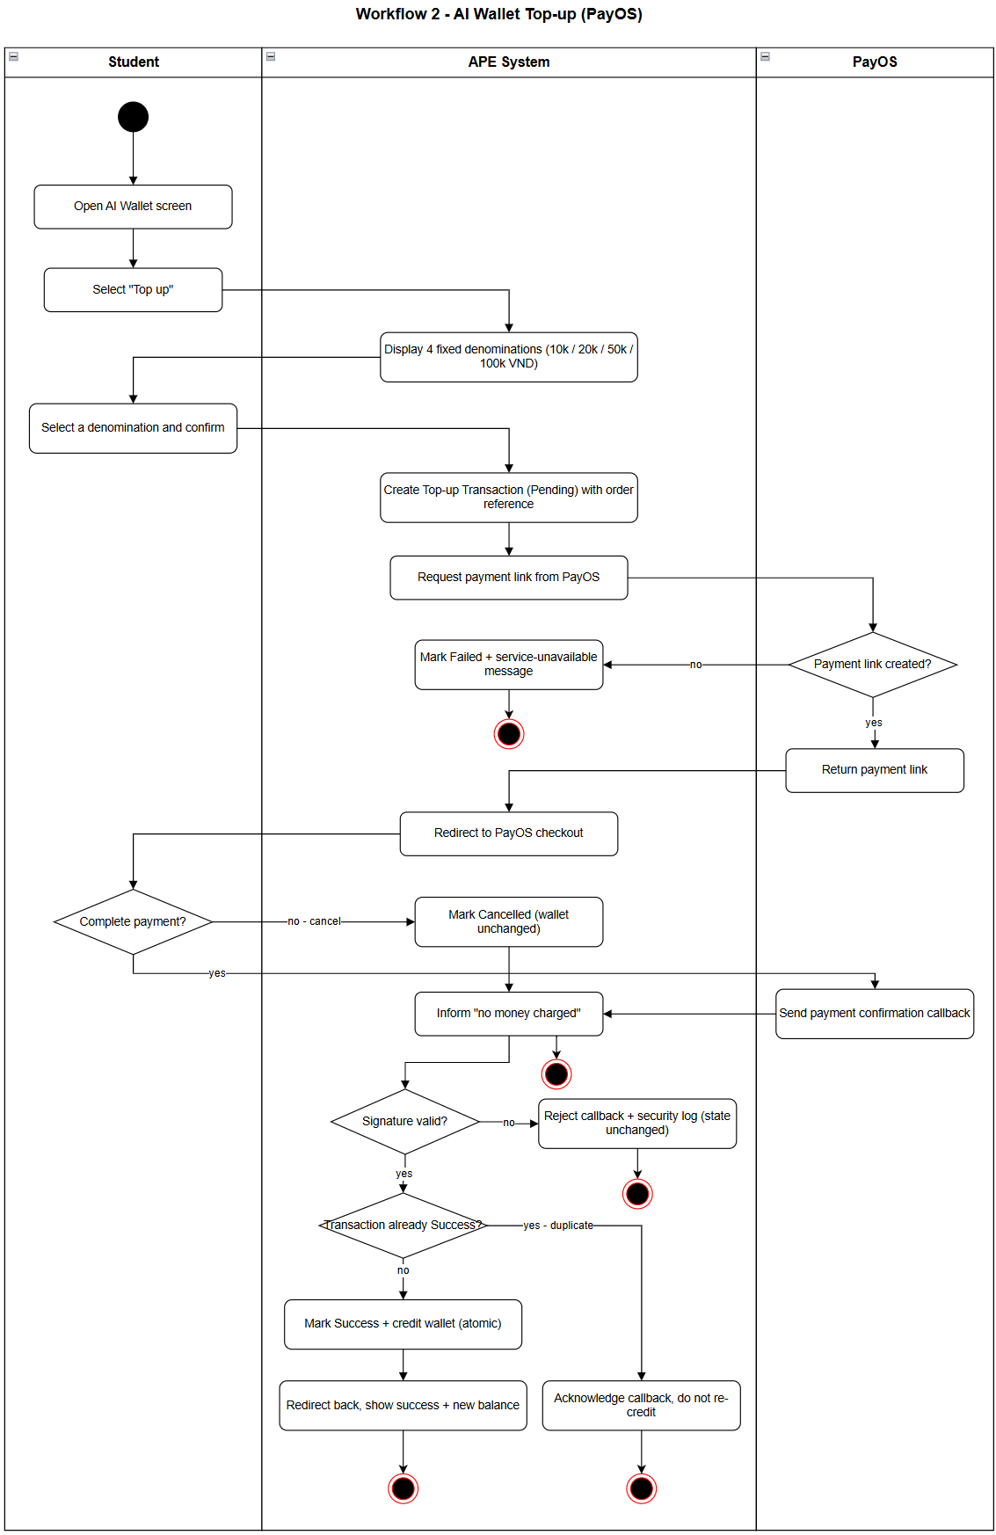
Figure 1-2-2 AI Wallet Top-Up

1.2.3 System Document Ingestion (Super Admin)
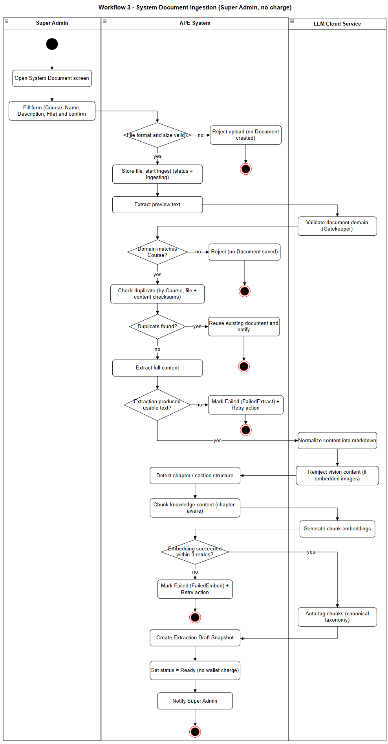
Figure 1-2-3 Swimlane-diagram System Document Ingestion

1.2.4 BYOS Document Ingestion (Student)
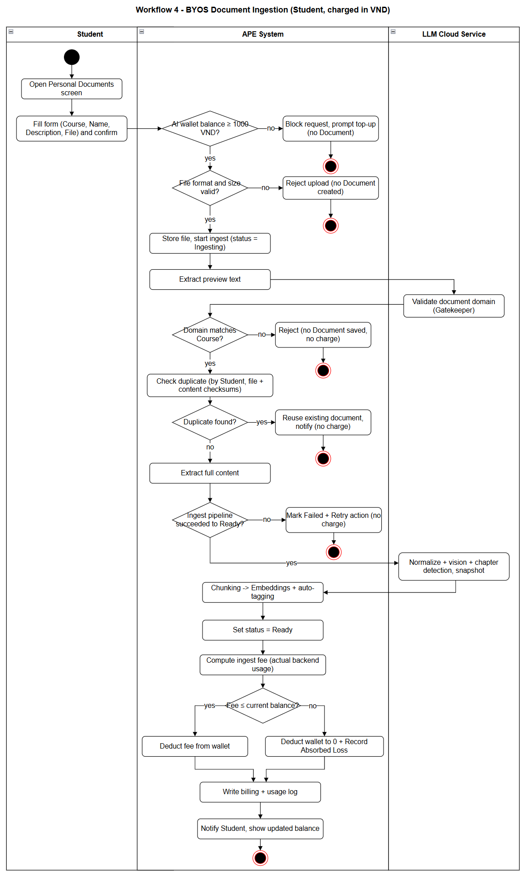
Figure 1-2-4 Swimlane-diagram BYOS Document Ingestion (Student)

1.2.5 AI Question Generation & Review
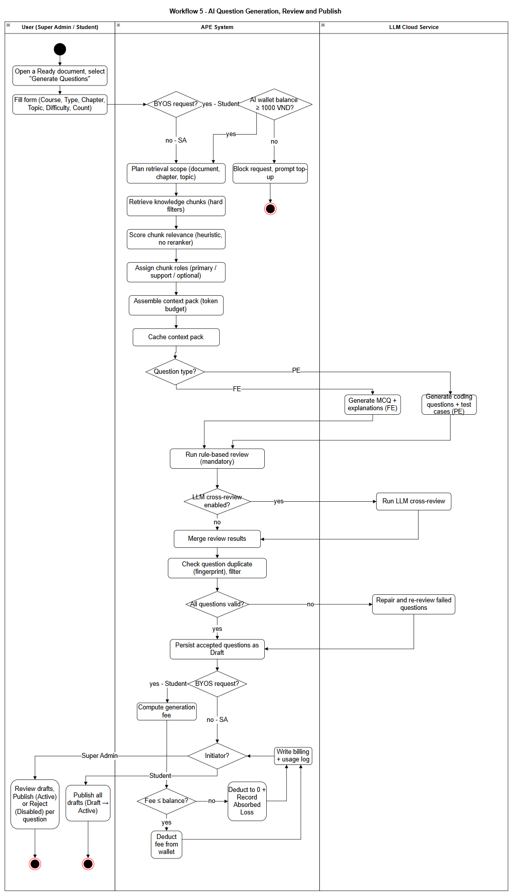
Figure 1-2-5 Swimlane-diagram AI Question Generation & Review

1.2.6 MCQ & Flashcard Practice
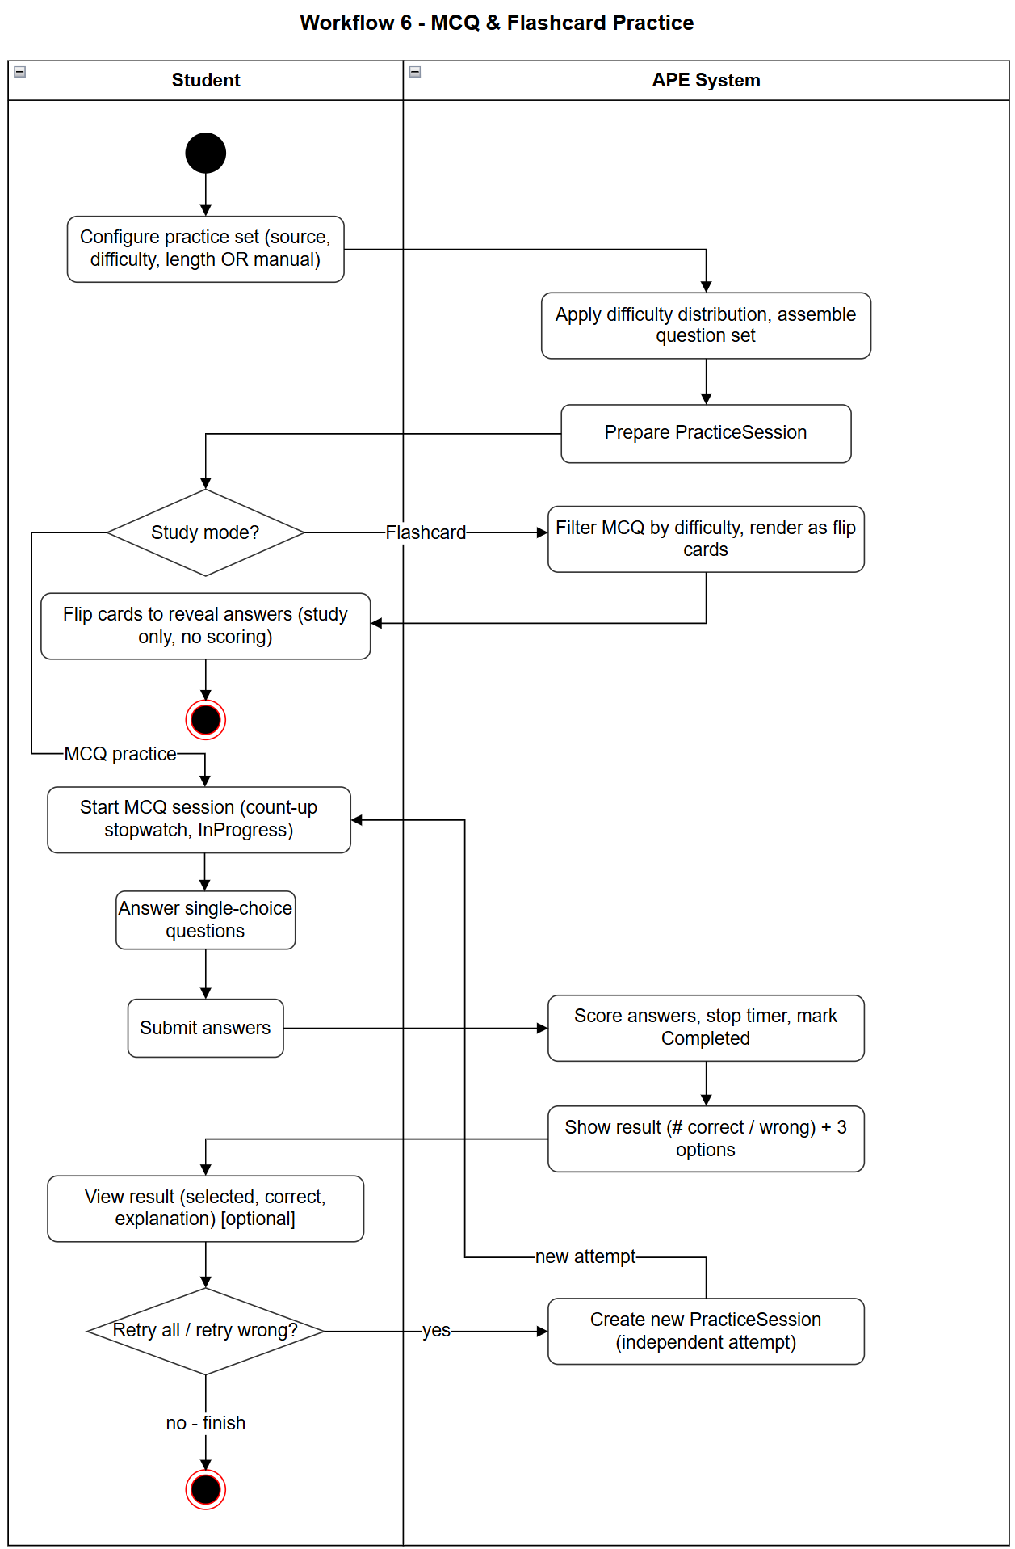
Figure 1-2-6 Swimlane-diagram MCQ & Flashcard Practice

1.2.7 Coding Practice & Grading
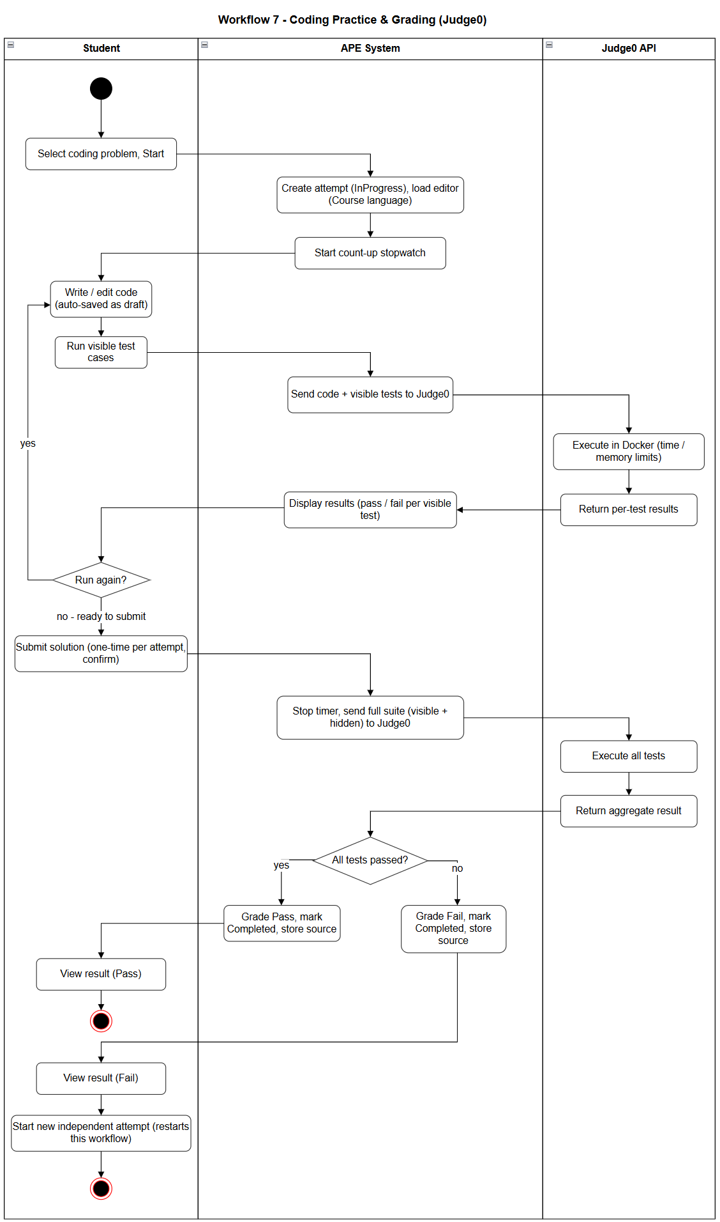
Figure 1-2-7 Swimlane-diagram Coding Practice & Grading

1.2.8 AI Code Mentor
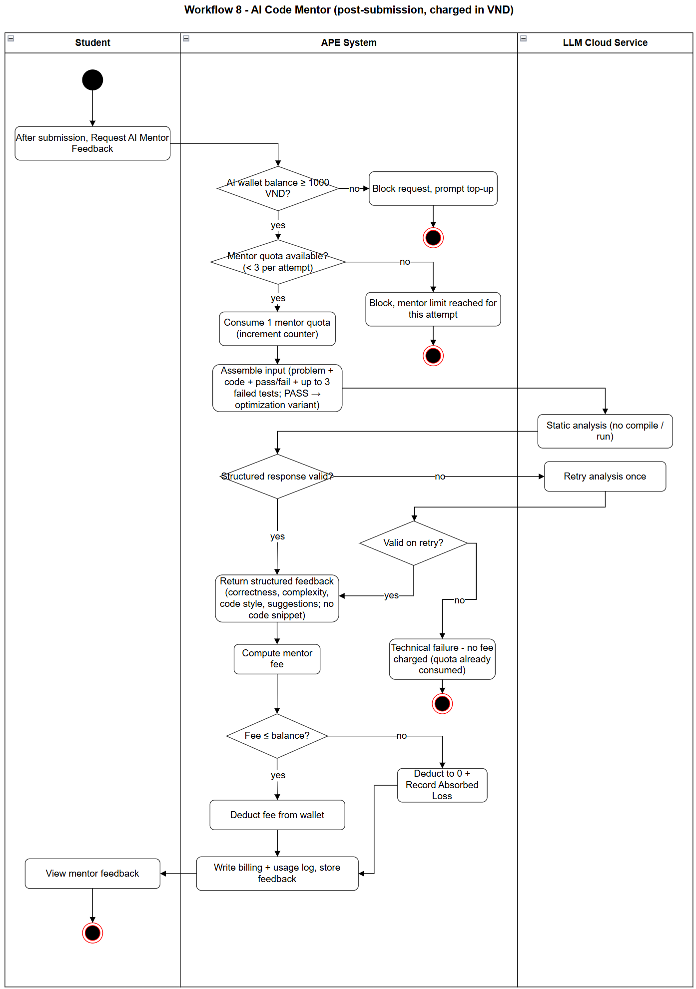
Figure 1-2-8 Swimlane-diagram AI Code Mentor

1.3 User Requirements

1.3.1 Actors
An actor is an external entity that interacts with the APE system. The table below describes all actors, including human users and external systems.

# | Actor | Description
1 | Student | The primary end-user role. Authenticates via Google, browses and practices the shared question bank, uploads personal study materials (BYOS) to generate a private question bank, takes Multiple Choice (FE) and Coding (PE) practice sessions, reviews results with answer explanations, requests post-submission AI Mentor feedback on submitted code, tracks personal learning analytics, and manages the AI wallet (VND top-up).
2 | Super Admin | The administrative role. Manages courses and topic-tag taxonomies, uploads system-wide learning materials, moderates AI-generated question banks by publishing or rejecting drafts, configures the AI runtime (provider credentials, agents, model presets, prompts, and rule artifacts), manages user accounts, and monitors system-wide dashboards including usage traffic, AI billing, and absorbed cost.
3 | Google SSO System | External identity provider. Handles user authentication through OAuth 2.0; receives Login Initiation and Token Verification Requests from APE and returns verified user identity and profile data.
4 | Judge0 API | External, self-hosted code execution engine. Receives executable source code, test case inputs, and execution constraints (time and memory limits); compiles and runs the code and returns standard outputs, compilation and error logs, and runtime metrics.
5 | LLM Cloud Service | External AI provider powering the ingest and generation pipelines. Receives clean text chunks, contextual prompts, and generation, review and mentor requests; returns generated practice content, review verdicts, AI Mentor feedback, auto-tags, and vector embeddings.
6 | Payment API (PayOS) | External payment gateway. Handles AI wallet top-up transactions in VND; receives payment link / QR generation requests and returns payment status confirmations both synchronously and via asynchronous webhook callback.

1.3.2 Use Cases (UC)
The following table lists the 126 use cases of the APE system, grouped by feature. Each use case is named as a verb followed by an object and delivers a distinct outcome of value to an actor.

ID | Use Case | Feature | Use Case Description
UC-01 | Login with Google | Authentication & Account | Authenticates a user (Super Admin or Student) through their Google account and establishes an authorized session.
UC-02 | Logout | Authentication & Account | Ends the current user session and clears the authentication state.
UC-03 | Authenticate via Google OAuth | Authentication & Account | Verifies the Google OAuth token and retrieves the user's identity and profile. Included by Login with Google.
UC-04 | View Own Profile | Authentication & Account | Allows a user to view their own account profile information.
UC-145 | View User List | Authentication & Account | Allows the Super Admin to view the list of user accounts with search and role/status filters.
UC-146 | View User Detail | Authentication & Account | Allows the Super Admin to view the read-only detail of a selected user account.
UC-147 | Moderate User Access Status | Authentication & Account | Allows the Super Admin to ban or unban a user account, blocking or restoring access without deleting it.
UC-05 | View AI Wallet Balance | AI Wallet & Payment | Allows a Student to view their current AI wallet balance in VND.
UC-06 | View Top-up Options | AI Wallet & Payment | Displays the available fixed top-up denominations (10k / 20k / 50k / 100k VND).
UC-07 | Top-up AI Wallet | AI Wallet & Payment | Allows a Student to add funds to their AI wallet by paying through the payment gateway.
UC-08 | Process Payment Callback | AI Wallet & Payment | Receives the payment gateway's confirmation and credits the paid amount to the Student's wallet.
UC-09 | Cancel Payment | AI Wallet & Payment | Allows a Student to cancel an in-progress top-up transaction.
UC-10 | View Top-up History | AI Wallet & Payment | Allows a Student to view the history of their wallet top-up transactions.
UC-11 | View Top-up Detail | AI Wallet & Payment | Allows a Student to view the details of a single top-up transaction.
UC-12 | Check Minimum Balance Guard | AI Wallet & Payment | Verifies the Student's wallet holds at least 1,000 VND before any AI request is allowed to run. Included by all AI actions.
UC-13 | Record Absorbed Loss | AI Wallet & Payment | Records the portion of an AI request cost that exceeds the Student's remaining balance as system-absorbed loss.
UC-148 | Create Wallet Package | AI Wallet & Payment | Allows the Super Admin to create a top-up wallet package (denomination).
UC-149 | View Wallet Package List | AI Wallet & Payment | Allows the Super Admin to view the configured wallet packages.
UC-150 | Update Wallet Package | AI Wallet & Payment | Allows the Super Admin to update an existing wallet package.
UC-151 | Delete Wallet Package | AI Wallet & Payment | Allows the Super Admin to delete a wallet package.
UC-14 | Create Course | Course Management | Allows the Super Admin to create a new course with its bound programming language.
UC-15 | View Course List | Course Management | Allows Super Admin and Students to view the list of available courses.
UC-16 | View Course Detail | Course Management | Allows Super Admin and Students to view the details of a course.
UC-17 | Update Course | Course Management | Allows the Super Admin to update an existing course.
UC-18 | Delete Course | Course Management | Allows the Super Admin to delete a course.
UC-24 | Upload System Document | Document Management | Allows the Super Admin to upload a system-wide learning document and trigger the ingest pipeline.
UC-25 | Upload Personal Document (BYOS) | Document Management | Allows a Student to upload a personal document and trigger the ingest pipeline. Requires wallet balance of at least 1,000 VND.
UC-26 | View System Document List | Document Management | Allows the Super Admin to view the list of system documents.
UC-27 | View Personal Document List | Document Management | Allows a Student to view their own uploaded documents.
UC-28 | View Document Detail | Document Management | Allows a user to view the details of a document.
UC-32 | Delete Document | Document Management | Allows a user to delete a document they own.
UC-33 | Download Original Document | Document Management | Allows a user to download the original uploaded file.
UC-34 | Extract Preview Text | AI Ingest Pipeline | Extracts a short preview of the document for domain validation before full processing.
UC-35 | Validate Document Domain (Gatekeeper) | AI Ingest Pipeline | Uses AI to verify that the document matches the selected course; rejects and stops the pipeline if it does not.
UC-36 | Check Document Duplicate | AI Ingest Pipeline | Detects whether the document has already been uploaded using two-stage checksums: file-level (before Preview) and content-level (after Normalize).
UC-37 | Reuse Existing Document | AI Ingest Pipeline | Reuses a previously ingested document instead of re-processing a duplicate.
UC-38 | Extract Full Content | AI Ingest Pipeline | Extracts the full text content from the uploaded document.
UC-39 | Normalize Extracted Content | AI Ingest Pipeline | Uses AI to clean and normalize the extracted text into structured markdown.
UC-40 | Reinject Vision Content | AI Ingest Pipeline | Uses AI vision to describe embedded images and reinsert them into the content.
UC-41 | Detect Document Structure | AI Ingest Pipeline | Detects the chapter and section structure of the document using rule-based analysis.
UC-42 | Chunk Knowledge Content | AI Ingest Pipeline | Splits the content into knowledge chunks along chapter and section boundaries.
UC-43 | Generate Chunk Embeddings | AI Ingest Pipeline | Generates vector embeddings for each knowledge chunk to support retrieval.
UC-44 | Auto-Tag Chunks | AI Ingest Pipeline | Uses AI to assign course topic tags to each knowledge chunk.
UC-46 | Deduct Ingest Fee (VND) | AI Ingest Pipeline | Deducts the ingest cost in VND from the Student's wallet when a BYOS document completes ingest successfully.
UC-47 | Configure Generation Request | AI Question Generation | Allows a user to configure a generation request (question type, chapter, topic, difficulty, count).
UC-48 | Plan Retrieval Scope | AI Question Generation | Determines the allowed knowledge scope based on the user's selection.
UC-49 | Retrieve Knowledge Chunks | AI Question Generation | Retrieves candidate knowledge chunks that satisfy the scope filters.
UC-50 | Score Chunk Relevance | AI Question Generation | Scores each candidate chunk using heuristic relevance signals.
UC-51 | Assign Chunk Roles | AI Question Generation | Assigns primary, support, or optional roles to the scored chunks.
UC-52 | Assemble Context Pack | AI Question Generation | Assembles the retrieved chunks into a context pack within the token budget.
UC-53 | Cache Context Pack | AI Question Generation | Caches the context pack for reuse in subsequent generations.
UC-54 | Generate MCQ Questions (FE) | AI Question Generation | Uses AI to generate multiple-choice questions from the context pack.
UC-55 | Generate MCQ Explanations | AI Question Generation | Uses AI to generate an explanation for each generated multiple-choice question.
UC-56 | Generate Coding Questions (PE) | AI Question Generation | Uses AI to generate coding problems from the context pack.
UC-57 | Generate Coding Test Cases | AI Question Generation | Uses AI to generate test cases (including hidden ones) for each coding problem.
UC-58 | Run Rule-based Review | AI Question Generation | Validates each generated question against schema, grounding, tag overlap, and duplicate rules.
UC-59 | Run LLM Cross-Review | AI Question Generation | Optionally uses a second AI model to assess the semantic quality of generated questions.
UC-60 | Merge Review Results | AI Question Generation | Combines rule-based and AI review outcomes into a final verdict per question.
UC-61 | Check Question Duplicate | AI Question Generation | Detects and filters duplicate questions using a question fingerprint.
UC-62 | Repair Failed Questions | AI Question Generation | Regenerates only the failed parts of questions instead of discarding the whole batch.
UC-63 | Persist Draft Questions | AI Question Generation | Saves accepted questions into the bank in Draft status.
UC-64 | Deduct Generation Fee (VND) | AI Question Generation | Deducts the generation and review cost in VND from the Student's wallet after processing (BYOS).
UC-65 | View Document Chapters | Retrieval Scope Browsing | Allows a user to view the detected chapters of a document.
UC-66 | View Chapter Topics | Retrieval Scope Browsing | Allows a user to view the topics available within a chapter.
UC-67 | View Course Topic Coverage | Retrieval Scope Browsing | Allows a user to view the topic coverage across a course.
UC-68 | View Document Topic Summary | Retrieval Scope Browsing | Allows a Student to view the topic summary of a personal document.
UC-69 | View Chapter-Topic Coverage | Retrieval Scope Browsing | Allows a user to view the chapter-topic coverage for scope selection.
UC-70 | View Draft Questions | Question Bank Management | Allows a user to view questions currently in Draft status.
UC-71 | Publish Question | Question Bank Management | Allows a Super Admin or Student to publish a single draft question to the active bank (SA publishes system bank; Student publishes their personal bank).
UC-72 | Reject Draft Question | Question Bank Management | Allows the Super Admin to reject a draft question.
UC-73 | Publish All Draft Questions | Question Bank Management | Allows a Student to publish an entire batch of draft questions in their personal bank.
UC-74 | Delete Question | Question Bank Management | Allows a user to delete a question they own.
UC-75 | View Question Detail | Question Bank Management | Allows a user to view the full detail of a question.
UC-76 | Browse Question Bank | Question Bank Browsing | Allows a Student to browse the question bank.
UC-77 | Filter Questions | Question Bank Browsing | Allows a Student to filter questions by course, type, difficulty, and topic.
UC-78 | Search Questions by Keyword | Question Bank Browsing | Allows a Student to search questions by keyword.
UC-79 | Preview Question | Question Bank Browsing | Allows a Student to preview a single question.
UC-80 | Configure Practice from System Bank | Practice Setup | Allows a Student to configure a practice session from the system question bank.
UC-81 | Configure Practice from Personal Bank | Practice Setup | Allows a Student to configure a practice session from their personal question bank.
UC-82 | Manually Select Coding Problems | Practice Setup | Allows a Student to manually select up to 5 coding problems (PE) and assemble them into a single Coding practice set. Applies to Coding practice only; no randomization.
UC-83 | Assemble MCQ Practice Set by Difficulty | Practice Setup | Allows a Student to assemble an MCQ or Flashcard practice set by specifying the number of Easy, Medium, and Hard questions to include. Applies to MCQ and Flashcard practice only.
UC-84 | Start MCQ Practice Session | MCQ & Flashcard Practice | Starts a multiple-choice practice session for a Student.
UC-85 | Submit MCQ Answers | MCQ & Flashcard Practice | Submits the Student's answers for scoring.
UC-86 | View MCQ Result | MCQ & Flashcard Practice | Displays the score and per-question review with correct answers and explanations.
UC-87 | Retry All Questions | MCQ & Flashcard Practice | Allows a Student to retry the entire set as a new session.
UC-89 | Resume In-Progress Session | MCQ & Flashcard Practice | Allows a Student to resume an unfinished practice session.
UC-90 | Start Flashcard Session | MCQ & Flashcard Practice | Starts a flashcard practice session for a Student.
UC-91 | Review Flashcards | MCQ & Flashcard Practice | Allows a Student to flip through flashcards showing questions and answers.
UC-92 | Start Coding Practice Session | Coding Practice | Starts a coding practice session for a Student on a selected problem from the practice set.
UC-93 | Save Draft Code | Coding Practice | Automatically saves the Student's in-progress code so the session can be resumed.
UC-94 | Run Test Cases | Coding Practice | Runs the Student's code against visible test cases via Judge0, with unlimited attempts.
UC-95 | Submit Coding Solution | Coding Practice | Submits the Student's code for final grading as a single, one-time submission.
UC-96 | View Submission Result | Coding Practice | Displays the pass or fail result of the submitted solution.
UC-97 | Resume Coding Session | Coding Practice | Allows a Student to resume an unfinished coding session.
UC-98 | Start New Coding Attempt | Coding Practice | Allows a Student to start a fresh attempt on a problem after a failed submission.
UC-99 | Request AI Mentor Feedback | AI Code Mentor | Allows a Student to request AI feedback on a submitted solution. Post-submission only, once per coding problem per attempt (re-attempting the problem resets the allowance); requires a wallet of at least 1,000 VND.
UC-100 | Analyze Submitted Code | AI Code Mentor | Uses AI to statically analyze the submitted code and produce structured feedback.
UC-101 | Enforce Mentor Quota | AI Code Mentor | Enforces the limit of one mentor request per coding problem per attempt.
UC-102 | Deduct Mentor Fee (VND) | AI Code Mentor | Deducts the mentor cost in VND from the Student's wallet after feedback is produced.
UC-103 | View Latest Mentor Feedback | AI Code Mentor | Allows a Student to view the most recent mentor feedback.
UC-105 | View Personal Dashboard | Progress & Analytics | Allows a Student to view their personal learning dashboard.
UC-106 | View Accuracy by Course | Progress & Analytics | Allows a Student to view their answer accuracy per course.
UC-108 | View Progress Chart | Progress & Analytics | Allows a Student to view their progress over time as a line chart.
UC-109 | View Practice History | Progress & Analytics | Allows a Student to view their past practice sessions.
UC-110 | View Practice Session Detail | Progress & Analytics | Allows a Student to view the details of a past practice session.
UC-111 | View System Dashboard | Progress & Analytics | Allows the Super Admin to view the system-wide dashboard.
UC-112 | View All Students Statistics | Progress & Analytics | Allows the Super Admin to view statistics across all students.
UC-152 | View System Traffic Statistics | Progress & Analytics | Allows the Super Admin to view system traffic and health metrics (request volume, response time, active users, and error rate).
UC-115 | Create Provider Credential | AI Configuration | Allows the Super Admin to add an AI provider credential.
UC-116 | View Provider Credential List | AI Configuration | Allows the Super Admin to view configured provider credentials.
UC-117 | Update Provider Credential | AI Configuration | Allows the Super Admin to update a provider credential.
UC-118 | Delete Provider Credential | AI Configuration | Allows the Super Admin to delete a provider credential.
UC-119 | Create AI Agent | AI Configuration | Allows the Super Admin to create a new AI agent with its provider, model, and generation settings.
UC-120 | View AI Agent List | AI Configuration | Allows the Super Admin to view the configured AI agents.
UC-121 | View AI Agent Detail | AI Configuration | Allows the Super Admin to view the details of an AI agent.
UC-122 | Configure Agent Model Settings | AI Configuration | Allows the Super Admin to configure an AI agent's model settings (provider, model, max tokens, temperature, and capability flags) directly.
UC-134 | Create Rule Artifact | AI Configuration | Allows the Super Admin to create a rule artifact (policy, rubric, or ground truth).
UC-135 | View Rule Artifact List | AI Configuration | Allows the Super Admin to view rule artifacts.
UC-136 | View Rule Artifact Detail | AI Configuration | Allows the Super Admin to view the details of a rule artifact.
UC-137 | Update Rule Artifact | AI Configuration | Allows the Super Admin to update a rule artifact.
UC-138 | Activate Rule Artifact Version | AI Configuration | Allows the Super Admin to activate a specific rule artifact version.
UC-139 | Delete Rule Artifact | AI Configuration | Allows the Super Admin to delete a rule artifact.
UC-140 | Configure AI Billing Settings | AI Configuration | Allows the Super Admin to configure the AI billing parameters (USD-to-VND rate, minimum wallet balance, and charge multiplier).
UC-141 | View AI Usage Logs | AI Configuration | Allows the Super Admin to view detailed AI usage logs.
UC-143 | View AI Billing & Absorbed Loss | AI Configuration | Allows the Super Admin to view AI billing records and system-absorbed loss.
UC-144 | Run AI Smoke Test | AI Configuration | Allows the Super Admin to run diagnostic smoke tests on AI components.

1.3.3 Use Case Diagrams

1.3.3.1 UCs for Student
The use cases are organised into workflow-based diagrams rather than one diagram per actor, because the system contains 148 use cases and a per-actor diagram would be unreadable. This section presents the five diagrams of the Student area. External systems (Judge0 Engine, LLM Provider) appear as secondary actors inside the workflow they serve and are connected only to the use cases they actually support.
Notation convention. To emphasise the AI processing order, pipeline stages are laid out as a vertical sequence connected by solid arrows that denote execution order; every stage is «included» by its entry use case. Dashed arrows carry the «include» and «extend» stereotypes. Each use case shows both its ID (matching the list in 1.3.2) and its name.
Rendering. Each diagram is provided as PlantUML source. Paste it into a PlantUML renderer (for example plantuml.com or an IDE plugin) to produce the image, then place the rendered image below the corresponding source in the final report.

1.3.3.1.1 Question Bank Browsing & Practice Setup
Actors: Student
Purpose: Covers how a Student explores the question bank and configures a practice session before starting to practice.
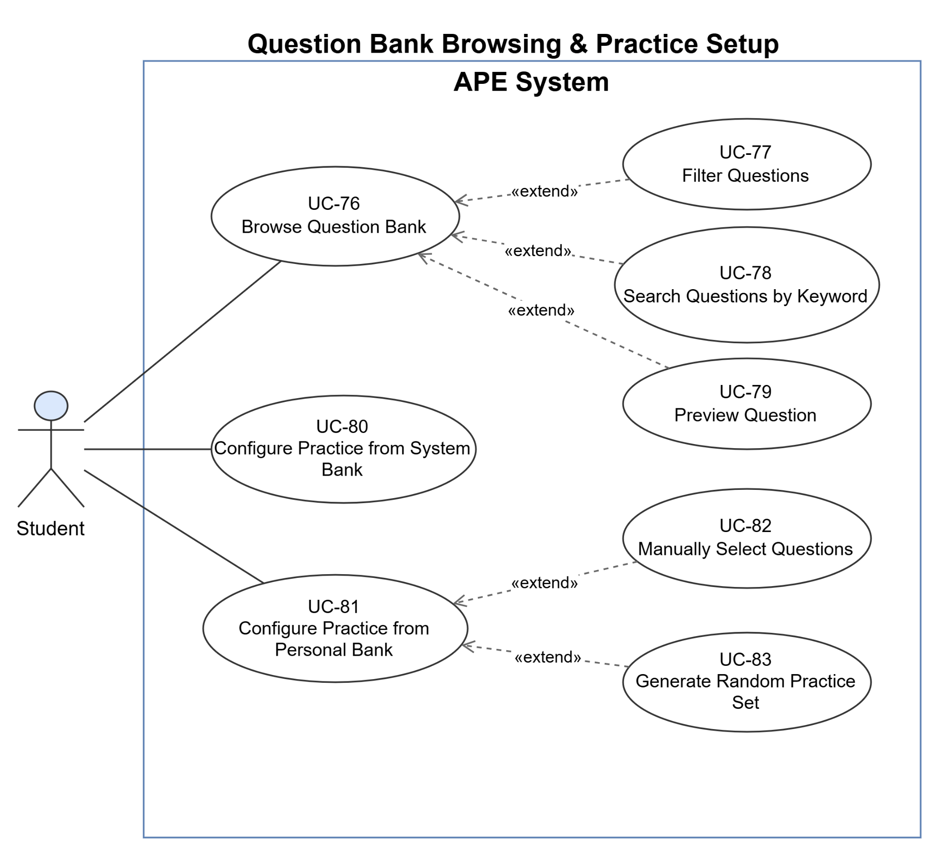
Figure 1-3-3-1-1 UseCase Diagram Question Bank Browsing & Practice Setup

1.3.3.1.2 MCQ & Flashcard Practice
Actors: Student
Purpose: Covers taking a multiple-choice practice session (submit, view result, retry) and reviewing flashcards.
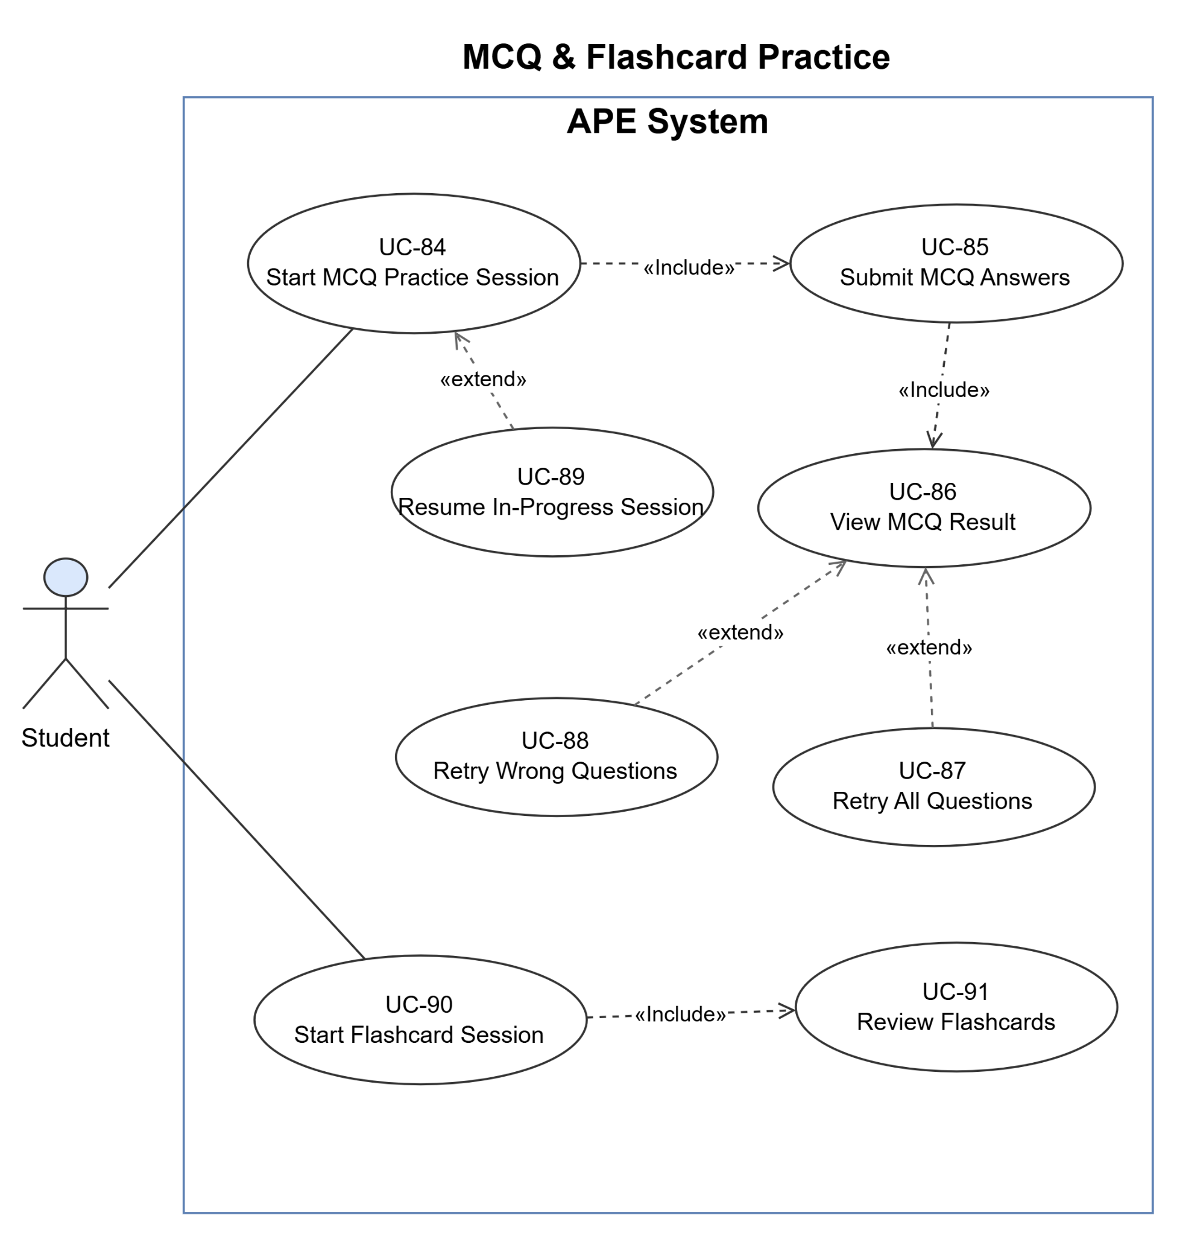
Figure 1-3-3-1-2 UseCase Diagram MCQ & Flashcard Practice

1.3.3.1.3 Coding Practice & AI Mentor
Actors: Student, Judge0 Engine, LLM Provider
Purpose: Covers solving a coding problem (run tests, single submission, new attempt) and requesting post-submission AI Mentor feedback. The mentor sub-flow is drawn as a sequence of supporting stages.
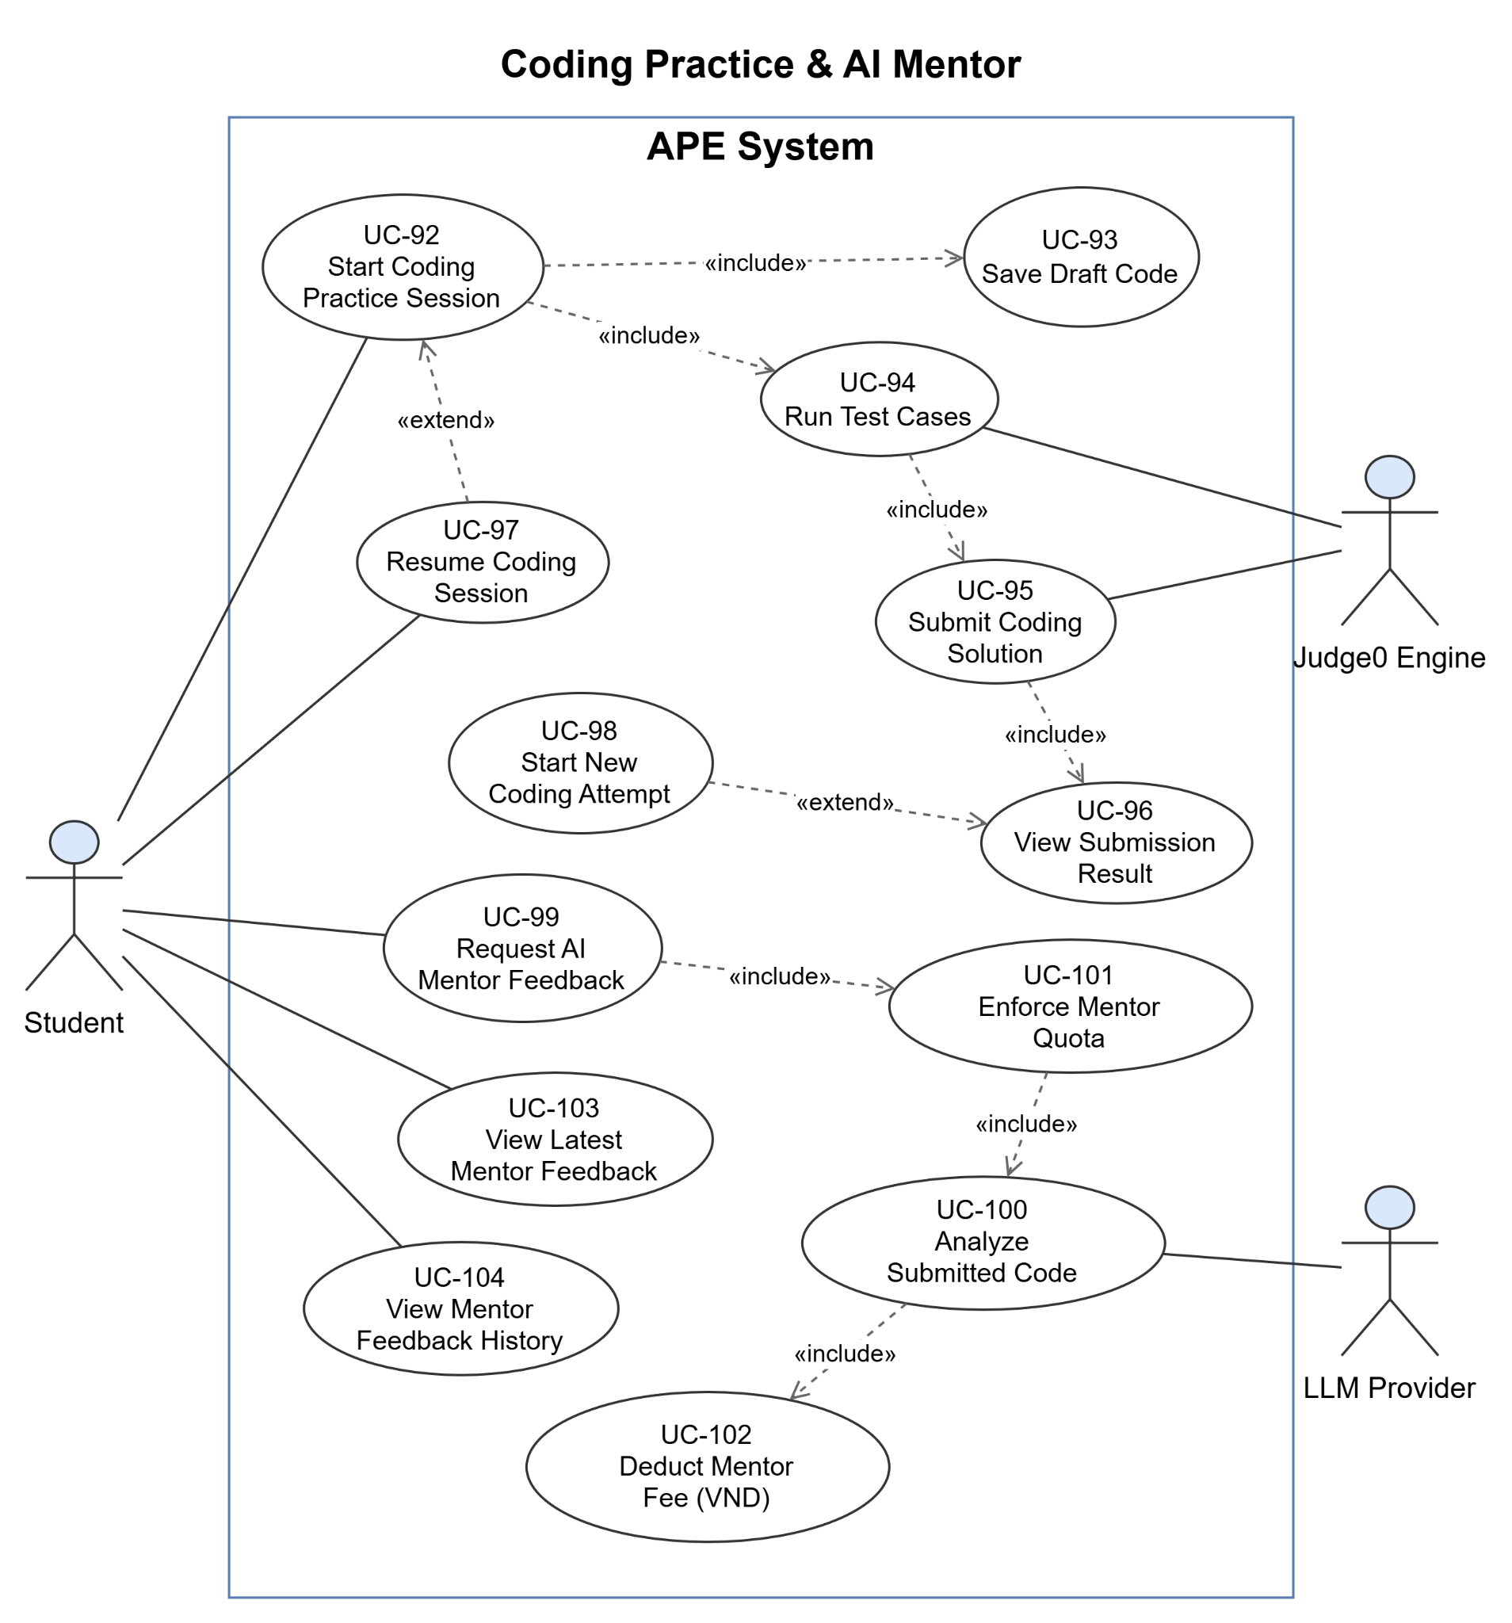
Figure 1-3-3-1-3 UseCase Diagram Coding Practice & AI Mentor

1.3.3.1.4 BYOS Ingestion
Actors: Student, LLM Provider
Purpose: Details the ingest pipeline triggered when a Student uploads a personal document (BYOS). Stages are drawn as a vertical sequence to emphasise execution order; all stages are «included» by the upload use case.
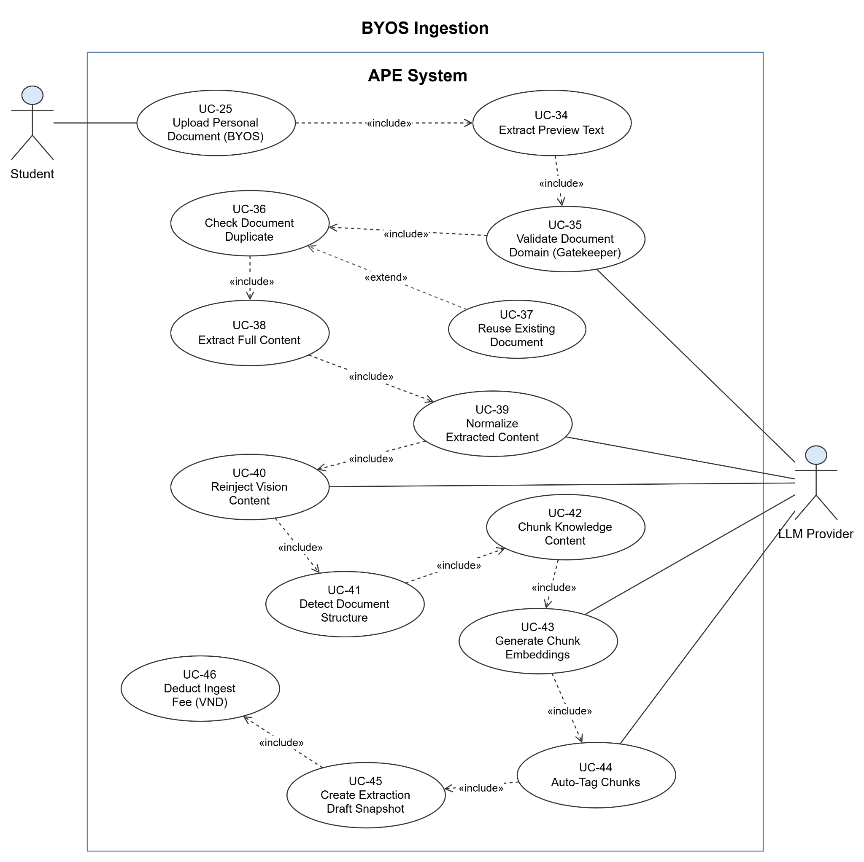
Figure 1-3-3-1-4 UseCase Diagram BYOS Ingestion

1.3.3.1.5 BYOS Generation & Publish
Actors: Student, LLM Provider
Purpose: The heaviest Student diagram. Covers browsing the retrieval scope, the full question-generation pipeline (with an FE/PE branch and optional review/repair stages), and publishing the resulting drafts into the personal bank. Generation stages are drawn as a vertical sequence.
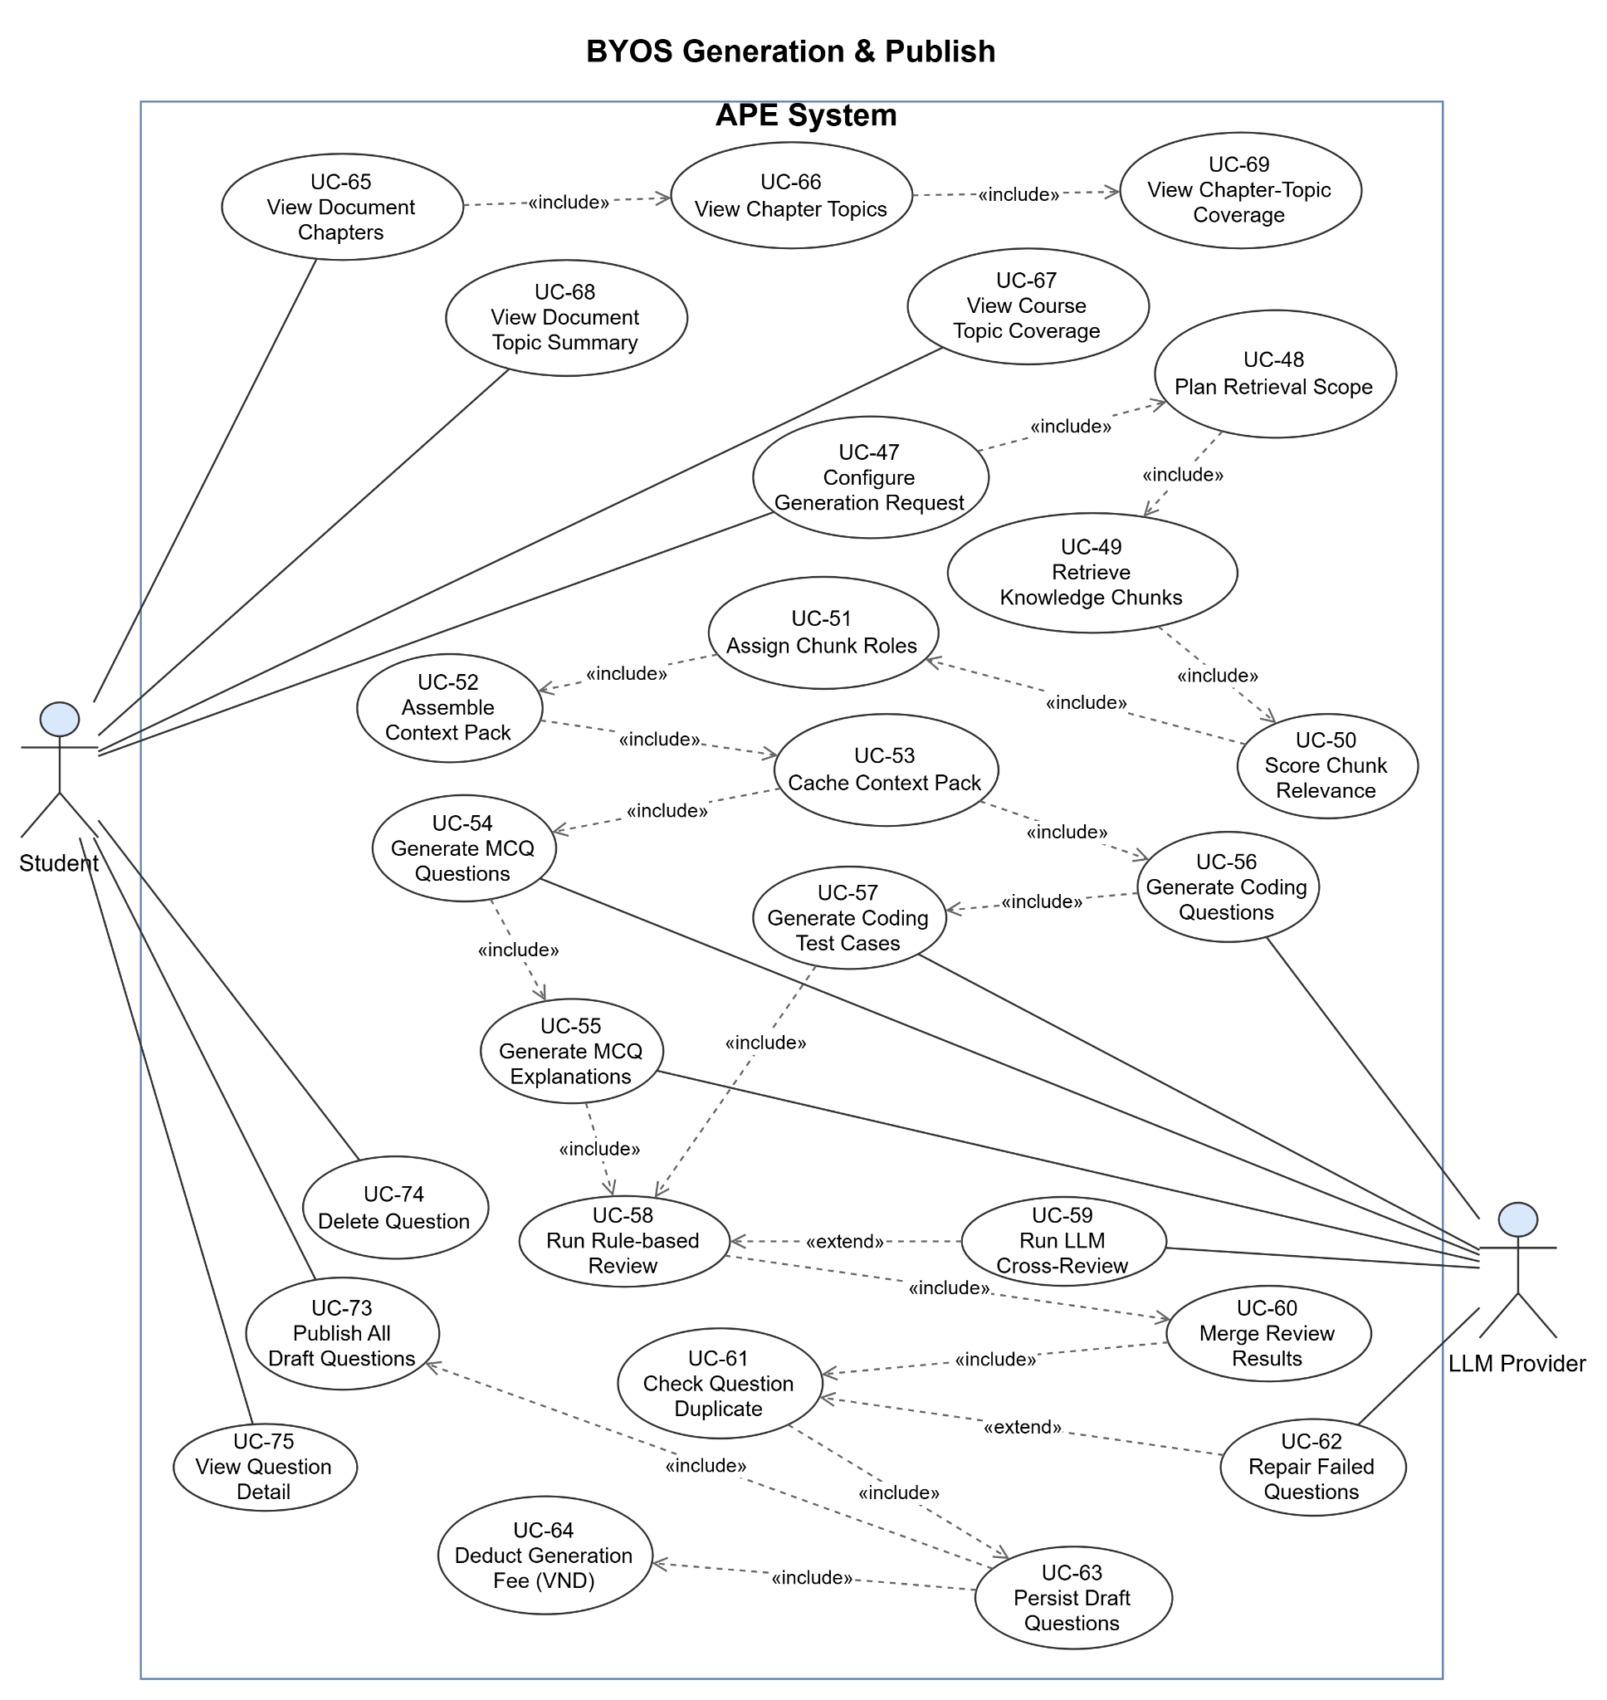
Figure 1-3-3-1-5 UseCase Diagram BYOS Generation & Publish

1.3.3.2 UCs for Super Admin

1.3.3.2.1 System Document Management
Actors: Super Admin
Purpose: Covers how the Super Admin manages system-wide learning documents: uploading, browsing the list, viewing detail and ingest status, inspecting the extraction draft, retrying a failed ingest, deleting and downloading.
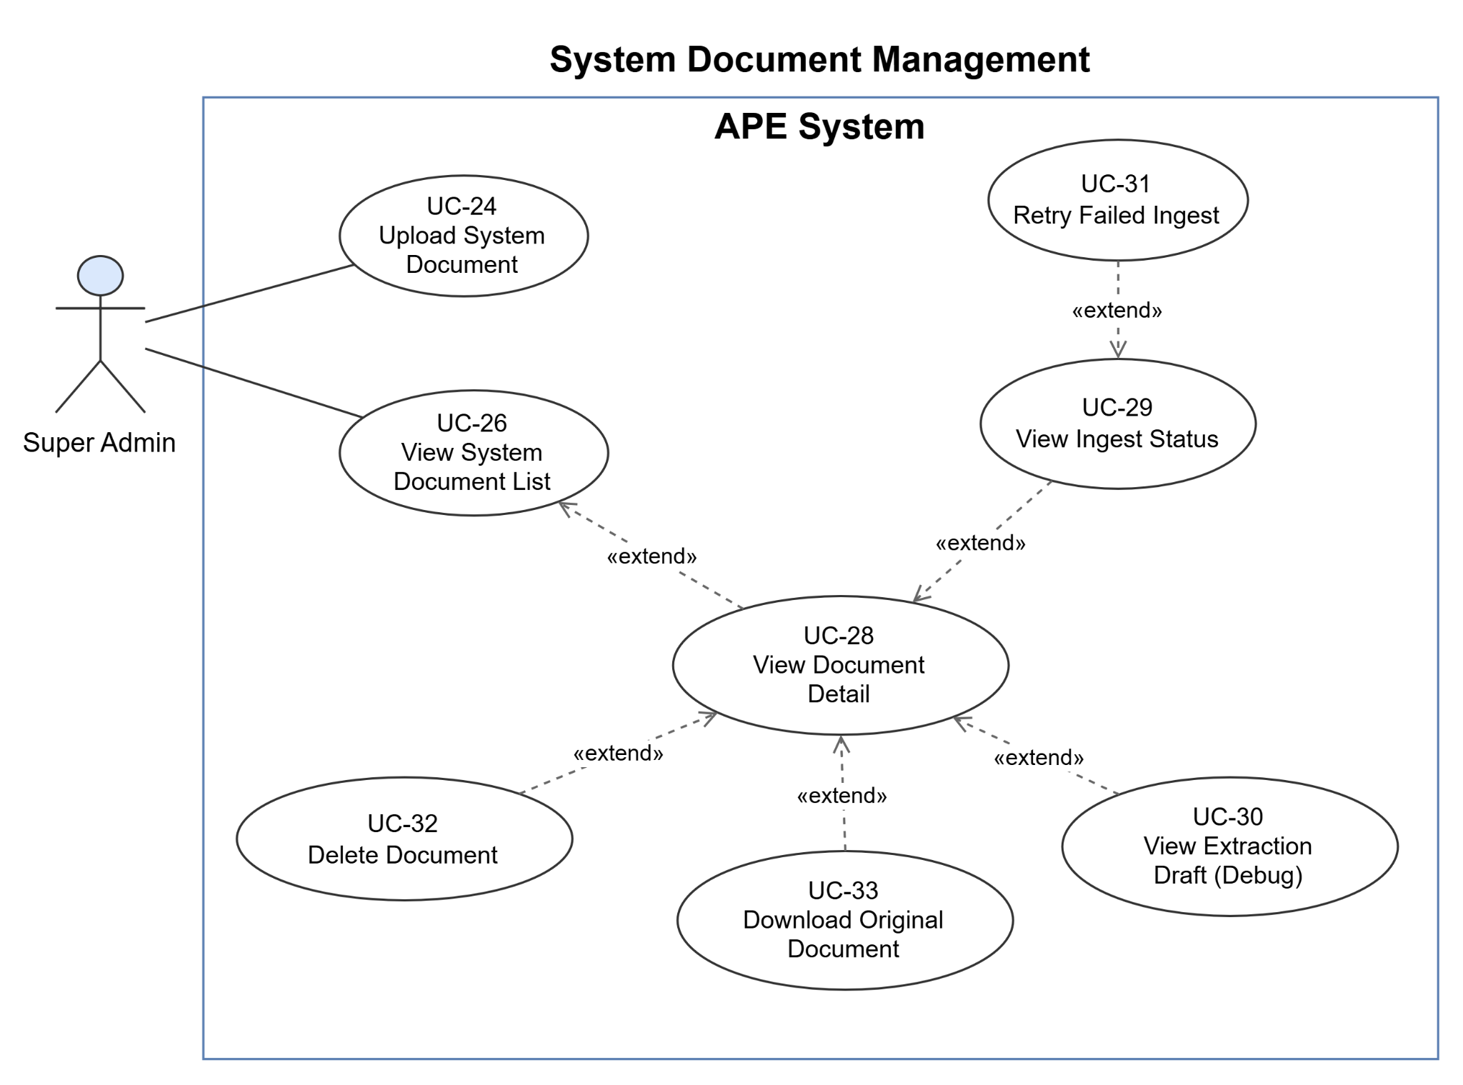
Figure 1-3-3-2-1 UseCase Diagram System Document Management

1.3.3.2.2 Ingest Pipeline Detail (System Document)
Actors: Super Admin, LLM Provider
Purpose: Details the ingest pipeline triggered when the Super Admin uploads a system document. Stages are laid out as a vertical sequence to emphasise execution order; all stages are «included» by the upload use case.
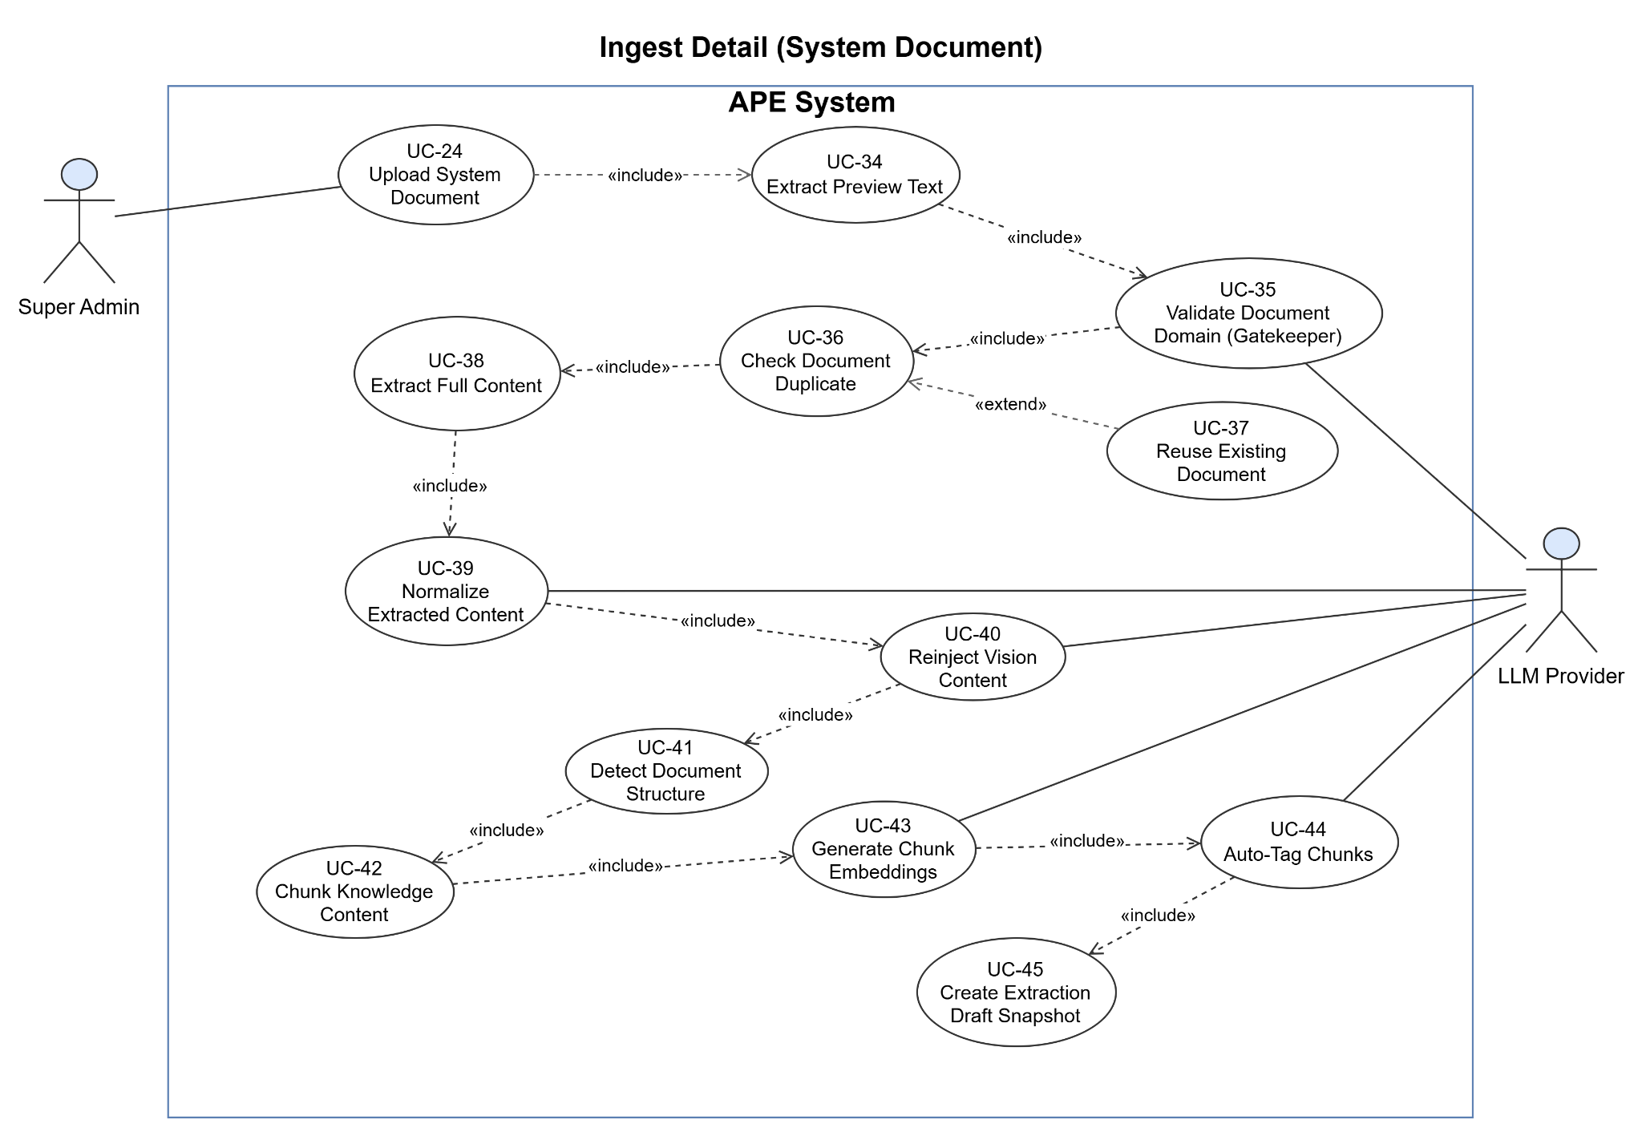
Figure 1-3-3-2-2 UseCase Diagram System Ingest Pipeline Detail (System Document)

1.3.3.2.3 Question Generation & Moderation
Actors: Super Admin
Purpose: Covers how the Super Admin launches a generation request for the system bank and then moderates the resulting draft questions by publishing or rejecting them.
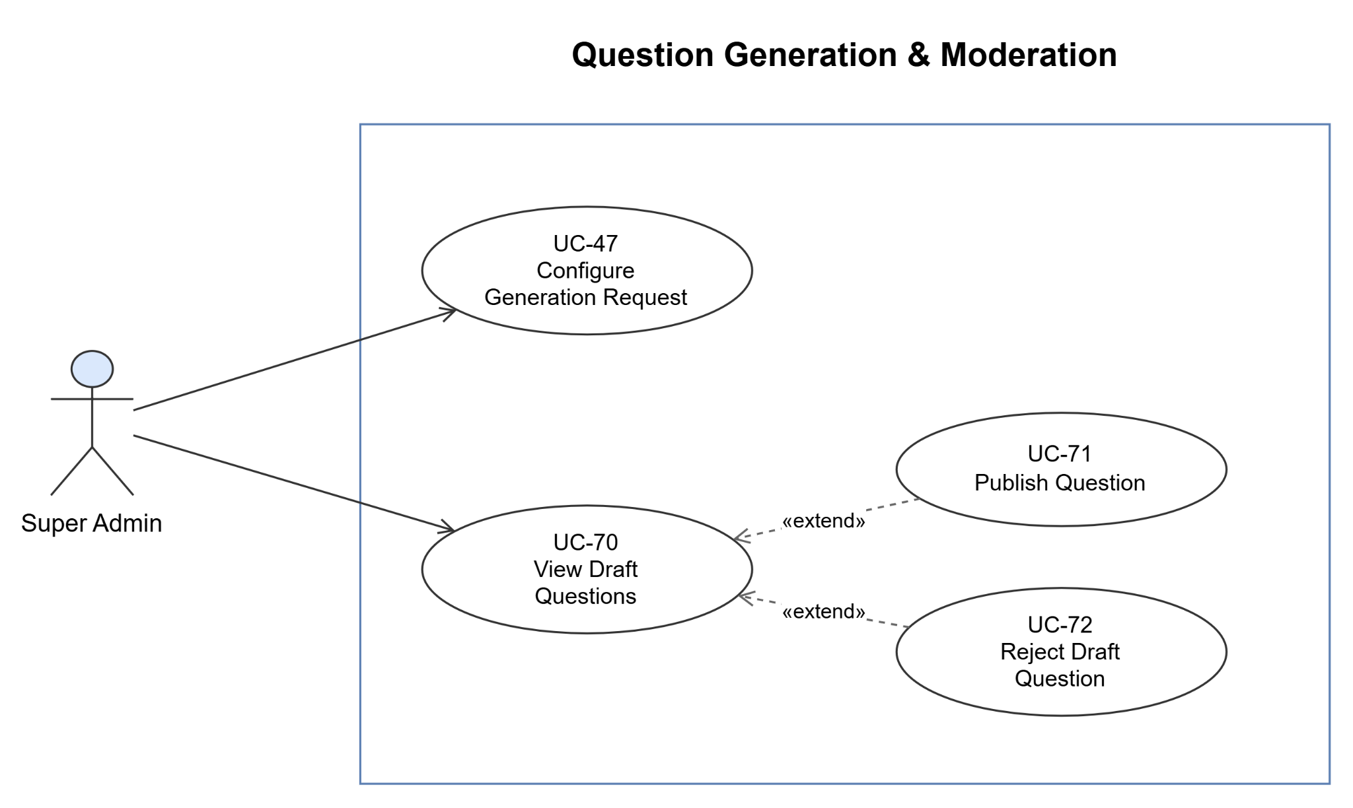
Figure 1-3-3-2-3 UseCase Diagram Question Generation & Moderation

1.3.3.2.4 Generation Pipeline Detail (System Content)
Actors: Super Admin, LLM Provider
Purpose: Details the question-generation pipeline triggered by the Super Admin for the system bank, including the FE/PE branch and the optional review and repair stages. Stages are laid out as a vertical sequence.

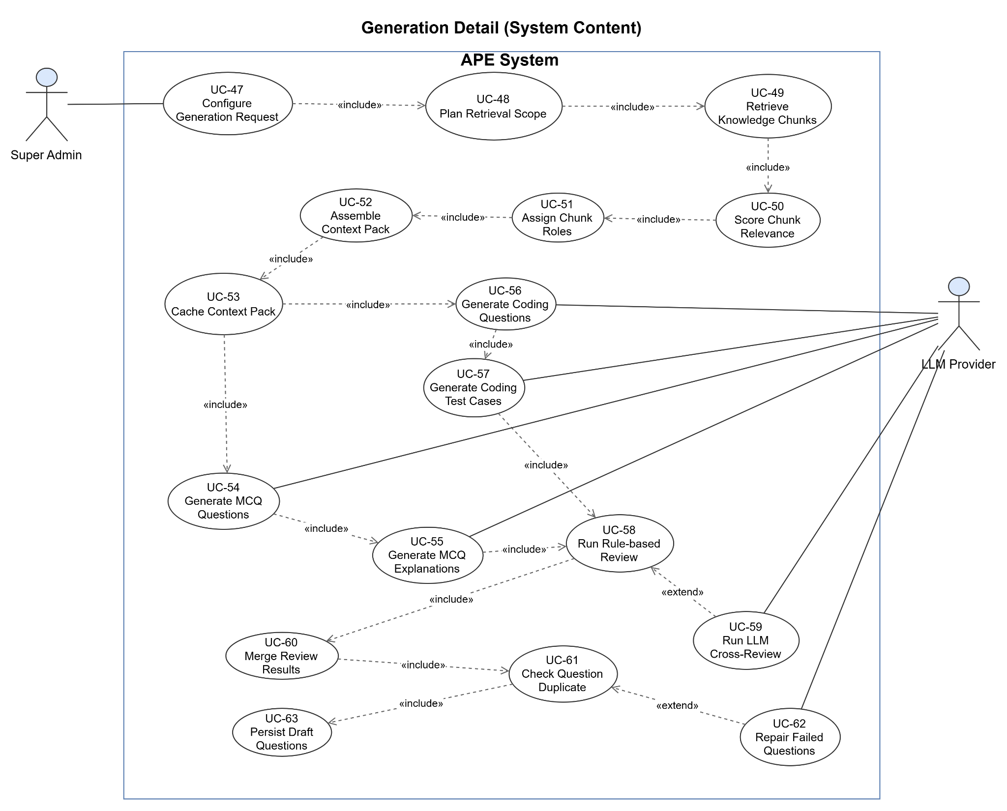
Figure 1-3-3-2-4 UseCase Diagram Generation Pipeline Detail (System Content)

1.4 System Functionalities

1.4.1 Screens Flow
This section shows the system screens and the navigation relationships among them. Because APE contains a large number of screens across two roles, the screen flow is split into two diagrams: a Student Screen Flow and an Admin (Super Admin) Screen Flow. The diagrams describe hub-and-spoke navigation - the entry-level menus and their primary destinations only. Downstream screens that are always reached by drilling into a primary destination (for example the per-document detail views, the per-submission result view, the AI Mentor feedback panel), inline detail panels embedded in a list screen, modal dialogs, and top-bar utilities (Profile, Logout) are not drawn on the hub diagrams; they are enumerated in §1.4.2 and specified in full in Section 3.

1.4.1.1 Student
The Student Flow starts with Google OAuth login leading to the Home dashboard, which serves as a secondary hub with quick-action shortcuts. The main header provides access to four other modules: Setup (hosting Upload, Generate, and Practice Configuration tracks); Wallet (linking to Top-up via PayOS and Payment History); Analytics (grouping Knowledge Analytics, Leaderboard, and Streak & Badges); and Practice (housing My Exams, System Exams, Question Bank, and Practice History). Opening an exam launches an MCQ, Flashcard, or Coding session. MCQ and Flashcard sessions show results in-page upon completion, whereas Coding submissions redirect to a Result Viewer. Downstream sub-views include Document Preview, Extraction Draft, an inline Question Detail panel, and an inline AI Mentor Feedback panel within the Result Viewer.

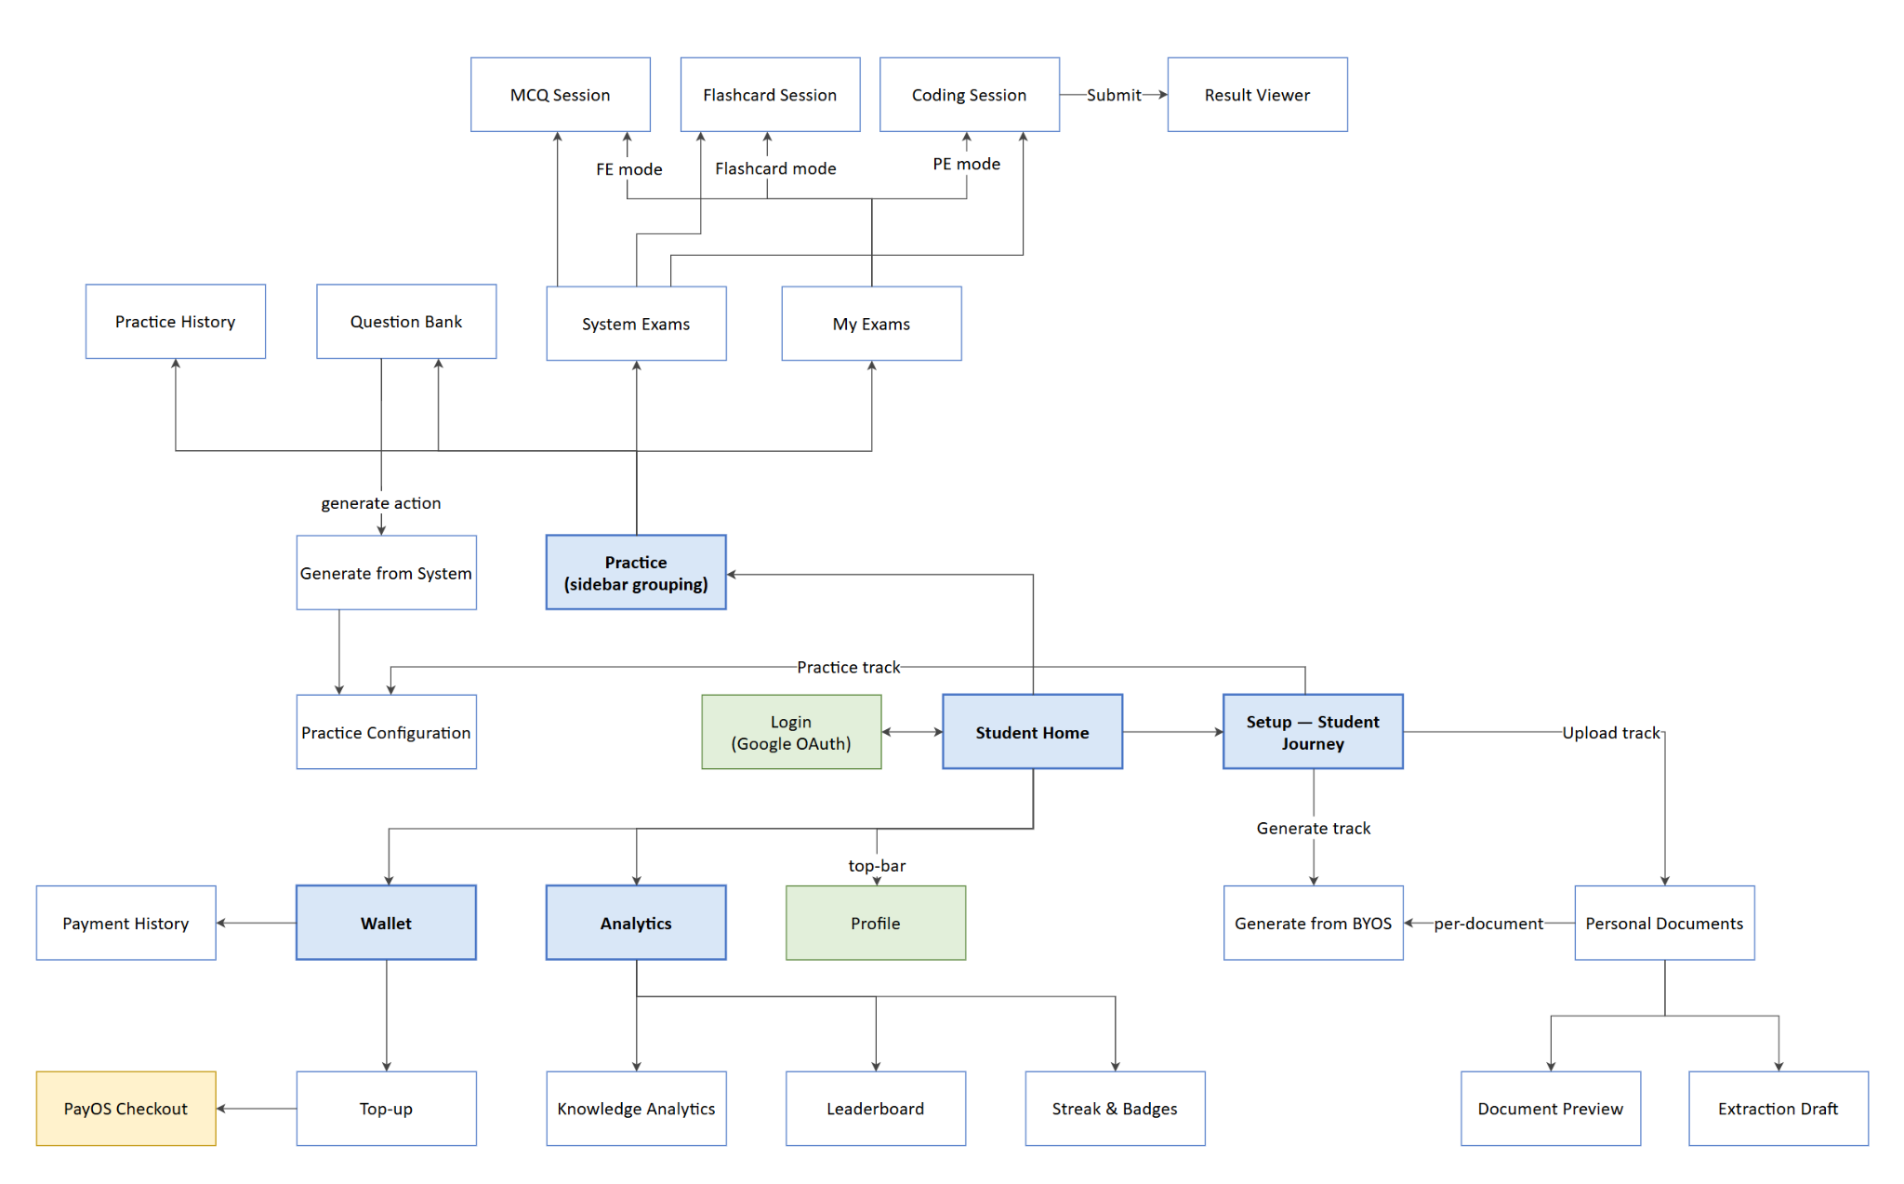
Figure 1-4-1-1 ScreenFlow-diagram Role Student

1.4.1.2 Super Admin
The Admin Flow starts with login leading to the Admin Dashboard, which serves as both the landing page and the operational analytics view. The left sidebar organizes features into five main sections: Overview (hosting the Dashboard); Management (grouping User Registry, Course Management, Question Management, Practice Setup, Wallet Packages, Document Management, and Generate Questions); AI Settings (housing Providers, AI Agents, Rule Artifacts, and AI Wallet Billing); AI Monitoring (containing Usage Logs); and AI Smoke Tests (hosting the six panels of the AI Smoke Test Suite: Gatekeeper, Extracted Content, Embedding + AutoTagging, Generation + Review, Code Mentor, and Support: API Probe). Downstream sub-views include Document Detail (which drills further into Extraction Draft and Generate Questions), Question Detail, a Question Import modal, and an inline Generation Result Panel for draft moderation.
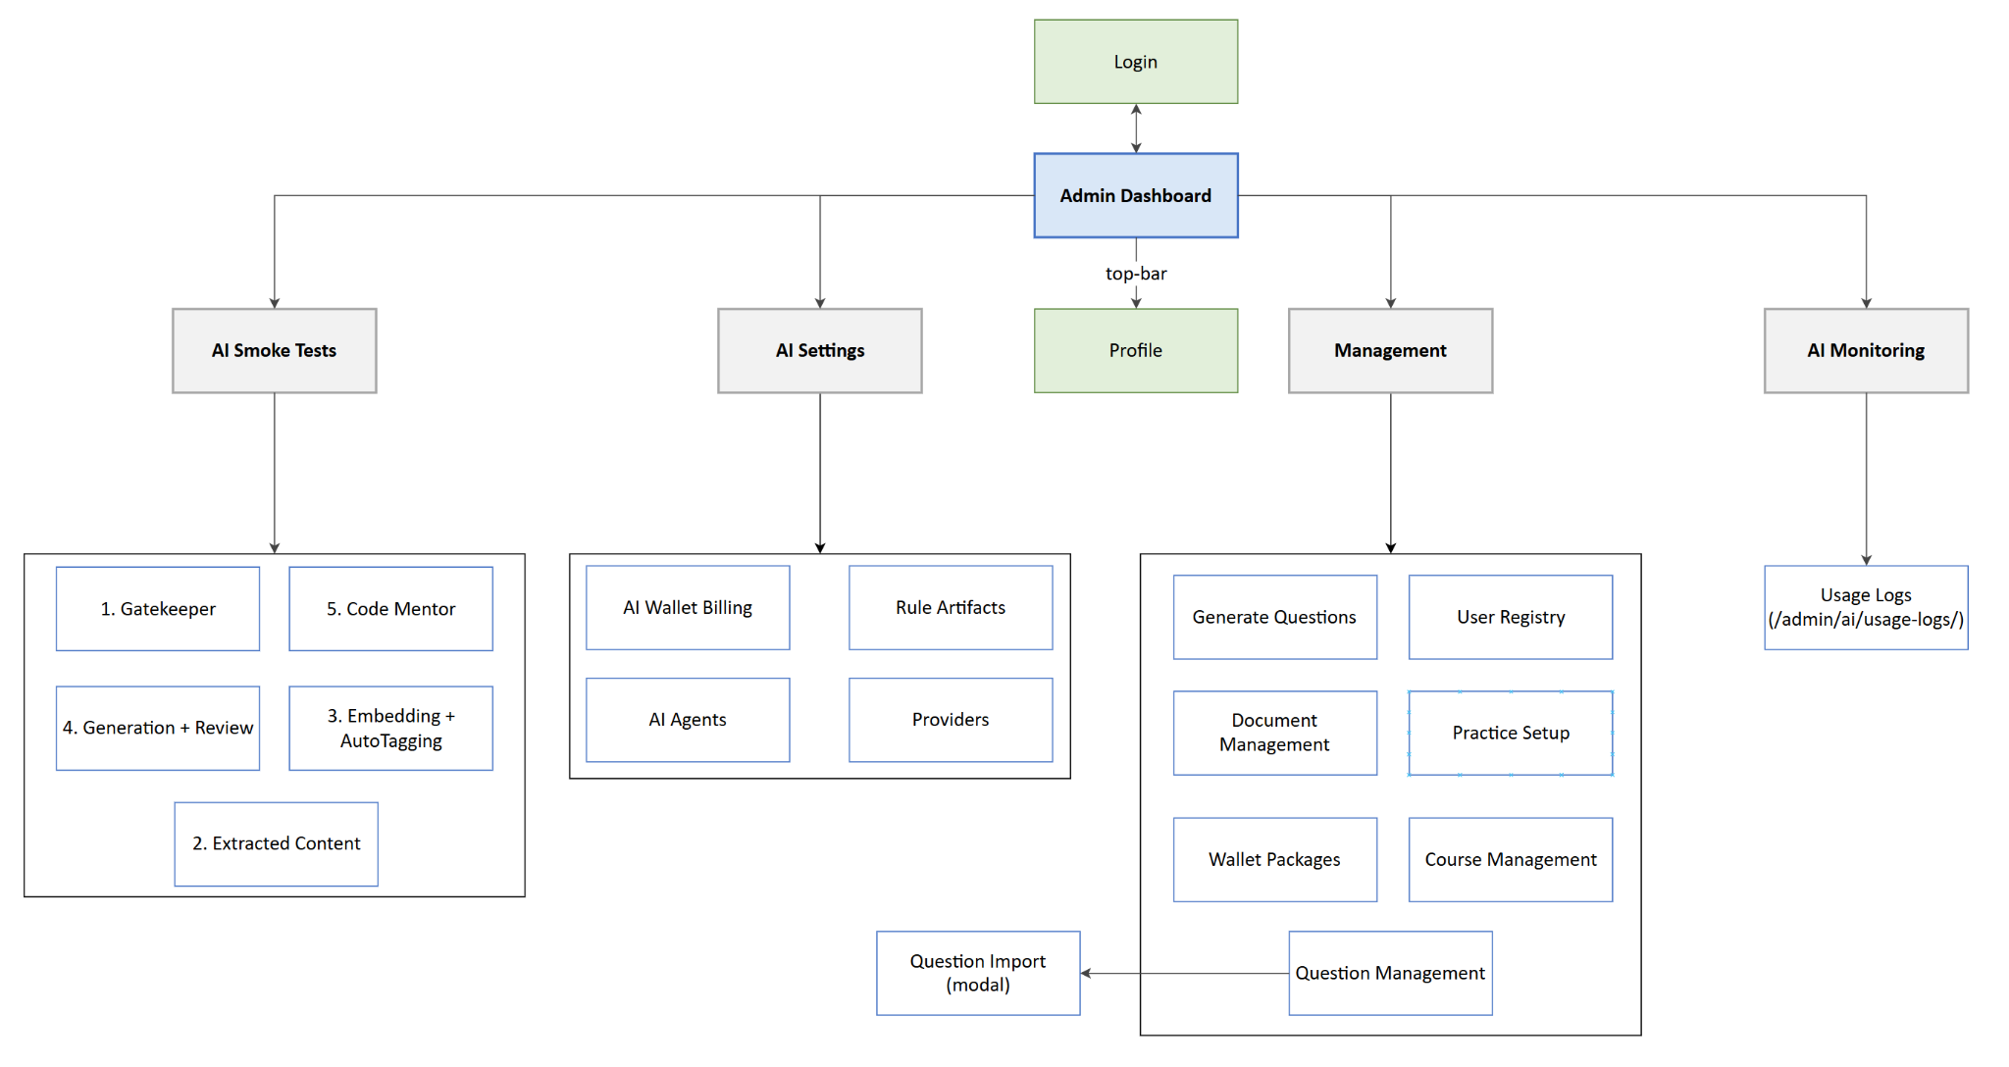
Figure 1-4-1-2 ScreenFlow-diagram Role Super-Admin

1.4.2 Screen Authorization

Screen | Student | Super Admin
Shared
Login (Google OAuth) | X | X
Profile | X | X
Student
Student Home / Dashboard | X
Setup (Student Journey / Setup Guide) | X
Personal Documents (My Documents) | X
Document Preview | X
Extraction Draft | X
Generate from System Bank | X
Generate from BYOS (Personal Doc) | X
Question Bank Browse | X
Question Detail (inline panel in Question Bank Browse) | X
Personal Practice Library (My Exams) | X
System Exam Library (System Exams) | X
Practice Configuration (FE/PE Exam Config) | X
MCQ Session | X
Flashcard Session | X
Coding Session | X
Result Viewer (Submission Result — PE only) | X
AI Mentor Feedback (inline panel in Result Viewer) | X
Practice History | X
Knowledge Analytics | X
Leaderboard | X
Streak & Badges | X
AI Wallet | X
Top-up | X
Payment History (Top-up History) | X
Super Admin
Admin Dashboard |  | X
User Registry (User Management) |  | X
Course Management |  | X
Wallet Packages Management |  | X
Document Management (System Documents) |  | X
Generate Questions (System Bank) |  | X
Question Management (System Bank + Moderation) |  | X
Question Import (modal in Question Management) |  | X
Practice Setup (Admin) |  | X
Providers (Provider Credentials) |  | X
AI Agents |  | X
Rule Artifacts |  | X
AI Wallet Billing |  | X
Usage Logs |  | X
AI Smoke Test — 1. Gatekeeper |  | X
AI Smoke Test — 2. Extracted Content |  | X
AI Smoke Test — 3. Embedding + AutoTagging |  | X
AI Smoke Test — 4. Generation + Review |  | X
AI Smoke Test — 5. Code Mentor |  | X
AI Smoke Test — Support: API Probe |  | X

1.4.3 Non-UI Functions

# | Feature | System Function | Description
1 | Document Ingestion | AI Ingest Pipeline (async job) | On document upload, runs the full ingest pipeline (preview, gatekeeper, duplicate check, extract, normalize, vision, chapter detection, chunk, embed, tag, snapshot) as a background job without blocking the UI; streams progress and notifies on completion.
2 | Question Generation | AI Generation Pipeline (async job) | For each generation request, runs retrieval, scoring, context pack assembly, LLM generation, review, duplicate check, and persists drafts, then deducts the fee for BYOS requests.
3 | Payment | PayOS Payment Callback Handler (webhook) | Receives the server-side callback from PayOS, verifies the signature, matches the pending transaction, and credits the wallet atomically; idempotent against duplicate callbacks.
4 | Authentication | Google OAuth Token Exchange (backend) | Handles the OAuth redirect, exchanges the authorization code for tokens, validates the ID token, and auto-provisions a new account on first login.
5 | Coding Practice | Judge0 Execution Integration (service) | Sends code and test cases to the self-hosted Judge0 environment with time and memory limits, returning per-test or aggregate results for Run and Submit.
6 | Billing | Fee Deduction & Absorbed Loss Service | At each charge point (ingest, generation, mentor), computes the VND fee from backend usage, deducts from the wallet (capped at 0), and records Absorbed Loss when the fee exceeds the balance.
7 | Data Retention | Retention / Purge Cron Job | Periodically hard-deletes soft-deleted documents (30 days), extraction snapshots (60 days), practice records (12 months), and code submissions (6 months).
8 | Real-time Progress | SignalR Progress Streaming (service) | Streams pipeline stage progress to the client; the job keeps running even if the browser tab is closed.
9 | Gamification | Streak / Leaderboard / Badge Service (backend) | Computes daily practice streaks, weekly leaderboard rankings, and unlockable badges; consumed by the Leaderboard and Streak & Badges screens through StudentGamificationController.
10 | Observability | AI Smoke Test / Health Diagnostics (backend) | Runs AI agents against controlled diagnostic inputs to verify the runtime after a configuration change; not charged to any student.

1.5 Entity Relationship Diagram
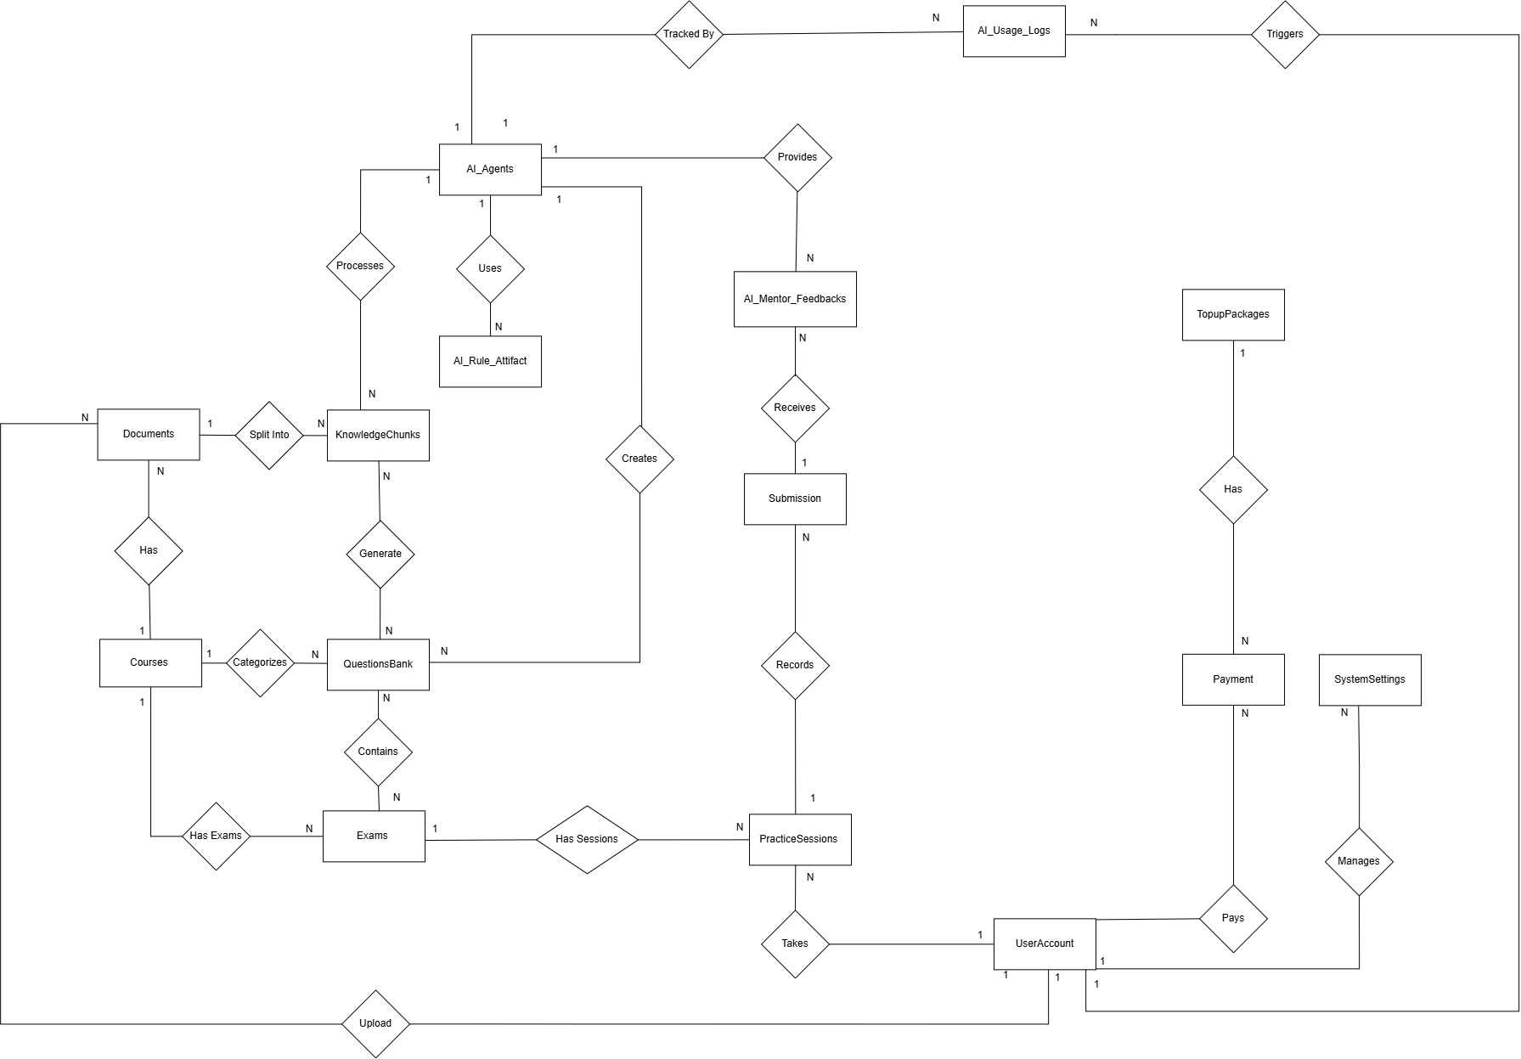
Figure 1-5 Entity Relationship Diagram
Entities Description
# | Entity | Description
1 | UserAccount | Manages identity information (Google SSO) for students and Admins, and handles system role-based access control (RBAC). It also stores Gamification progress (EXP points, learning Streaks) and manages Credit balances (Free/Paid) for utilizing AI services.
2 | Courses | A catalog of core subjects supported by the system. Acts as the root reference to categorize documents, questions, and performance statistics.
3 | Documents | Stores file paths and statuses of uploaded course syllabi and lecture slides that have been validated and approved (via AI Gatekeeper screening).
4 | KnowledgeChunks | The main data repository for the system (Vector Database). Stores small knowledge chunks automatically extracted from Documents, including the original raw text and multi-dimensional Vector matrices to serve RAG (Retrieval-Augmented Generation) queries.
5 | QuestionsBank | Stores the polymorphic structure of all Multiple-Choice Questions (FE) and Practical Programming Exercises (PE). It contains problem descriptions, skeleton code, solutions, and hidden Test Cases automatically generated by AI from KnowledgeChunks.
6 | Exams | A configuration wrapper for a specific exam or practice playlist. Defines the execution mode (Timed Mock Test or Free Practice), difficulty level, visibility (Public/Private), and contains a list of questions belonging to a specific course.
7 | PracticeSessions | Records the lifecycle of a student's coding practice or mock test session. Manages auto-save draft states to prevent data loss, records start/end times, and finalizes the total score for the entire session.
8 | Submissions | Detailed history of each source code submission made by a student during a practice session. Contains independent evaluation statuses from the Judge0 environment (Pass, Fail, Compile Error), the number of passed Test Cases, and execution runtime.
9 | AI_Mentor_Feedbacks | Stores pedagogical analyses, advice, and logical debugging hints provided by the AI Code Mentor for each failed submission (Strictly prohibits storing exact code solutions).
10 | Daily_Practice_Summaries | A daily summary table of each student's practice achievements and performance, providing clean aggregated data for AI Analytics.
11 | Payment | Manages the history of financial transactions and user Credit top-ups. Records detailed balance fluctuations (before/after transactions) and exchange rates to ensure transparent auditing.
12 | AI_Agents | A registry/dictionary defining "AI Personnels" (e.g., Gatekeeper, Mentor, Generator). Manages the configurations of LLM Models (such as GPT-4o, Gemini 3.5 Flash, etc.), Token limits, and Credit pricing per API call.
13 | AI_Rule_Attifact | A centralized repository for rule templates used to communicate and instruct the AI. Supports Versioning to help administrators easily rollback and optimize accuracy.
14 | AI_Usage_Logs | An Audit Trail that records all API transactions between the system and AI providers. Deeply tracks Token consumption (Input/Output), costs, caller IDs, and temporarily stores Payload contents (JSON) for evidence and debugging.

2. Use Case Specifications

This section specifies the complex use cases involved in the main business processes of the APE system, grouped by system feature. Simple create, view, and delete use cases are described in the Functional Requirements (Section 3). A use case is specified here if it satisfies at least two of: it is the entry point of a main workflow; its normal flow has five or more steps or a business branch; it has two or more non-trivial alternative flows; it orchestrates two or more use cases via include or extend; or it is business-critical (billing, security, data integrity, idempotency).

2.1 Authentication & Account

2.1.1 UC-01: Login with Google
Primary Actors | Super Admin, Student | Secondary Actors | Google SSO System
Description | As a user (Super Admin or Student), I want to sign in to APE using my Google account so that I can access the system securely without creating and remembering a separate password. Google OAuth 2.0 is the only authentication method supported by the system.
Preconditions | 1. The user owns a valid Google account.  2. The user is not currently authenticated in APE.
Postconditions | 1. The user is authenticated and an application session (access token) is established.  2. If this is the user's first login, a user account record is created automatically with the default role Student.  3. The user is redirected to the landing page corresponding to their role (Super Admin dashboard or Student home).
Normal Flow | 1. The user opens the APE login page and selects "Login with Google".  2. The system redirects the user to the Google OAuth 2.0 consent screen («include» UC-03 Authenticate via Google OAuth).  3. The user selects a Google account and grants consent.  4. The Google SSO System redirects back to APE with an authorization code.  5. The system exchanges the authorization code for tokens with the Google SSO System and validates the ID token (issuer, audience, expiry, signature).  6. The system retrieves the user's basic profile (email, display name, avatar) from the verified token.  7. The system looks up the user account by email and loads the associated role (Super Admin or Student).  8. The system issues an application session and access token.  9. The system redirects the user to the role-appropriate landing page. The AI wallet balance is displayed in the header for Student accounts.
Alternative Flows | A1 - First-time login (auto-provisioning). At step 7, no account exists for the email. The system creates a new user account with role Student and an AI wallet with balance 0 VND (no trial amount is granted), then continues from step 8. No onboarding tutorial or additional profile form is shown. A2 - User denies consent. At step 3, the user cancels or denies the Google consent screen. The system returns the user to the APE login page with a message that sign-in was cancelled. No session is created. A3 - Invalid or expired authorization response. At step 5, token exchange or ID-token validation fails. The system aborts the login, logs the failure, and shows a generic sign-in error asking the user to try again. No session is created. A4 - Google SSO System unavailable. At step 2 or 5, the Google SSO System cannot be reached. The system shows a service-unavailable message and asks the user to retry later. No session is created. A5 - Account banned. At step 7, the account exists but its access status is Banned (see UC-147). The system rejects the login, does not issue a session, and shows a message that the account has been suspended.

2.2 AI Wallet & Payment

2.2.1 UC-07: Top-up AI Wallet
Primary Actors | Student | Secondary Actors | Payment API (PayOS)
Description | As a Student, I want to top up my AI wallet with Vietnamese Dong (VND) through the PayOS payment gateway so that I have sufficient balance (at least 1,000 VND) to use paid AI features such as BYOS document ingestion, AI question generation, and AI Code Mentor.
Preconditions | 1. The Student is authenticated (UC-01).  2. The PayOS payment gateway is reachable.  3. At least one active Wallet Package (denomination) has been configured by the Super Admin (UC-148).
Postconditions | 1. The Student's AI wallet balance is increased by exactly the selected denomination amount (the wallet unit is VND; no credit or token intermediary exists).  2. A Top-up Transaction record with status Success is persisted and appears in the Student's top-up history.  3. The updated balance is reflected in the application header.
Normal Flow | 1. The Student opens the AI Wallet screen and selects "Top up".  2. The system displays the active Wallet Packages (default denominations: 10,000 / 20,000 / 50,000 / 100,000 VND, minimum 10,000 VND; no custom amount is allowed).  3. The Student selects one denomination and confirms.  4. The system creates a Top-up Transaction record with status Pending, containing the amount, the Student ID, and a unique order reference.  5. The system requests a payment link from PayOS for the order and redirects the Student to the PayOS checkout page.  6. The Student completes the payment on the PayOS checkout page.  7. PayOS sends a server-side payment confirmation callback to the system («include» UC-08 Process Payment Callback), which verifies the signature, matches the order reference, marks the transaction Success, and atomically credits the wallet.  8. The Student is redirected back to APE; the system displays a success confirmation and the updated wallet balance in the header.
Alternative Flows | A1 - Student cancels the payment. At step 6, the Student cancels on the PayOS checkout page or navigates back («extend» UC-09 Cancel Payment). The transaction is marked Cancelled; the wallet balance is unchanged; the system informs the Student that no money was charged. A2 - Payment fails at the gateway. At step 6-7, PayOS reports a failed payment (for example a declined card or a timeout at the bank side). The callback (UC-08) marks the transaction Failed and does not credit the wallet. The Student may restart from step 1. A3 - PayOS unavailable when creating the payment link. At step 5, the system cannot obtain a payment link. The Pending transaction is marked Failed, and the system shows a service-unavailable message asking the Student to retry later. The wallet is unchanged. A4 - Return without callback. At step 8, the Student is redirected back to APE before the callback has arrived. The system shows the transaction as Pending and refreshes the balance once the callback is processed; no manual action is required from the Student.

2.2.2 UC-08: Process Payment Callback
Primary Actors | Payment API (PayOS) | Secondary Actors | Student (indirect)
Description | As the payment gateway (PayOS), the system exposes a server-side webhook endpoint that receives asynchronous payment result notifications, verifies their authenticity, matches them to the originating Top-up Transaction, and updates the transaction status and wallet balance in a single idempotent operation. This use case is «included» by UC-07 Top-up AI Wallet and is the sole entry point through which a wallet credit occurs.
Preconditions | 1. A Top-up Transaction with status Pending exists with a unique order reference (created by UC-07).  2. The PayOS webhook endpoint is exposed and configured with a shared secret used for HMAC signature verification.
Postconditions | 1. If the payment succeeded and the signature is valid: the transaction transitions Pending → Success, the wallet balance is credited exactly once with the transaction amount, and a Wallet Ledger entry is recorded.  2. If the payment failed: the transaction transitions Pending → Failed and the wallet is unchanged.  3. If the callback is a duplicate, invalid, or targets an unknown or terminal transaction: no wallet change occurs and an audit entry is recorded.
Normal Flow | 1. PayOS sends an HTTP POST request to the configured callback endpoint carrying the payment result payload, including the order reference, amount, payment status, and an HMAC signature.  2. The system verifies the HMAC signature of the payload using the shared secret.  3. The system locates the Top-up Transaction by order reference.  4. The system validates that the transaction is in Pending status (the only state from which a state change is allowed).  5. The system validates that the callback's amount matches the transaction's stored amount.  6. In a single atomic database operation, the system marks the transaction Success, increments the Student's wallet balance by the transaction amount, and records a Wallet Ledger entry citing the order reference.  7. The system responds HTTP 200 to PayOS to acknowledge delivery.
Alternative Flows | A1 - Invalid signature. At step 2, signature verification fails. The system responds HTTP 400, records a security log entry (order reference, source IP, timestamp), does not update the transaction, and does not credit the wallet. A2 - Order reference not found. At step 3, no transaction matches. The system responds HTTP 200 (to prevent PayOS from retrying indefinitely) with a reject reason logged, and takes no state change. A3 - Duplicate callback (idempotency). At step 4, the transaction is already in a terminal state (Success or Failed). The system responds HTTP 200 to stop PayOS retries, does not increment the wallet, and logs the duplicate delivery. This guarantees the wallet is credited at most once per transaction. A4 - Payment reported as failed. At step 1, the payload indicates a failed payment outcome. In the atomic operation at step 6, the system transitions the transaction Pending → Failed with no wallet credit and responds HTTP 200. A5 - Amount mismatch. At step 5, the callback amount differs from the persisted transaction amount. The system rejects the callback with HTTP 400, marks the transaction as Suspicious for manual review by the Super Admin, and writes a security log entry. No wallet credit occurs. A6 - Concurrent callback delivery. Two callback deliveries for the same order reference arrive nearly simultaneously. The atomic conditional update at step 6 (guarded by status = Pending) succeeds for at most one delivery; the other proceeds through A3.

2.3 Document Management & AI Ingest

2.3.1 UC-24: Upload System Document
Primary Actors | Super Admin | Secondary Actors | LLM Cloud Service
Description | As a Super Admin, I want to upload a subject-domain document to a specific course so that the system extracts its knowledge, splits it into chapter-aware Knowledge Chunks, and makes it available as a retrieval source for AI question generation. System documents are shared across all students of the course and are not billed. The ingest pipeline runs synchronously in the foreground; there is no background job and no persisted processing status.
Preconditions | 1. The Super Admin is authenticated (UC-01).  2. The target Course exists.  3. The file is in a supported format (txt, doc, docx, pptx, pdf, md) and does not exceed 20 MB.
Postconditions | 1. On success: the Document is persisted, its Knowledge Chunks are indexed with topic tags and embeddings, and the document appears in the System Document List, selectable as a generation source for all users of the Course.  2. On failure (validation, gatekeeper rejection, duplicate, or any pipeline stage error): nothing is persisted; no partial document, no failed record, and no retry action exists.
Normal Flow | 1. The Super Admin opens the System Documents screen and selects "Upload Document".  2. The Super Admin fills the upload form (Course, Document Name, Description, File) and confirms; the system shows a confirmation prompt because ingestion runs synchronously and cannot be cancelled once started. No question quantity is chosen at this step.  3. The system validates the file format and size, stores the file temporarily, and computes its file-level checksum.  4. The system performs the file-level duplicate check within the Course scope («include» UC-36 Check Document Duplicate, stage 1).  5. The system extracts a short preview text from the file («include» UC-34 Extract Preview Text).  6. The system sends the preview to the LLM Cloud Service to verify that the document matches the selected Course's subject domain («include» UC-35 Validate Document Domain / Gatekeeper). The verdict is final and cannot be overridden.  7. The system extracts the full text content using format-specific parsers («include» UC-38 Extract Full Content).  8. The system normalizes the content into structured markdown, preserving headings and image placeholders («include» UC-39 Normalize Extracted Content).  9. The system computes the content-level checksum and performs the content-level duplicate check within the Course scope («include» UC-36, stage 2).  10. If the document contains embedded images, the system uses the LLM vision capability to describe them and reinject the descriptions at the correct placeholders («include» UC-40 Reinject Vision Content).  11. The system detects the chapter and section structure using rule-based analysis of headings, numbering patterns, and slide or page markers («include» UC-41 Detect Document Structure).  12. The system splits the normalized content into chapter-aware Knowledge Chunks carrying chapter and section metadata («include» UC-42 Chunk Knowledge Content).  13. The system calls the LLM Cloud Service to generate an embedding vector for each chunk («include» UC-43 Generate Chunk Embeddings).  14. The system calls the LLM Cloud Service to assign topic tags to each chunk from the canonical taxonomy seeded for the Course («include» UC-44 Auto-Tag Chunks).  15. The system persists the Document and its Knowledge Chunks in a single transaction and displays the new document in the System Document List.
Alternative Flows | A1 - Invalid file (format or size). At step 3, validation fails. The system rejects the upload with a descriptive message; nothing is persisted and no pipeline stage runs. A2 - File-level duplicate detected. At step 4, the file checksum matches an existing Document in the Course («extend» UC-37 Reuse Existing Document). The pipeline stops immediately; the system informs the Super Admin, reuses the existing document, and creates nothing new. A3 - Gatekeeper rejects the document. At step 6, the Gatekeeper concludes the document is outside the Course subject domain. The pipeline stops, nothing is saved, and the system returns the Super Admin to the upload screen with a rejection message. The verdict cannot be overridden. A4 - Content-level duplicate detected. At step 9, the content-level checksum matches an existing Document in the Course after normalization («extend» UC-37 Reuse Existing Document). The pipeline stops; the system reuses the existing document and informs the Super Admin. A5 - Pipeline failure at any AI stage. At any of steps 7 to 14, a technical failure (for example a scanned PDF with no text layer, or an embedding call error) aborts the synchronous request. The system returns an error and the Super Admin can upload again; nothing is persisted, so there is no failed document record and no separate retry action. For PDFs, the message notes that only PDFs with a text layer are supported. A6 - No chapter detected. At step 11, the detector finds zero chapters. The system falls back to synthetic "Untitled Section N" chapters and continues; no warning surface is shown. A7 - Vision enrichment unavailable. At step 10, the vision call fails or produces no usable description. The system continues the pipeline with the text-only content. A8 - Tab closed mid-processing. If the Super Admin closes the browser tab during synchronous processing, the request is aborted server-side and nothing is persisted; the Super Admin must upload the document again.

2.3.2 UC-25: Upload Personal Document (BYOS)
Primary Actors | Student | Secondary Actors | LLM Cloud Service
Description | As a Student, I want to upload my own personal document (Bring Your Own Source — BYOS) to a specific course so that I can generate practice questions grounded on my own material. The document is scoped to me only and its ingest cost is charged in VND from my wallet after successful ingestion. The pipeline runs synchronously in the foreground; a gatekeeper rejection stops the pipeline with no charge.
Preconditions | 1. The Student is authenticated (UC-01).  2. The target Course exists.  3. The file is in a supported format (txt, doc, docx, pptx, pdf, md) and does not exceed 20 MB.  4. The Student's AI wallet balance is at least 1,000 VND.
Postconditions | 1. On success: the Document is persisted to the Student's personal pool, its Knowledge Chunks are indexed with topic tags and embeddings, the ingest fee is deducted from the wallet (capped at balance 0), and a billing transaction plus usage log are recorded; if the fee exceeded the balance, an Absorbed Loss record exists.  2. On failure before the charge point: nothing is persisted and no fee is charged.
Normal Flow | 1. The Student opens the Personal Documents screen and selects "Upload Document".  2. The Student fills the upload form (Course, Document Name, Description, File) and confirms; the system shows a confirmation prompt because ingestion runs synchronously and cannot be cancelled once started.  3. The system checks the minimum balance guard; the request proceeds only if the wallet balance is at least 1,000 VND («include» UC-12 Check Minimum Balance Guard).  4. The system validates the file format and size, stores it temporarily, and runs the ingest pipeline synchronously within the request.  5. The system runs the same ingest stages as UC-24 (file-level duplicate check, preview extract, gatekeeper, full extract, normalize, content-level duplicate check, vision reinjection, chapter detection, chunking, embedding, auto-tagging), with one scope difference: both duplicate checks run within the Student's own documents rather than per Course.  6. On successful completion (Knowledge Chunks exist), the system computes the ingest fee from actual backend resource usage and deducts it from the Student's wallet («include» UC-46 Deduct Ingest Fee). A billing transaction and usage log entry are recorded.  7. The system shows the new document in the Personal Document List and the updated wallet balance in the header.
Alternative Flows | A1 - Insufficient balance. At step 3, the balance is below 1,000 VND. The system blocks the request before any pipeline stage runs, does not create a Document, and prompts the Student to top up (UC-07). A2 - Gatekeeper rejects the document. As in UC-24 A3, the pipeline stops and the Student is returned to the upload screen; nothing is saved and no fee is charged, because the pipeline never reached the charge point. A3 - Duplicate detected. A checksum match (file-level or content-level) is found within the Student's own documents («extend» UC-37 Reuse Existing Document). The system reuses the existing document, informs the Student, and charges nothing since no AI processing was performed. A4 - Ingestion fails before completion. Any pipeline stage fails terminally (as in UC-24 A5). The synchronous request returns an error; nothing is persisted and no fee is charged, and the Student can upload again. A5 - Fee exceeds remaining balance. At step 6, the computed fee is greater than the current balance («extend» UC-13 Record Absorbed Loss). The Student still receives the fully ingested document; the wallet is deducted to exactly 0 (never negative); the difference is recorded as Absorbed Loss, which the Student never sees. A6 - Vision or chapter fallbacks. As in UC-24 A6 and A7; the pipeline continues with the available content. A7 - Tab closed mid-processing. If the Student closes the tab during synchronous processing, the request is aborted server-side; nothing is persisted and no fee is charged; the Student must upload the document again.

2.3.3 UC-32: Delete Document
Primary Actors | Super Admin, Student | Secondary Actors | -
Description | As a document owner (Super Admin for system documents, Student for personal BYOS documents), I want to delete a document so that it is removed from my document list and can no longer be used as a knowledge source for AI question generation. Questions already generated from the document are retained as independent entities and remain available for practice.
Preconditions | 1. The user is authenticated.  2. The target Document exists and the user is its owner (Super Admin for system documents; the uploading Student for BYOS documents).
Postconditions | 1. The Document is soft-deleted: it disappears from active document lists, its Knowledge Chunks are excluded from retrieval, and it is no longer selectable as a new generation source.  2. Previously generated questions (Active and Draft) that reference this document are retained and remain usable in practice; the document is shown with a "deleted" tag in the Practice Setup document picker for consistency.  3. The original file and document data are permanently purged 30 days after the soft delete by a scheduled retention job.  4. No wallet refund is issued for BYOS documents; fees already charged are final.
Normal Flow | 1. The user opens the document list (System Document List for Super Admin, Personal Document List for Student) and selects "Delete" on a document they own.  2. The system displays a confirmation dialog warning that the document will no longer be usable for new question generation and that any previously generated questions will be retained.  3. The user confirms the deletion.  4. The system verifies ownership, marks the Document as soft-deleted, excludes its Knowledge Chunks from retrieval, removes it from active document lists, and disables it as a generation source.  5. The system confirms the deletion to the user. A scheduled retention job permanently purges the file and Document data 30 days later.
Alternative Flows | A1 - User cancels. At step 3, the user dismisses the confirmation dialog. No change is made. A2 - Not the owner. At step 4, the ownership check fails, for example a Student attempting to delete another student's document through a crafted request. The system rejects the operation with an authorization error and logs the attempt. A3 - Document referenced by an in-progress ingest. In the unlikely case that a delete arrives while an ingest is still in progress (only possible for concurrent Super Admin sessions on the same document), the system rejects the delete and asks the user to retry once the ingest completes.

2.4 AI Question Generation

2.4.1 UC-47: Configure Generation Request
Primary Actors | Super Admin, Student | Secondary Actors | LLM Cloud Service
Description | As a user (Super Admin generating for the system bank, or Student generating for their personal BYOS bank), I want to configure and trigger an AI question-generation request scoped to a specific document, chapter selection, and topic tags so that the system retrieves the relevant knowledge, generates questions of the chosen type and difficulty, reviews them, and persists the accepted ones as drafts. For a Student, the generation and review cost is charged in VND from the wallet after the pipeline produces a usable result. The pipeline runs synchronously in the foreground.
Preconditions | 1. The user is authenticated (UC-01).  2. At least one source Document has been successfully ingested and is available for generation (system pool for Super Admin; the Student's own BYOS pool for Student).  3. For a Student: the AI wallet balance is at least 1,000 VND.
Postconditions | 1. Accepted questions are persisted into the question bank with status Draft (FEQuestion for multiple-choice, PEQuestion for coding), scoped to the Course (system pool) or to the owner (personal pool).  2. A Context Pack is cached with coverage metadata and per-chunk selection reasons for audit.  3. For a Student: the generation fee is deducted from the wallet (capped at balance 0) and a billing transaction plus usage log are recorded; if the fee exceeded the balance, an Absorbed Loss record exists.  4. For the Super Admin: no wallet deduction occurs (system generation is not charged).
Normal Flow | 1. The user opens a successfully ingested document and selects "Generate Questions".  2. The user fills the generation form: Question Type (FE / PE), Chapters (Student capped at 3; Super Admin unbounded), Topic Tags (at least one), Difficulty rows (Easy / Medium / Hard) and per-row Count (max 50 for FE, max 10 for PE, max 3 rows).  3. For a Student, the system checks the minimum balance guard; the request proceeds only if the balance is at least 1,000 VND («include» UC-12 Check Minimum Balance Guard).  4. The system plans the retrieval scope from the selected document, chapters, and topics («include» UC-48 Plan Retrieval Scope).  5. The system retrieves candidate Knowledge Chunks within the scope, applying hard filters (source scope, course and document, chapter key, ownership, retrieval-enabled, active) («include» UC-49 Retrieve Knowledge Chunks).  6. The system scores each chunk using heuristic signals (topic, lexical, structure, content quality, neighbor bonus, redundancy penalty, value density); no AI reranker is used («include» UC-50 Score Chunk Relevance).  7. The system assigns each selected chunk a role — primary, support, or optional — based on document match, chapter alignment, topic overlap, and density («include» UC-51 Assign Chunk Roles).  8. The system assembles the Context Pack from the ranked chunks within the token budget («include» UC-52 Assemble Context Pack).  9. The system caches the Context Pack together with covered topics, dominant chapter, and selection reasons («include» UC-53 Cache Context Pack).  10. The system calls the LLM Cloud Service to generate questions from the Context Pack: for multiple-choice, questions plus one explanation each («include» UC-54 Generate MCQ Questions, «include» UC-55 Generate MCQ Explanations); for coding, questions plus test cases including hidden ones («include» UC-56 Generate Coding Questions, «include» UC-57 Generate Coding Test Cases).  11. The system runs the mandatory rule-based review on each generated question, checking schema validity, grounding against source chunks, topic-tag overlap, in-batch duplicates, and the low-value coding guard («include» UC-58 Run Rule-based Review).  12. The system merges the review outcomes into a final verdict per question («include» UC-60 Merge Review Results).  13. The system checks each accepted question against existing ones using a question fingerprint, scoped by Course or owner («include» UC-61 Check Question Duplicate).  14. The system persists the accepted questions into the bank with status Draft («include» UC-63 Persist Draft Questions).  15. For a Student, once generation and review have completed with a usable result, the system computes the generation fee from actual backend usage and deducts it from the wallet («include» UC-64 Deduct Generation Fee); a billing transaction and usage log are recorded.  16. The system displays the resulting draft questions in the Generation Result Panel, from which the user can review each draft, publish (UC-71), publish all (UC-73), or delete individual drafts (UC-74).
Alternative Flows | A1 - Insufficient balance. At step 3, the balance is below 1,000 VND. The system blocks the request before running any pipeline stage and prompts the Student to top up (UC-07); nothing is generated and no fee is charged. A2 - LLM cross-review enabled. When the Super Admin has enabled optional LLM review for the reviewer agent, a second AI model assesses semantic quality between steps 11 and 12 («extend» UC-59 Run LLM Cross-Review); its result is merged with the rule-based verdict. The generator and reviewer are not required to use different models; no warning is shown when they match. A3 - Some questions fail review. At steps 11 to 12, one or more questions fail. The system regenerates only the failed parts rather than discarding the whole batch («extend» UC-62 Repair Failed Questions); repaired questions are re-reviewed. Questions that fail as a quality outcome (for example needs_revision) still count as consumed AI compute and are therefore still billed for a Student. A4 - Duplicate questions filtered. At step 13, fingerprint matches are found. Duplicate questions are filtered out and not persisted; the remaining unique questions proceed. Because narrow scopes are allowed, the system does not warn when generated questions are close in idea. A5 - Generation fee exceeds balance. At step 15, the computed fee is greater than the current balance («extend» UC-13 Record Absorbed Loss). The Student still receives the full set of draft questions; the wallet is deducted to exactly 0 (never negative); the excess is recorded as Absorbed Loss, which the Student never sees. A6 - Technical failure before usable result. If the LLM call or pipeline throws a technical error before any usable result is produced (for example a provider outage or an unrecoverable parse error), the request fails and no fee is charged for a Student; the charge point is reached only after generation and review complete successfully. A7 - Fewer questions than requested. If the pipeline produces fewer valid questions than the requested count, the system persists what it did produce, informs the user, and offers a Generate More action to run an additional request for the remainder. A8 - Tab closed mid-processing. If the user closes the browser tab during synchronous processing, the request is aborted server-side; nothing is persisted and no fee is charged (charge point not reached).

2.5 Question Bank Management

2.5.1 UC-71: Publish Question
Primary Actors | Super Admin, Student | Secondary Actors | -
Description | As a moderator of the appropriate bank (Super Admin for the system bank, Student for their own personal BYOS bank), I want to publish a single draft question so that it transitions from Draft to Active and becomes usable in practice. Publishing is the moderation gate for system-generated questions and a per-question activation option for personal questions (the Student may alternatively publish all drafts at once via UC-73).
Preconditions | 1. The user is authenticated.  2. The target question exists with status Draft.  3. For the Super Admin: the target is a system-pool question. For the Student: the target is a personal-pool question owned by the Student.
Postconditions | 1. The question's status changes from Draft to Active.  2. For a system-pool question: the question becomes available to all students in the shared bank (browsing and practice).  3. For a personal-pool question: the question becomes usable in the Student's personal practice configuration (UC-81).  4. The question record remains in the same collection; only its status changes.
Normal Flow | 1. The user opens the location that lists draft questions — for the Super Admin, the System Question Bank & Moderation screen (which uses UC-70); for the Student, the Generation Result Panel following a BYOS generation, or the personal draft view.  2. The user optionally opens the full detail of a specific draft (UC-75) to review its content.  3. The user selects "Publish" on the draft question.  4. The system verifies the ownership guard — Super Admin role for a system-pool target, or matching owner for a personal-pool target — and validates that the question is in Draft status.  5. In an atomic operation, the system transitions the question's status from Draft to Active.  6. The system confirms the action; the question now appears in the active bank for the corresponding audience (all students for system-pool; the owning Student for personal-pool).
Alternative Flows | A1 - Reject instead of publish (Super Admin only). From the same draft review view, the Super Admin may instead reject the question (UC-72 Reject Draft Question), transitioning it from Draft to Disabled. This option is not available to the Student, who uses Delete Question (UC-74) for unwanted personal drafts. A2 - Question no longer in Draft. At step 4, the question is not in Draft status — for example it was already published, deleted concurrently, or rejected. The system aborts the transition and shows a message that the question is no longer a draft; the list is refreshed. A3 - Ownership guard fails. At step 4, the ownership check fails — for example a Student attempting to publish another student's personal question, or a non-Super-Admin attempting a system-pool publish, through a crafted request. The system rejects the operation with an authorization error and logs the attempt. A4 - Editing is not supported. If the reviewer finds the draft question incorrect, the system provides no edit action; the only options are to publish, reject (Super Admin only), or delete (UC-74) the question.

2.5.2 UC-72: Reject Draft Question
Primary Actors | Super Admin | Secondary Actors | -
Description | As a Super Admin, I want to reject a draft question in the system pool so that it is marked as Disabled and never appears in the active bank for students. Rejection is the negative moderation outcome, complementary to publishing (UC-71). Personal-pool questions do not use this flow; the owning Student removes unwanted drafts via Delete Question (UC-74).
Preconditions | 1. The Super Admin is authenticated.  2. The target question exists in the system pool with status Draft.
Postconditions | 1. The question's status changes from Draft to Disabled.  2. The question is not visible in the student-facing active bank and is not selectable in practice configuration.  3. The question record remains in the same collection for audit and analytics; only its status changes. No wallet refund concept applies (system generation is not charged).
Normal Flow | 1. The Super Admin opens the System Question Bank & Moderation screen listing draft questions (UC-70).  2. The Super Admin optionally opens the full detail of a specific draft (UC-75) to review its content.  3. The Super Admin selects "Reject" on the draft question.  4. The system verifies Super Admin authorization and validates that the question is in Draft status.  5. In an atomic operation, the system transitions the question's status from Draft to Disabled.  6. The system confirms the action; the question is removed from the draft view and does not appear in the active bank.
Alternative Flows | A1 - Publish instead of reject. From the same draft review view, the Super Admin may instead publish the question (UC-71). A2 - Question no longer in Draft. At step 4, the question is not in Draft status — for example it was already published, deleted, or rejected concurrently. The system aborts the transition and shows a message that the question is no longer a draft; the list is refreshed. A3 - Rejected question cannot be republished. Once transitioned to Disabled, a question cannot be moved back to Draft or Active through the moderation flow. If the Super Admin wishes to add a similar question to the active bank, a new generation request (UC-47) or bulk import is required. A4 - Authorization failure. At step 4, the request is issued by a non-Super-Admin actor through a crafted request. The system rejects the operation with an authorization error and logs the attempt.

2.5.3 UC-73: Publish All Draft Questions
Primary Actors | Student | Secondary Actors | -
Description | As a Student, I want to publish an entire batch of draft questions in my personal (BYOS) bank in one action so that they become usable for my own practice without per-question moderation. Personal banks do not require Super Admin approval; the Student is the sole moderator of their own pool. The per-question publish option (UC-71) remains available for selective activation.
Preconditions | 1. The Student is authenticated.  2. The Student owns at least one question in status Draft in their personal bank within the acted-upon scope (for example the drafts produced by a single generation request).
Postconditions | 1. Every draft question owned by the Student within the acted-upon scope transitions from Draft to Active in a single atomic operation.  2. The published questions become usable in the Student's personal practice configuration (UC-81).  3. No Super Admin moderation is involved.  4. No wallet refund concept applies; the generation fee (UC-64) was already charged at the successful charge point of UC-47.
Normal Flow | 1. The Student opens the location listing personal draft questions — the Generation Result Panel following a BYOS generation (UC-47), or the personal draft view (UC-70).  2. The Student optionally reviews individual drafts (UC-75) and deletes any obviously bad ones (UC-74) before publishing.  3. The Student selects "Publish all".  4. The system verifies ownership for every question in scope and validates that each is in Draft status.  5. In a single atomic operation, the system transitions every draft question in scope from Draft to Active.  6. The system confirms the action; the questions are now available for the Student's personal practice configuration (UC-81).
Alternative Flows | A1 - Incorrect AI-generated question. The Student cannot edit a question; for a faulty personal question (for example a wrong test case), the system offers Delete Question (UC-74). No refund is issued for a deleted question, since the generation fee was already charged. A2 - No draft questions in scope. At step 3, the scope contains no draft questions (for example all were already published or deleted). The "Publish all" action is unavailable or has no effect, and the system indicates there is nothing to publish. A3 - Ownership guard fails. At step 4, the ownership guard fails for a targeted question — for example through a crafted request that widens the scope to another student's drafts. The system rejects the whole operation with an authorization error and logs the attempt; no partial publish occurs. A4 - Selective publish preferred. If the Student wants to activate only some drafts rather than all, the per-question Publish option (UC-71) is used from the same view; the two flows are mutually compatible.

2.6 Practice Setup

2.6.1 UC-80: Configure Practice from System Bank
Primary Actors | Student | Secondary Actors | -
Description | As a Student, I want to configure an MCQ or Flashcard practice set from the shared system question bank by selecting a course, a source document, optional topics, and how many Easy, Medium, and Hard questions to include, so that the system assembles a set of published questions matching my selection. Coding practice is configured separately by manually selecting problems (see UC-82).
Preconditions | 1. The Student is authenticated (UC-01).  2. The selected Course has published (Active) MCQ or Flashcard questions in the system bank for the chosen document.
Postconditions | 1. An MCQ or Flashcard practice set is assembled from the system bank according to the chosen per-difficulty counts.  2. A practice session is prepared for the Student to start; it becomes In-Progress when the session begins via UC-84 or UC-90.
Normal Flow | 1. The Student opens the Practice Set screen and chooses the system bank as the source.  2. The Student selects the Course and the question type (MCQ or Flashcard).  3. The Student selects a source Document; a document is mandatory for the system bank as well as the personal bank.  4. The system displays the topics detected in that Document; the Student selects zero, one, or several topics — leaving the selection empty means all topics of the Document are included.  5. The Student enters directly how many Easy, Medium, and Hard questions to include; the set size is the sum of the three counts. There is no fixed length preset and no automatic difficulty-ratio distribution.  6. The system assembles the practice set from Active questions matching the Course, document, selected topics, type, and per-difficulty counts («include» UC-83 Assemble MCQ Practice Set by Difficulty).  7. The system prepares the practice session and presents the ready-to-start set to the Student.
Alternative Flows | A1 - Fewer questions than requested in a difficulty bucket. At step 6, the bank holds fewer Active questions than the requested count for one or more difficulty levels. The system caps that level to the maximum available, assembles the set from what exists, and informs the Student; it does not block the configuration. A2 - No questions available. The selected Course and document have no Active questions of the chosen type. The system informs the Student that no practice set can be built for this selection and suggests changing it. A3 - Deleted source document. The chosen Document has been soft-deleted (UC-32); it is still shown in the picker with a "deleted" tag so that its retained questions remain practisable. The system assembles the set as usual from those retained Active questions.

2.6.2 UC-81: Configure Practice from Personal Bank
Primary Actors | Student | Secondary Actors | -
Description | As a Student, I want to configure an MCQ or Flashcard practice set from my personal (BYOS) question bank by selecting a course, one of my documents, optional topics, and how many Easy, Medium, and Hard questions to include, so that I can practice on my own uploaded material. Coding practice on my own problems is configured separately by manually selecting problems (see UC-82).
Preconditions | 1. The Student is authenticated.  2. The Student owns published (Active) MCQ or Flashcard questions in their personal bank for the selected Course and document.
Postconditions | 1. An MCQ or Flashcard practice set is assembled from the Student's personal bank according to the chosen per-difficulty counts.  2. A practice session is prepared for the Student to start via UC-84 or UC-90.
Normal Flow | 1. The Student opens the Practice Set screen and chooses the personal bank as the source.  2. The Student selects the Course and the question type (MCQ or Flashcard).  3. The Student selects one of their own source Documents; a document is mandatory.  4. The system displays the topics detected in that Document; the Student selects zero, one, or several topics — empty means all topics of the Document.  5. The Student enters directly how many Easy, Medium, and Hard questions to include; the set size is the sum of the three counts. Manual per-question picking and fixed length presets are not used for MCQ or Flashcard practice.  6. The system assembles the practice set from the Student's Active questions matching the selection («include» UC-83 Assemble MCQ Practice Set by Difficulty).  7. The system prepares the practice session and presents the ready-to-start set to the Student.
Alternative Flows | A1 - Fewer questions than requested. The personal bank lacks enough questions in some difficulty buckets. The system caps each affected level to the maximum available, assembles what exists, and informs the Student. A2 - No personal questions. The Student has no Active personal questions in scope, for example none published yet (see UC-73). The system informs the Student and suggests generating (UC-47) and publishing (UC-73) questions first. A3 - Deleted source document. As in UC-80 A3, a soft-deleted personal Document remains selectable so that its retained questions stay practisable.

2.6.3 UC-82: Manually Select Coding Problems
Primary Actors | Student | Secondary Actors | -
Description | As a Student, I want to build a Coding practice set by manually picking up to five specific coding problems from the system or personal bank so that I control exactly which problems I attempt in one session. Unlike MCQ practice, Coding practice does not use per-difficulty counts or randomization; the problem list is explicitly selected.
Preconditions | 1. The Student is authenticated.  2. At least one Active PE (Coding) question exists in the selected source scope (system bank for the chosen Course, or the Student's personal bank).
Postconditions | 1. A Coding practice set is assembled from the explicitly selected problems in the order chosen by the Student.  2. A Coding practice session is prepared; each problem can be started individually via UC-92.
Normal Flow | 1. The Student opens the Coding Practice Setup screen.  2. The Student selects the source bank (system or personal) and the Course; the Course determines the fixed programming language for the session.  3. The system displays the list of Active PE (Coding) questions in scope, with title, difficulty, and topic tags; filters (difficulty, topic, keyword) are available to narrow the list.  4. The Student selects between one and five problems via checkboxes; the running count is displayed.  5. The Student confirms the selection.  6. The system validates the selection (all belong to the same Course, count between 1 and 5, all in Active status) and assembles the Coding practice set in the chosen order.  7. The system prepares the practice session and presents the ready-to-start set to the Student.
Alternative Flows | A1 - Selection exceeds cap. At step 4, the Student attempts to select a sixth problem. The system prevents the additional selection and shows a message that the cap is five problems per Coding practice set. A2 - Empty selection. At step 5, no problem is selected. The Confirm action is disabled and the system indicates that at least one problem must be picked. A3 - Cross-course selection. At step 6, a selected problem does not match the chosen Course (this cannot happen through the UI but is guarded against crafted requests). The system rejects the assembly and asks the Student to re-select within one Course. A4 - Selected problem deleted concurrently. At step 6, one of the selected problems has been deleted (UC-74) between selection and confirmation. The system removes it from the assembled set, informs the Student, and lets the Student either continue with the remaining problems or add a replacement. A5 - Deleted source document. A selected problem's source Document has been soft-deleted (UC-32); the problem itself remains Active and is included in the set as usual.

2.7 MCQ & Flashcard Practice

2.7.1 UC-84: Start MCQ Practice Session
Primary Actors | Student | Secondary Actors | -
Description | As a Student, I want to start a multiple-choice practice session from a configured set so that I can answer the questions while my elapsed time is tracked.
Preconditions | 1. The Student is authenticated.  2. A practice set has been configured (UC-80 or UC-81).
Postconditions | 1. A practice session exists with status In-Progress, bound to the assembled question set.  2. A stopwatch begins counting up from zero.  3. The session state is persisted so it survives a tab close (resumable via UC-89).
Normal Flow | 1. From the prepared practice set, the Student selects "Start".  2. The system creates a practice session with status In-Progress and records the start time.  3. The system starts a stopwatch that counts up (no countdown).  4. The system presents the questions; each is single-choice with exactly one correct answer.  5. The Student answers questions in any order and may revisit previous answers before submitting. Selected answers are persisted incrementally so that a tab close does not lose them.
Alternative Flows | A1 - Tab closed or connection lost mid-session. The session state is retained as In-Progress; closing the tab does not discard progress. The Student can later resume it (UC-89). A2 - Student navigates away without submitting. The session remains In-Progress until the Student either submits (UC-85) or resumes and completes it later. A3 - Underlying question deleted mid-session. If a question is deleted (UC-74) after the session started, the session retains the frozen snapshot of the question; the deletion does not affect the running session.

2.7.2 UC-85: Submit MCQ Answers
Primary Actors | Student | Secondary Actors | -
Description | As a Student, I want to submit my answers for the current MCQ session so that the system stops the stopwatch, scores the session, and shows a result summary from which I can view the detailed review or start a retry.
Preconditions | 1. An In-Progress practice session exists for the Student (started via UC-84).
Postconditions | 1. The session is scored and its status becomes Completed; the stopwatch stops and the total elapsed time is recorded.  2. The correct and incorrect counts are stored, and per-question answer records are persisted.  3. The session is available in practice history (UC-109 and UC-110).
Normal Flow | 1. The Student selects "Submit" for the in-progress session.  2. The system stops the stopwatch and records the total elapsed time.  3. The system scores each answer against the correct option and computes the number correct and incorrect. Unanswered questions are counted as incorrect.  4. The system marks the session Completed and displays the summary (number correct and incorrect) plus three options: Retry All, Retry Wrong, and View Result.  5. View Result («include» UC-86 View MCQ Result): the system shows the full list of questions with the Student's selected answer, the correct answer, and the explanation for each.
Alternative Flows | A1 - Retry all questions. From the result summary, the Student chooses to redo the entire set («extend» UC-87 Retry All Questions). The system creates a new practice session (an independent attempt) containing all questions; the original completed session is unchanged. A2 - Retry wrong questions. From the result summary, the Student chooses to redo only the incorrectly answered questions («extend» UC-88 Retry Wrong Questions). The system creates a new practice session containing just those questions; this can be repeated until none remain wrong. Each retry is an independent attempt. A3 - Submit with unanswered questions. At step 1, some questions are unanswered. The system asks the Student to confirm submission first; on confirmation, the unanswered questions are counted as incorrect for scoring. A4 - Concurrent double submit. If the Student clicks Submit twice quickly, only the first submission takes effect; the second returns the same completed result without rescoring.

2.7.3 UC-89: Resume In-Progress Session
Primary Actors | Student | Secondary Actors | -
Description | As a Student, I want to resume an unfinished practice session so that I can continue from where I left off after a tab close or interruption, with my previous answers restored and the stopwatch continuing from the saved elapsed time.
Preconditions | 1. The Student is authenticated.  2. At least one practice session with status In-Progress exists for the Student.
Postconditions | 1. The session is reopened in its saved state, with previously entered answers restored and the stopwatch resumed from the saved elapsed time.  2. The session remains In-Progress until submitted (UC-85).
Normal Flow | 1. The Student opens the practice area and sees a "Resume" prompt for the In-Progress session.  2. The Student selects "Resume".  3. The system loads the saved session state: assembled question set, entered answers, and saved elapsed time.  4. The system resumes the stopwatch from the saved elapsed time.  5. The Student continues answering and may submit at any time (UC-85).
Alternative Flows | A1 - No in-progress session. The Student has no resumable session. The system indicates there is nothing to resume and offers to configure a new practice set (UC-80 or UC-81). A2 - Session already completed elsewhere. The targeted session was submitted in another context and is now Completed. The system opens its result view (UC-86) instead of resuming. A3 - Multiple in-progress sessions. The Student has more than one In-Progress session. The system lists them with course, type, and last-updated timestamp, and lets the Student pick which one to resume.

2.7.4 UC-90: Start Flashcard Session
Primary Actors | Student | Secondary Actors | -
Description | As a Student, I want to review MCQ questions in flashcard mode so that I can study the material at my own pace without submission or scoring. Flashcards are a study render mode over an MCQ practice set: each question is shown as the front of a card and the correct answer plus explanation is revealed on flip.
Preconditions | 1. The Student is authenticated.  2. A practice set has been configured with question type Flashcard (via UC-80 or UC-81).
Postconditions | 1. A flashcard session is started over the configured set.  2. The Student can flip through the cards (UC-91). No score or completion record is persisted, since flashcards are study-only.
Normal Flow | 1. From the prepared flashcard set, the Student selects "Start".  2. The system renders each question as a flashcard front, hiding the answer options.  3. Review flashcards («include» UC-91 Review Flashcards): the Student flips a card to reveal the correct answer and explanation, then advances to the next card.  4. The Student proceeds through the deck at their own pace and may end the session at any time.
Alternative Flows | A1 - No questions in scope. No MCQ questions match the selected configuration, for example the personal bank has none published yet. The system informs the Student that no flashcards can be built for this selection. A2 - Flashcard is study-only. Because flashcards are a study render mode, there is no scoring or submission; the Student simply flips through cards. Scored practice uses the MCQ session flow (UC-84 and UC-85). A3 - Session end without persistence. Ending the session or closing the tab does not persist any score, count, or completion record; flashcards do not appear in practice history.

2.8 Coding Practice

2.8.1 UC-92: Start Coding Practice Session
Primary Actors | Student | Secondary Actors | -
Description | As a Student, I want to start a coding practice attempt on a selected problem from my Coding practice set so that I can write, test, and submit a solution in the language bound to the problem's Course, with my in-progress code auto-saved.
Preconditions | 1. The Student is authenticated (UC-01).  2. A Coding practice set has been assembled (UC-82) and a specific problem is chosen from it.
Postconditions | 1. A coding session (attempt) exists in status In-Progress, bound to the selected problem, with the programming language fixed by the problem's Course.  2. A count-up stopwatch is running.  3. The in-progress code is auto-saved so the session is resumable (UC-97).
Normal Flow | 1. The Student selects a coding problem from the practice set and chooses "Start".  2. The system creates a coding session (attempt) in status In-Progress, records the start time, and loads the editor with the language bound to the problem's Course (one Course maps to one programming language).  3. The system starts a stopwatch that counts forward (no countdown).  4. As the Student writes code, the system automatically saves the draft code («include» UC-93 Save Draft Code) so the work can be resumed later.  5. The Student develops the solution in the editor, running visible test cases as needed (UC-94) before the single final submission (UC-95).
Alternative Flows | A1 - Tab closed or connection lost. The attempt remains In-Progress and the last auto-saved draft code is retained; the Student can resume later (UC-97). A2 - Resuming an existing attempt. If an unfinished attempt for this problem already exists, the system opens the resume flow (UC-97) instead of creating a new attempt. A3 - Problem deleted concurrently. If the problem is deleted (UC-74) after the attempt starts, the session retains its frozen snapshot of the problem statement, skeleton code, and test cases; the deletion does not affect the running attempt.

2.8.2 UC-95: Submit Coding Solution
Primary Actors | Student | Secondary Actors | Judge0 API
Description | As a Student, I want to submit my coding solution for final grading so that Judge0 executes it against the full test suite (visible plus hidden) and the attempt is graded Pass only if all tests pass. The submission is one-time per attempt; a failed attempt must be redone as a new attempt (UC-98).
Preconditions | 1. An In-Progress coding attempt exists (started via UC-92) that has not yet consumed its single submission.  2. The Judge0 API is reachable at grading time.
Postconditions | 1. The stopwatch stops and total elapsed time is recorded.  2. The attempt's grade is set to Pass (all tests passed) or Fail (any test failed) and its status becomes Completed.  3. The submitted code, Judge0 execution result, and per-test outcome are persisted for the attempt.  4. The Student may optionally request AI mentor feedback (UC-99) once, in the same attempt.
Normal Flow | 1. The Student selects "Submit" and confirms (submission is one-time per attempt).  2. The system stops the stopwatch and records the total elapsed time.  3. The system sends the code, language, and the full test suite (visible and hidden) to the Judge0 API with the problem's time and memory limits.  4. Judge0 executes against all tests and returns the aggregate result.  5. The system grades the attempt as Pass only if all tests pass; otherwise Fail. The attempt is marked Completed.  6. View result («include» UC-96 View Submission Result): the system displays the pass or fail outcome for the submission.  7. After submission (pass or fail), the Student may optionally request AI mentor feedback (UC-99).
Alternative Flows | A1 - Submission fails grading. If the result is Fail, the attempt is closed as Completed (Fail); the Student may start a fresh, independent attempt to try again («extend» UC-98 Start New Coding Attempt). A2 - Attempt already submitted. At step 1, the attempt was already submitted and its single submission is consumed. The system blocks re-submission and directs the Student to view the result (UC-96) or start a new attempt (UC-98). A3 - Judge0 unavailable during submission. The execution service cannot be reached at grading time. The system does not finalize the attempt as graded, informs the Student, and allows retrying the submission once the service is available; the one-time submission is not consumed by a failed execution call. A4 - Judge0 timeout or resource error. Judge0 returns a per-test error (time limit exceeded, memory limit exceeded, runtime error). The system treats that test as failed and grades the attempt accordingly; the submission is consumed normally.

2.8.3 UC-98: Start New Coding Attempt
Primary Actors | Student | Secondary Actors | -
Description | As a Student, I want to start a fresh, independent attempt on a coding problem after a completed attempt (pass or fail) so that I can practice the problem again with a new mentor allowance and my previous attempt's result preserved.
Preconditions | 1. The Student is authenticated.  2. A prior attempt on the target problem exists with status Completed.
Postconditions | 1. A new coding attempt exists in status In-Progress for the same problem, independent from prior attempts.  2. A fresh stopwatch starts from zero and an empty or starter editor is loaded.  3. The new attempt has its own single submission (UC-95) and its own mentor allowance (UC-99, UC-101).  4. All prior attempts remain persisted and unchanged.
Normal Flow | 1. From the submission result of a completed attempt (UC-96), the Student selects "Start New Attempt".  2. The system creates a new coding session (attempt) in status In-Progress for the same problem.  3. The system starts a new count-forward stopwatch and initializes an empty or starter editor; auto-save applies to the new attempt (UC-93).  4. The Student works on the new attempt, which has its own single submission (UC-95) and its own mentor quota.
Alternative Flows | A1 - Prior attempt not yet submitted. If the previous attempt is still In-Progress, the system directs the Student to resume it (UC-97) rather than starting a new attempt. A2 - Passed attempt. Starting a new attempt is still permitted after a passing submission, for example to practice an optimized solution; the new attempt is independent and does not overwrite the passed result. A3 - Problem deleted between attempts. If the problem was deleted (UC-74) after the last attempt, the "Start New Attempt" action is unavailable and the system informs the Student.

2.9 AI Code Mentor

2.9.1 UC-99: Request AI Mentor Feedback
Primary Actors | Student | Secondary Actors | LLM Cloud Service
Description | As a Student, I want to request AI mentor feedback on my submitted coding solution so that I receive structured feedback (correctness, complexity, code style, suggestions) to guide improvement. The mentor is available post-submission only, at most one request per problem per attempt, and requires the wallet minimum balance guard. The mentor fee is charged in VND from the wallet once usable feedback is produced.
Preconditions | 1. The Student is authenticated.  2. The current attempt on the coding problem has been submitted (UC-95) and is Completed.  3. The AI wallet balance is at least 1,000 VND.  4. No mentor request has been made on this problem attempt (see UC-101 Enforce Mentor Quota).
Postconditions | 1. A structured mentor feedback record is produced and stored for the attempt, viewable as latest (UC-103) and in history (UC-104).  2. The mentor allowance for this problem attempt is marked as used.  3. The mentor fee is deducted from the wallet (capped at balance 0) with a billing and usage log entry; if the fee exceeded the balance, an Absorbed Loss record exists.
Normal Flow | 1. After submitting the problem, the Student selects "Request AI Mentor Feedback".  2. The system checks the minimum balance guard; the request proceeds only if the balance is at least 1,000 VND («include» UC-12 Check Minimum Balance Guard).  3. The system enforces the mentor allowance, permitting the request only if no mentor call has been made on this problem attempt («include» UC-101 Enforce Mentor Quota).  4. The system assembles the mentor input: the problem statement, the submitted code, the pass or fail outcome, and up to three failed test cases (input, expected, actual). Hidden tests and passed tests are not included. If the submission passed all tests, a variant focused on optimization is used.  5. The system calls the LLM Cloud Service to statically analyse the code (no compilation or execution) and produce structured feedback («include» UC-100 Analyze Submitted Code).  6. The system returns structured feedback with the fields correctness, time complexity, space complexity, code style, and suggestions; no code snippets are provided, and a caveat notes that statically inferred complexity may not be exact.  7. Once usable feedback has been produced, the system deducts the mentor fee from the wallet («include» UC-102 Deduct Mentor Fee) and records a billing transaction and usage log.  8. The system displays the feedback and marks the mentor allowance for this problem attempt as used.
Alternative Flows | A1 - Insufficient balance. At step 2, the balance is below 1,000 VND. The system blocks the request before calling the mentor and prompts the Student to top up (UC-07); no feedback is produced and no fee is charged. A2 - Allowance already used. At step 3, the mentor has already been used on this problem attempt. The system blocks the request and informs the Student that the single mentor use for this attempt has been consumed; the allowance resets only when a new attempt on the problem is started (UC-98). A3 - Malformed AI response. At steps 5 to 6, the structured response fails to parse. The system retries the analysis once; if it still fails, this is treated as a technical failure and no fee is charged. A4 - Technical failure before usable feedback. If the provider fails entirely or an exception occurs before usable feedback is produced, no feedback is stored and no fee is charged; the charge point is reached only when usable feedback exists. A technical failure still consumes the single allowance for the attempt. A5 - Fee exceeds remaining balance. At step 7, the computed fee is greater than the current balance («extend» UC-13 Record Absorbed Loss). The Student still receives the full feedback; the wallet is deducted to exactly 0 (never negative); the excess is recorded as Absorbed Loss, which the Student never sees.

2.10 Progress & Analytics

2.10.1 UC-105: View Personal Dashboard
Primary Actors | Student | Secondary Actors | -
Description | As a Student, I want a single dashboard summarising my practice activity — accuracy by course, average time per question, and progress over time — so that I can see my learning trend without navigating multiple screens.
Preconditions | 1. The Student is authenticated (UC-01).  2. The Student has completed at least one practice session; otherwise an empty-state dashboard is shown.
Postconditions | 1. The system displays aggregated metrics for the Student; no persistent state changes.
Normal Flow | 1. The Student opens the Personal Dashboard.  2. The system aggregates the Student's practice history and presents summary metrics: total questions answered, overall accuracy, and recent activity.  3. The dashboard shows accuracy broken down per course («include» UC-106 View Accuracy by Course).  4. The dashboard shows the average time spent per question («include» UC-107 View Average Time per Question).  5. The dashboard shows progress over time as a line chart («include» UC-108 View Progress Chart).  6. From the dashboard, the Student can open their full practice history (UC-109 View Practice History).  7. The system displays the assembled dashboard.
Alternative Flows | A1 - No completed sessions. At step 2, the Student has no Completed practice sessions. The system shows empty-state placeholders for each metric with a call to action to configure a first practice set (UC-80 or UC-81). A2 - Partial data. The Student has sessions in only some courses. The system displays the courses with data and omits the empty ones from per-course breakdowns rather than showing zero rows. A3 - Flashcard sessions excluded. Because flashcards are study-only (see UC-90 A3), no flashcard activity contributes to accuracy or time metrics.

2.10.2 UC-109: View Practice History
Primary Actors | Student | Secondary Actors | -
Description | As a Student, I want to browse my past practice sessions in reverse chronological order with filtering and pagination so that I can find a specific session and open its details.
Preconditions | 1. The Student is authenticated.
Postconditions | 1. The system displays the requested history page; no persistent state changes.
Normal Flow | 1. The Student opens the Practice History screen, directly or from the dashboard (UC-105).  2. The system lists the Student's past practice sessions in reverse chronological order, each showing the date, course, question type, set size, score or accuracy, and time taken.  3. The Student optionally filters by course or type and paginates the list.  4. The Student selects a session to view its full detail («include» UC-110 View Practice Session Detail).  5. The system displays the requested history and, on selection, the selected session's detail. Practice sessions are retained indefinitely.
Alternative Flows | A1 - No sessions match filter. At step 3, no sessions match the applied filters. The system shows an empty result and lets the Student clear the filters. A2 - Filter reset. The Student clears all filters; the system reloads the unfiltered list.

2.10.3 UC-110: View Practice Session Detail
Primary Actors | Student | Secondary Actors | -
Description | As a Student, I want to open the full detail of a past practice session so that I can review each question, my answer, the correct answer with explanation for MCQ, or the submission and outcome for Coding, and learn from mistakes.
Preconditions | 1. The Student is authenticated.  2. The target practice session exists and belongs to the Student.
Postconditions | 1. The system displays the requested session detail; no persistent state changes.
Normal Flow | 1. From the practice history (UC-109), the Student selects a session.  2. The system verifies the session belongs to the Student and loads its record.  3. The system displays the session summary (course, type, set size, score or accuracy, total time) and a per-question breakdown: for MCQ, each question with the Student's answer, the correct answer, and the explanation; for Coding, the per-problem outcome and submission result.  4. The Student reviews the breakdown and returns to the history.
Alternative Flows | A1 - Not the owner. At step 2, the session does not belong to the Student (crafted request). The system rejects with an authorization error and logs the attempt. A2 - Session not found. The referenced session does not exist. The system shows a not-found message and returns to the history list. A3 - Referenced question deleted after session. A question referenced by the session has since been deleted (UC-74). The session detail still shows the frozen snapshot of the question captured at the time it was answered.

2.11 Course Management

2.11.1 UC-14: Create Course
Primary Actors | Super Admin | Secondary Actors | -
Description | As a Super Admin, I want to create a new Course bound to exactly one programming language so that documents, questions, and practice sessions in that Course use the correct Judge0 language for code execution. The Course is the top-level organisational unit for content across the system.
Preconditions | 1. The Super Admin is authenticated (UC-01).
Postconditions | 1. A new Course exists with a unique subject code, name, description, and bound programming language.  2. The Course is immediately visible to Super Admin and Students in the Course list (UC-15).  3. The Course can be selected as a target for document upload (UC-24, UC-25) and question generation (UC-47).
Normal Flow | 1. The Super Admin opens the Course Management screen and selects "Create Course".  2. The system displays the create form: Subject Code, Name, Description, Programming Language (single select from the supported Judge0 languages).  3. The Super Admin fills the form and confirms.  4. The system validates: Subject Code is unique across active courses, Name is not blank, Programming Language is one of the supported values.  5. The system persists the Course in the active state and adds it to the Course list.  6. The system confirms the creation and shows the new Course in the list.
Alternative Flows | A1 - Duplicate subject code. At step 4, the Subject Code matches an existing active course. The system rejects the creation, keeps the form open, and asks the Super Admin to choose a different code. A2 - Missing required field. A required field (Subject Code, Name, or Programming Language) is empty. The system highlights the missing fields and blocks the submit until they are filled. A3 - Unsupported programming language. The submitted Programming Language is not one of the values supported by the Judge0 configuration. The system rejects the creation and lists the supported values. A4 - Cancel. The Super Admin dismisses the form. No Course is created and no data is persisted.

2.12 User Management

2.12.1 UC-147: Moderate User Access Status
Primary Actors | Super Admin | Secondary Actors | -
Description | As a Super Admin, I want to ban a user (blocking their access) or unban a previously banned user so that I can enforce policy without deleting the user's data (documents, questions, practice history, wallet). Banning is reversible; deleting is not offered from this flow.
Preconditions | 1. The Super Admin is authenticated (UC-01).  2. The target user account exists.  3. The Super Admin cannot ban their own account.
Postconditions | 1. The user's access status is set to Banned or Active as chosen.  2. If banned: the user's current sessions are invalidated at next request; subsequent Login with Google attempts are rejected at UC-01 A5; owned data (documents, questions, wallet, history) is preserved.  3. If unbanned: the user can log in again and resume normal use; wallet balance and content are unchanged from the ban period.  4. An audit log entry records who performed the change, the timestamp, the previous and new status, and the reason (if provided).
Normal Flow | 1. The Super Admin opens the User Management screen (UC-145) and selects a user to open the detail (UC-146).  2. The Super Admin selects "Ban" (for an active user) or "Unban" (for a banned user).  3. The system displays a confirmation dialog: for Ban, an optional reason text field and a warning that the user will lose access immediately; for Unban, a plain confirmation.  4. The Super Admin confirms.  5. The system updates the user's access status atomically, invalidates active sessions on ban, and writes the audit log entry.  6. The system confirms the action and refreshes the user detail with the new status.
Alternative Flows | A1 - Cancel. At step 4, the Super Admin dismisses the confirmation. No change is made. A2 - Self-ban attempt. At step 4, the target is the Super Admin's own account. The system rejects the operation with a message that a Super Admin cannot ban their own account. A3 - Target already in requested state. The target user is already Banned when Ban is requested (or already Active when Unban is requested). The system indicates no change was needed and does not write an audit entry. A4 - Concurrent status change. Another Super Admin changed the status between selection and confirmation. The system detects the state mismatch, aborts the change, refreshes the detail, and asks the Super Admin to review before retrying.

2.13 Wallet Package Management

2.13.1 UC-148: Create Wallet Package
Primary Actors | Super Admin | Secondary Actors | -
Description | As a Super Admin, I want to create a new Wallet Package (a fixed top-up denomination in VND) so that Students can choose it as a top-up option on the AI Wallet screen (UC-07). The set of active Wallet Packages defines the entire selection presented to Students; there is no custom amount.
Preconditions | 1. The Super Admin is authenticated (UC-01).
Postconditions | 1. A new Wallet Package exists with a unique amount in VND, a display order, and an Active flag.  2. The package immediately becomes available on the AI Wallet Top-up screen (UC-07) for Students, ordered by the configured display order.
Normal Flow | 1. The Super Admin opens the Wallet Package management screen (UC-149) and selects "Create Package".  2. The system displays the create form: Amount (VND, integer, minimum 10,000 and multiple of 1,000), Display Order (integer), Active (checkbox, default true).  3. The Super Admin fills the form and confirms.  4. The system validates: Amount is unique across active packages, Amount meets the minimum and multiple constraints, Display Order is a positive integer.  5. The system persists the package and adds it to the active list.  6. The system confirms the creation; Students will see the new option on their next top-up.
Alternative Flows | A1 - Duplicate amount. At step 4, the Amount matches an existing active package. The system rejects the creation and asks the Super Admin either to choose a different amount or to update the existing package instead (UC-150). A2 - Amount below minimum or not a multiple of 1,000. The system rejects with a validation message stating the constraint. A3 - Missing required field. A required field is empty. The system blocks the submit until it is filled. A4 - Cancel. The Super Admin dismisses the form. No package is created.

2.14 AI Configuration & Operations

2.14.1 UC-119: Create AI Agent
Primary Actors | Super Admin | Secondary Actors | -
Description | As a Super Admin, I want to create a new AI Agent with its provider credential, model, generation settings, and capability flags embedded directly on the agent so that a specific role in the AI pipeline (for example Gatekeeper, Normalizer, Embedding, QuestionGenerator, Reviewer, Mentor) runs on a well-defined model configuration. Model settings are embedded on the agent — there is no separate AI Preset entity.
Preconditions | 1. The Super Admin is authenticated (UC-01).  2. At least one Provider Credential exists (created via UC-115).
Postconditions | 1. A new AI Agent exists with a unique name, a role, a linked Provider Credential, a chosen Model, generation settings (max tokens, temperature), and capability flags (for example text, vision, embedding).  2. The agent is available for pipeline stages that reference this role in subsequent generation, ingest, or mentor calls.
Normal Flow | 1. The Super Admin opens the AI Agent list (UC-120) and selects "Create Agent".  2. The system displays the create form: Name, Role (from the fixed set of pipeline roles), Provider Credential (select from UC-116 list), Model (text input or select depending on provider), Max Tokens (positive integer), Temperature (0.0 to 2.0), Capability Flags (multi-select: text, vision, embedding, etc.).  3. The Super Admin fills the form and confirms.  4. The system validates: Name is unique among active agents, Role is a supported value, the chosen Provider Credential exists and is not deleted, the capability flags are appropriate for the role (for example the Embedding role requires the embedding capability), Max Tokens and Temperature are within bounds.  5. The system persists the agent.  6. The system confirms the creation; the agent appears in the AI Agent list and is available for pipeline stages that reference its role.
Alternative Flows | A1 - Capability mismatch. At step 4, the chosen model lacks a capability required by the role (for example a text-only model for the Embedding role). The system rejects the creation and explains which capability is required. A2 - Missing provider credential. The selected Provider Credential no longer exists or has been deleted. The system aborts the save and asks the Super Admin to add or fix the credential (UC-115) first. A3 - Duplicate agent name. The Name matches an existing active agent. The system rejects the creation and asks for a different name. A4 - Out-of-range settings. Max Tokens or Temperature falls outside the accepted range. The system highlights the offending field and blocks the submit. A5 - Cancel. The Super Admin dismisses the form. No agent is created.

2.14.2 UC-122: Configure Agent Model Settings
Primary Actors | Super Admin | Secondary Actors | -
Description | As a Super Admin, I want to reconfigure an existing AI Agent's model settings — Provider Credential, Model, Max Tokens, Temperature, and Capability Flags — directly so that I can update the model an agent uses without changing prompts or rule artifacts, which are managed separately.
Preconditions | 1. The Super Admin is authenticated.  2. At least one Provider Credential exists (UC-115).  3. The target AI Agent exists.
Postconditions | 1. The AI Agent runs on the updated model settings for future requests.  2. In-flight requests already dispatched to the previous configuration complete under the old settings; new requests use the new settings.
Normal Flow | 1. The Super Admin opens the AI Agent list (UC-120) and selects an agent to view its detail (UC-121).  2. The Super Admin edits the agent's model settings — Provider Credential, Model, Max Tokens, Temperature, and Capability Flags — ensuring the capability flags suit the agent's role.  3. The system validates the settings: the chosen Provider Credential exists, the capabilities fit the role, and numeric settings are in range.  4. The system saves the updated settings on the agent.  5. The system confirms the change; the agent now runs on the configured model for future requests.
Alternative Flows | A1 - Capability mismatch. At step 3, the chosen model lacks a capability required by the agent's role. The system rejects the change and explains the required capability. A2 - Missing or invalid provider credential. The selected provider has no valid credential at save time. The system aborts the save and asks the Super Admin to add or fix the credential (UC-115). A3 - Settings do not affect prompts or rules. If the Super Admin expected the model settings to change prompts or rubrics, the system clarifies that these are configuration only; prompt and rule artifact changes are made via UC-131 and UC-137 respectively. A4 - Out-of-range settings. As in UC-119 A4.

2.14.3 UC-132: Activate Prompt Version
Primary Actors | Super Admin | Secondary Actors | -
Description | As a Super Admin, I want to activate a specific version of a prompt so that AI stages using that prompt immediately switch to the chosen version. Activation atomically deactivates the previously active version, giving me controlled rollout with rollback by simply re-activating an earlier version.
Preconditions | 1. The Super Admin is authenticated.  2. The target Prompt exists with at least one saved version (see UC-128).  3. The target version is not the currently active version.
Postconditions | 1. The target version is marked Active for that Prompt.  2. Any version that was Active before this action is marked Inactive; there is at most one Active version per Prompt at any moment.  3. Subsequent AI stages that resolve this Prompt receive the newly activated version.  4. An audit log entry records who activated which version and when.
Normal Flow | 1. The Super Admin opens the Prompt list (UC-129) and selects a Prompt to view its detail (UC-130).  2. The system displays the Prompt's versions with their status (Active or Inactive), created-at timestamp, and change summary.  3. The Super Admin selects "Activate" on the desired version.  4. The system asks for confirmation, showing the version being activated and the version that will be deactivated.  5. The Super Admin confirms.  6. In a single atomic operation, the system marks the previous Active version Inactive and marks the target version Active.  7. The system writes an audit log entry and confirms the action; the new version takes effect for subsequent AI calls.
Alternative Flows | A1 - Target already Active. At step 3, the selected version is already Active. The Activate action is disabled or has no effect; the system indicates that no change is needed. A2 - Cancel. At step 5, the Super Admin dismisses the confirmation. No change is made. A3 - Concurrent activation. Another Super Admin activated a different version between selection and confirmation. The system detects the changed state, aborts the change, refreshes the version list, and asks the Super Admin to review before retrying. A4 - Rollback via re-activation. To roll back a bad rollout, the Super Admin repeats this UC on the previously Active version; the flow is symmetric and does not require a dedicated "rollback" action.

2.14.4 UC-141: View AI Usage Logs
Primary Actors | Super Admin | Secondary Actors | -
Description | As a Super Admin, I want to view detailed AI usage log entries (per-call records with agent, provider, model, tokens, cost in VND, and outcome) with filtering and pagination so that I can inspect specific requests, diagnose issues, and audit billing.
Preconditions | 1. The Super Admin is authenticated.
Postconditions | 1. The system displays the requested log page; no persistent state changes.
Normal Flow | 1. The Super Admin opens the AI Usage Logs screen.  2. The Super Admin applies filters (date range, agent, provider or model, outcome, and free-text search on the user or transaction).  3. The system queries the persisted usage logs within the retention window (90 days) and returns the matching entries paginated in reverse chronological order.  4. The system displays each entry with agent, provider and model, input and output tokens, computed cost in VND, absorbed loss (if any), outcome, and timestamp.  5. The Super Admin selects an entry to view its full detail (request metadata, response metadata, and any error).
Alternative Flows | A1 - No logs match the filter. At step 3, no entries fall within the selected filters. The system shows an empty result and indicates that no usage matches the criteria. A2 - Entry beyond retention. A referenced entry has passed the 90-day retention window and has been purged. The system indicates the entry is no longer available. A3 - Very large filter range. The chosen filter matches an unusually large result set. The system paginates the response and shows a hint that a narrower filter is recommended.

2.14.5 UC-144: Run AI Smoke Test
Primary Actors | Super Admin | Secondary Actors | LLM Cloud Service
Description | As a Super Admin, I want to run a diagnostic smoke test that exercises the key AI components (for example provider connectivity, embedding, question generation, review) end-to-end with a minimal fixture so that I can confirm the system is healthy after a config change without waiting for real Student traffic. The test is an operational diagnostic and does not charge any Student wallet.
Preconditions | 1. The Super Admin is authenticated.  2. The relevant agents have configured model settings (UC-122) and reachable Provider Credentials.
Postconditions | 1. A smoke-test run record exists with per-component results (Pass or Fail with a reason).  2. No Student wallet is charged, regardless of outcome; usage under the smoke test is excluded from billing.
Normal Flow | 1. The Super Admin opens the AI Smoke Test screen and selects "Run".  2. The system dispatches the fixture request to each component in sequence: Provider Connectivity, Embedding, Question Generator, Reviewer, and Mentor (as configured).  3. Each component invokes its configured agent with the fixture input and records the outcome.  4. The system aggregates the results into a run record and displays per-component Pass or Fail with the error detail on failure.  5. The Super Admin reviews the results and, on any failure, navigates to the failing agent (UC-122) or its credential (UC-115) to correct the configuration.
Alternative Flows | A1 - A component fails. At step 3, one or more components fail (for example the QuestionGenerator agent errors). The run continues for the remaining components; the system reports the specific component as failed with the error detail so the Super Admin can inspect the failing agent's model settings (UC-122) or Provider Credential (UC-115). A2 - Provider outage during the run. A provider becomes unreachable mid-run. The system marks the dependent components as failed with a connectivity reason and still reports results for the components that completed. A3 - No billing regardless of outcome. Whether the smoke test passes or fails, no Student wallet is charged; the run is an operational diagnostic and is excluded from Student billing. A4 - Concurrent run. If a smoke-test run is already in progress, the system rejects a new Run request until the current run finishes, to avoid noisy results.

3. Functional Requirements

3.1 Authentication & Account
Feature scope: account access for both roles via Google OAuth 2.0 only (no email/password), profile viewing, logout, and user administration.
Use cases: UC-01→04 · UC-145→147 (proposed — User Management).
Roles: Student, Super Admin.

3.1.1 Login (Google OAuth) — Roles: Student, Super Admin

3.1.1.1 UI Layout (Mockup)
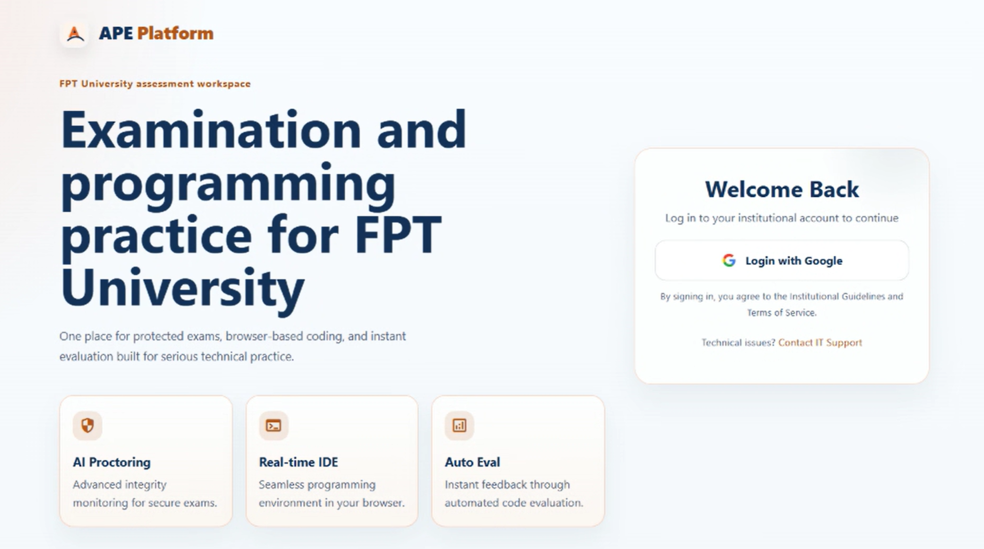
Figure 3-1-1-1 UI Mockup Login

3.1.1.2 Description
The sole unauthenticated entry point of the system. It offers Google Sign-In as the only authentication method for both roles, auto-provisions a Student account from the Google profile on first login, and routes the authenticated user to the role-appropriate landing page (Student Dashboard / Admin Dashboard). Realizes: UC-01 Login with Google · UC-03 Authenticate via Google OAuth (included, non-UI).

3.1.1.3 Field Specification
Field Name | Description
Login Card | Field Group
Login with Google | Action (button); renders the Google Identity Services button; on credential callback calls POST /api/auth/google { idToken } then GET /api/auth/me.
Loading Indicator | Display; text “Signing you in…”; shown while the authentication request is in flight.
Error Message | Display; shown on authentication failure.
Success Message | Display; format "Login successful: {fullName or email}"; shown briefly on success before routing.

3.1.2 Profile — Roles: Student, Super Admin

3.1.2.1 UI Layout (Mockup)

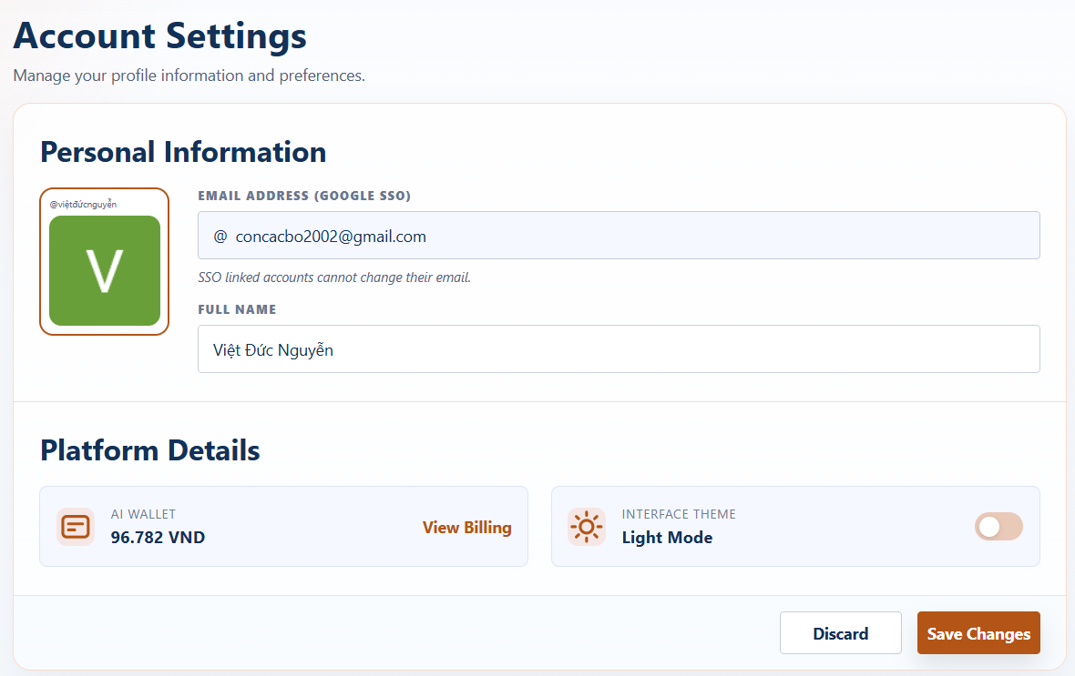
Figure 3-1-2-1 UI Mockup Profile

3.1.2.2 Description
Displays the authenticated user’s identity: avatar and email are read-only (sourced from Google SSO — SSO-linked accounts cannot change their email), while the user’s full name is editable and saved via the profile API. The screen also surfaces the current AI wallet balance with a shortcut to the wallet, and a local interface-theme toggle (Light / Dark). Logout is available from the top bar. Realizes: UC-04 View Own Profile · UC-02 Logout (top-bar action).

3.1.2.3 Field Specification
Field Name | Description
Personal Information | Field Group
Avatar | Display; image (URL); sourced from Google SSO; read-only.
Email Address (Google SSO) | Display; read-only; hint: “SSO linked accounts cannot change their email.”
Full Name | Text input; required (FE rejects empty after trim); BE constraint MaxLength(100); persisted via PUT /api/student/profile { fullName }.
Avatar URL | Not editable on FE; BE accepts MaxLength(500) and requires a valid URL.
Platform Details | Field Group
AI Wallet | Display; format "{value} VND".
View Billing | Action (button); navigates to §3.2.1 AI Wallet.
Interface Theme | Display; shows “Light Mode” or “Dark Mode”.
Theme Toggle | Toggle; toggles light/dark theme locally (client-side only).
Actions | Field Group
Discard | Action (button); resets the draft full name to the last saved value.
Save Changes | Action (button); persists the full name via PUT /api/student/profile.

3.1.3 User Management (Admin) — Role: Super Admin

3.1.3.1 UI Layout (Mockup)
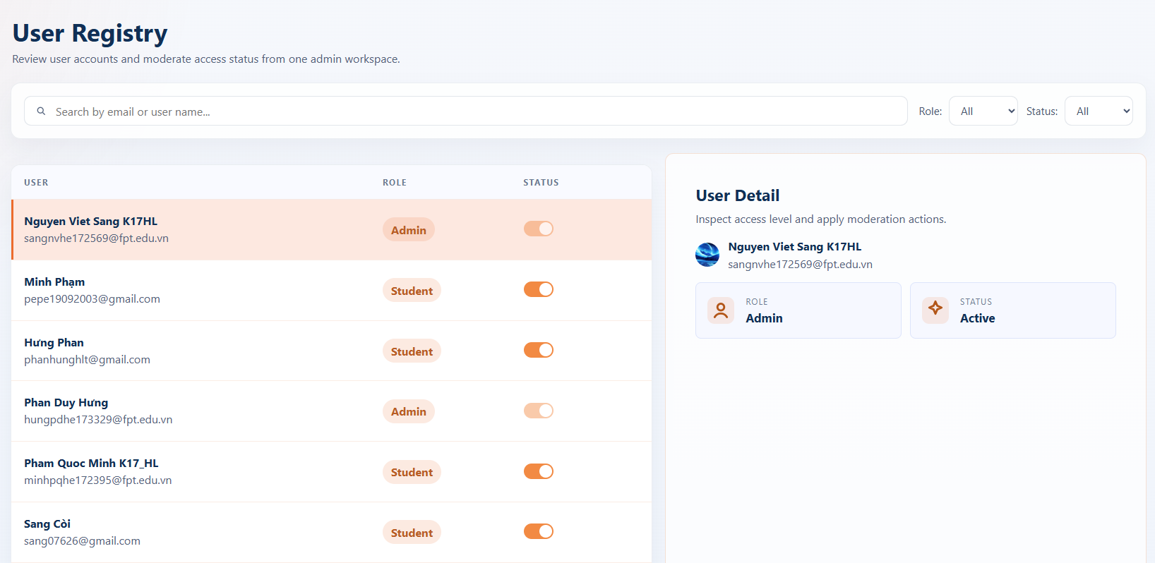
Figure 3-1-3-1 UI Mockup User Management

3.1.3.2 Description
Lets the Super Admin review user accounts and moderate access status. Provides search by email/name, role and status filters, a user list, a Ban/Unban toggle, and a read-only user detail panel. There is no in-app role assignment — the first Super Admin is still seeded out-of-band; deactivation blocks access but does not delete the account.
Realizes: UC-145 View User List · UC-146 View User Detail · UC-147 Moderate User Access Status (all proposed).

3.1.3.3 Field Specification
Field Name | Description
Filters | Field Group
Search | Text input; matches user by email or name.
Role Filter | Select; enum { All, Student, Super Admin }. Filters the list by role.
Status Filter | Select; enum { All, Active, Banned }. Filters the list by access status.
User List | Field Group
User | Display; user’s name and email. Read-only.
Role | Display; enum { Student, Super Admin }. Read-only (no in-app role change).
Status | Display; enum { Active, Banned }. Read-only.
Ban / Unban | Action (toggle) per row; switches the account between Active and Banned.
User Detail | Field Group
User Detail Panel | Display; read-only detail of the selected user (identity + access status).

3.2 AI Wallet & Payment
Feature scope: a VND-denominated AI wallet — viewing balance and top-up options, topping up via the payment gateway (PayOS), viewing top-up history, and admin configuration of denominations. Deductions, the minimum-balance guard, and Absorbed Loss are backend concerns surfaced only as effects.
Use cases: UC-05→13 · UC-148→151 (proposed — Wallet Packages).
Roles: Student, Super Admin.

3.2.1 AI Wallet — Role: Student

3.2.1.1 UI Layout (Mockup)
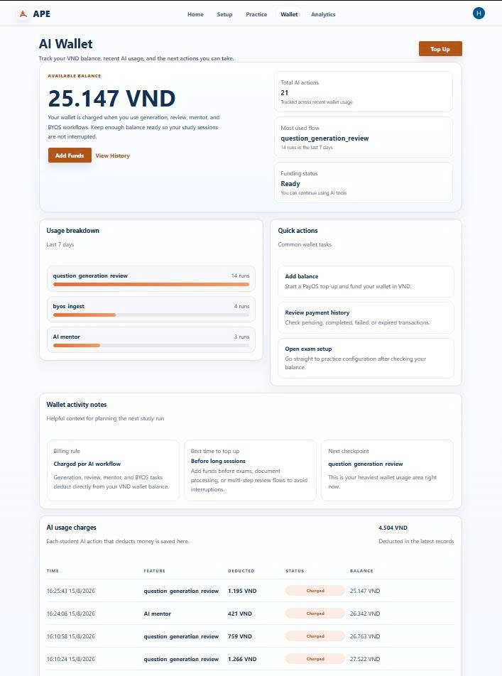
Figure 3-2-1-1 UI Mockup AI Wallet

3.2.1.2 Description
Shows the Student’s current wallet balance in VND, quick actions to top up or view payment history, a short usage overview for the last 7 days (total AI actions, most-used flow, funding status), a per-feature usage breakdown, and a detailed AI Usage Charges table listing each deduction (charged / refunded / system-absorbed / waived) with the resulting balance. The minimum-balance guard (≥ 1,000 VND) that gates every AI action is enforced by the backend and surfaced here as blocking when the balance is insufficient.
Realizes: UC-05 View AI Wallet Balance · UC-06 View Top-up Options. UC-12 Check Minimum Balance Guard (backend effect).

3.2.1.3 Field Specification
Field Name | Description
Hero | Field Group
Available Balance | Display; format "{value} VND".
Top Up | Action (button); navigates to §3.2.2 Top-up.
Add Funds | Action (button); navigates to §3.2.2 Top-up.
View History | Action (button); navigates to §3.2.3 Top-up History.
Summary Cards (last 7 days) | Field Group
Total AI Actions | Display; count of AI runs.
Most Used Flow | Display; top feature by usage count.
Funding Status | Display; enum { Ready, Low balance }.
Usage Breakdown | Field Group
Feature Name | Display; mapped label (e.g. “Upload document”, “Generate questions”, “AI mentor”).
Run Count | Display; per-feature bar.
Quick Actions | Field Group
Add Balance | Action (button); navigates to §3.2.2 Top-up.
Review Payment History | Action (button); navigates to §3.2.3 Top-up History.
Open Exam Setup | Action (button); navigates to §3.7 Practice Setup.
AI Usage Charges Table | Field Group
Total Deducted | Display; format "{value} VND".
Time | Table column; format vi-VN locale datetime.
Feature | Table column; mapped label from featureKey.
Deducted | Table column; format "{value} VND".
Status | Table column; pill badge; enum { Charged, Refunded, System absorbed, Waived }.
Balance | Table column; format "{value} VND" (resulting balance after the deduction).

3.2.2 Top-up — Role: Student

3.2.2.1 UI Layout (Mockup)
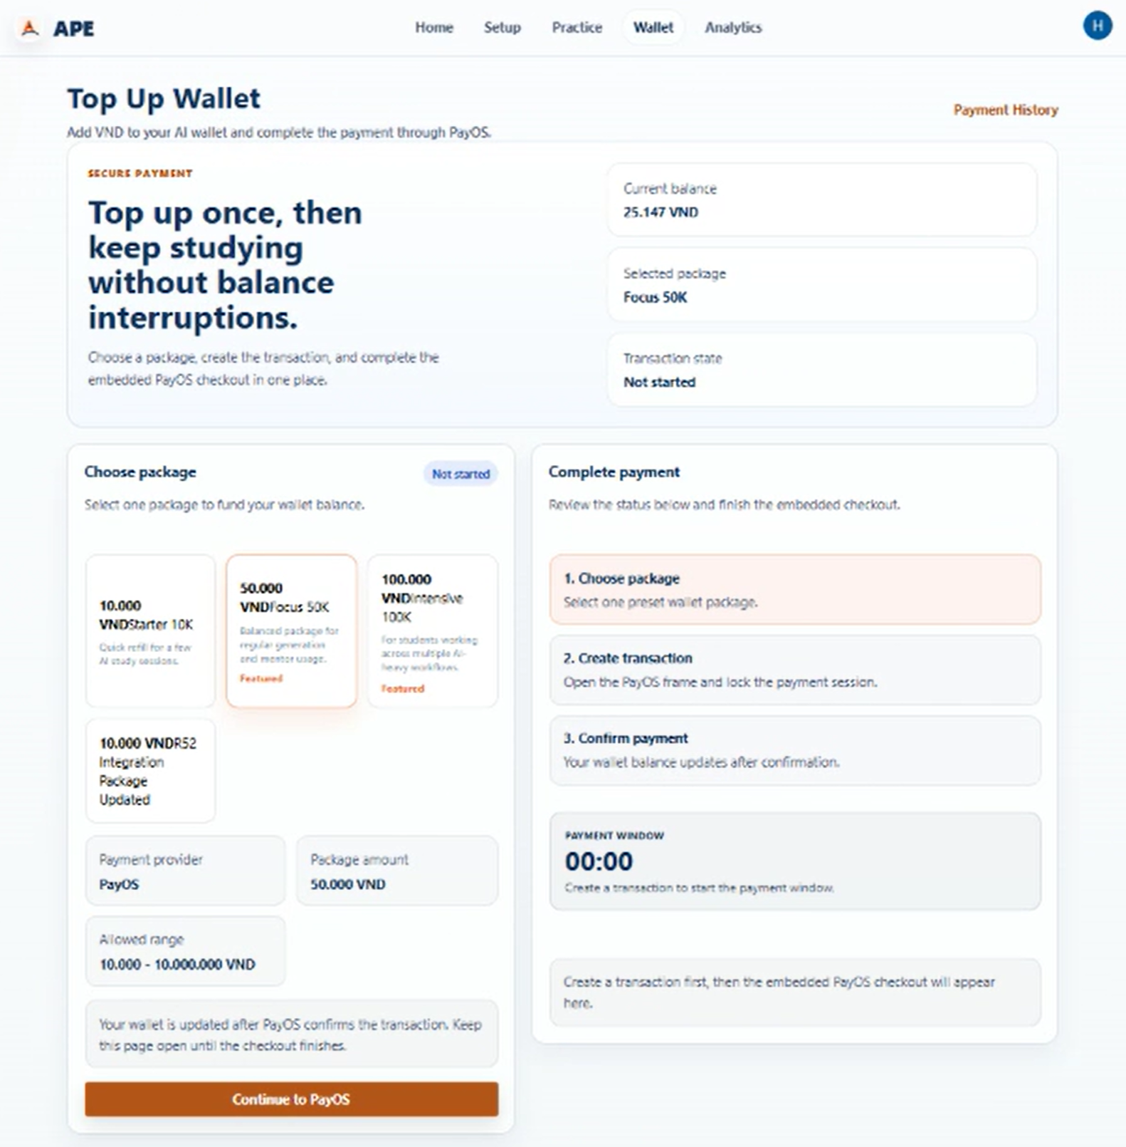
Figure 3-2-2-1 UI Mockup TopUp

3.2.2.2 Description
Lets the Student select a top-up denomination, initiate payment through the gateway, and cancel an in-progress transaction; the paid amount is credited via the backend payment callback.
Realizes: UC-06 View Top-up Options · UC-07 Top-up AI Wallet · UC-09 Cancel Payment · UC-08 Process Payment Callback (backend effect).

3.2.2.3 Field Specification
Field Name | Description
Hero Stats | Field Group
Current Balance | Display; format "{value} VND".
Selected Package | Display; the selected package name, or the placeholder “Choose a package”.
Transaction State | Display; enum { Not started, Awaiting payment, Completed, Failed, Cancelled }.
Payment History | Action (button); navigates to §3.2.3 Top-up History.
Choose Package | Field Group
Package Cards | Selectable group (button); each card shows amountVnd, name, description, and a “Featured” badge when isFeatured; single-select.
Transaction Status Pill | Display; mirrors Transaction State as a pill badge.
Payment Provider | Display; sourced from top-up constraints (default “PayOS”).
Package Amount | Display; sourced from the selected package.
Allowed Range | Display; format "{min} – {max} VND"; sourced from GET /api/student/wallet/topups/constraints.
Continue to PayOS | Action (button); disabled when no package is selected; calls POST /api/student/wallet/topups/create { packageId, amountVnd }; FE validates that amountVnd lies within the allowed range.
Complete Payment | Field Group
Step Indicators | Display; three-step progress indicator (1–2–3) reflecting the current stage.
Payment Window Countdown | Display; format "MM:SS"; starts at 5 minutes (300 s).
Cancel Transaction | Action (button); calls POST /api/student/wallet/topups/{paymentId}/cancel.
PayOS Embedded Checkout | Display; embedded iframe rendered via @payos/payos-checkout.

3.2.3 Top-up History — Role: Student

3.2.3.1 UI Layout (Mockup)
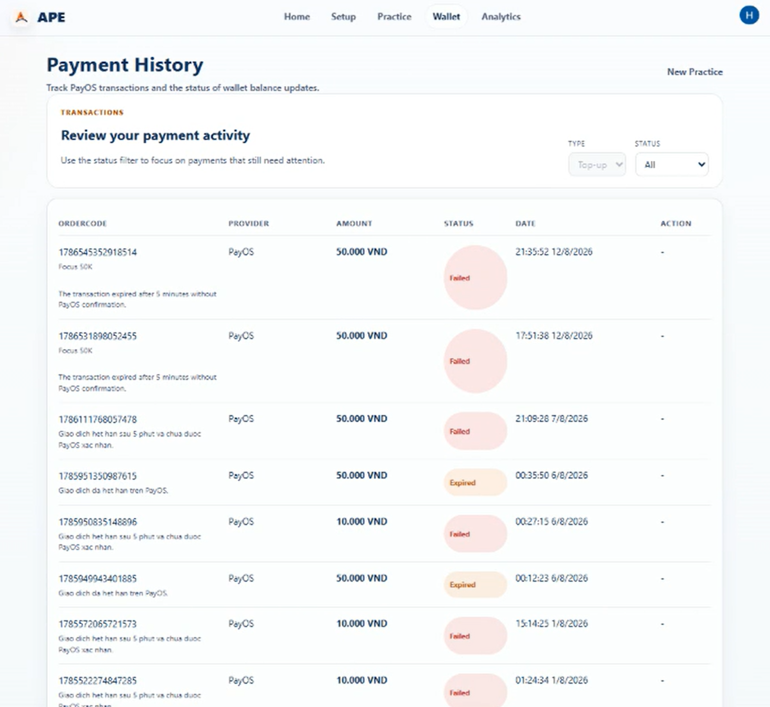
Figure 3-2-3-1 UI Mockup Top Up History

3.2.3.2 Description
Lists the Student’s past wallet top-up transactions and opens the detail of a single transaction. The list auto-refreshes every 5 seconds while pending transactions are present.
Realizes: UC-10 View Top-up History · UC-11 View Top-up Detail.

3.2.3.3 Field Specification
Field Name | Description
Filters | Field Group
Type | Select; enum { Top-up } (single value, disabled).
Status | Select; enum { All, Completed, Pending, Failed, Expired, Cancelled }; default "All".
History Table (auto-refreshes every 5 s when pending rows exist) | Field Group
OrderCode | Table column; includes the packageName sub-line; for Pending rows shows a countdown "MM:SS remaining"; for Failed rows shows failureReason.
Provider | Table column; the payment provider name.
Amount | Table column; format "{value} VND".
Status | Table column; pill badge; enum { Completed, Pending, Failed, Expired, Cancelled }.
Date | Table column; paidAt when present, otherwise createdAt; format vi-VN locale.
Action | Table column; “Pay now” link when status = Pending and checkoutUrl exists and not expired; navigates to /wallet/top-up/?paymentId={id}.

3.2.4 Wallet Packages Management (Admin) — Role: Super Admin

3.2.4.1 UI Layout (Mockup)
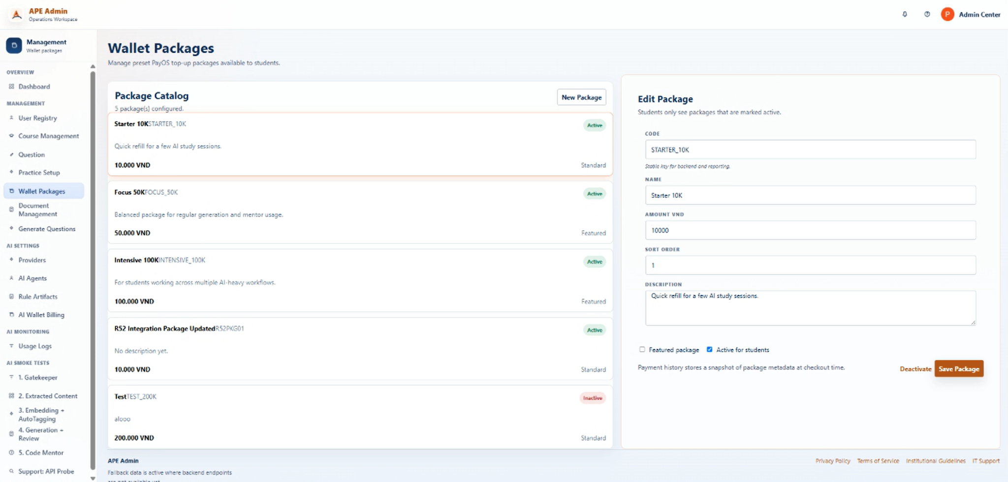
Figure 3-2-4-1 UI Mockup Login Wallet Packages Management (Admin)

3.2.4.2 Description
Lets the Super Admin configure the top-up packages (denominations) offered to Students — create, list, update, and delete packages; the default set is 10k / 20k / 50k / 100k VND.
Realizes: UC-148 Create Wallet Package · UC-149 View Wallet Package List · UC-150 Update Wallet Package · UC-151 Delete Wallet Package (all proposed).
Supports: UC-06 View Top-up Options.

3.2.4.3 Field Specification
Field Name | Description
Package Catalog | Field Group
New Package | Action (button); clears the edit form to create a new package.
Package Cards | Selectable list (button); each card shows name, code, description, amountVnd, a status pill { Active, Inactive }, and a Featured / Standard badge.
Edit / Create Panel | Field Group
Code | Text input; stable key used by the backend and reporting.
Name | Text input; the package display name.
Amount VND | Number input; min 10000; step 1000.
Sort Order | Number input; min 0; step 1.
Description | Textarea; 4 rows.
Featured Package | Checkbox; default false.
Active for Students | Checkbox; default true.
Deactivate / Activate | Action (button); calls PATCH /api/admin/wallet-packages/{id}/status { isActive }.
Save Package / Create Package | Action (button); calls PUT /api/admin/wallet-packages/{id} (edit) or POST /api/admin/wallet-packages (create) with payload { code, name, description, amountVnd, sortOrder, isActive, isFeatured }.

3.3 Course Management
Feature scope: course lifecycle with a bound programming language. Topic tags are auto-assigned by the AI ingest pipeline (UC-44) and consumed as filter values in generation, practice-setup, and question-bank screens — no dedicated admin CRUD screen.
Use cases: UC-14→18. Role: Super Admin.

3.3.1 Course Management (Admin) — Role: Super Admin

3.3.1.1 UI Layout (Mockup)
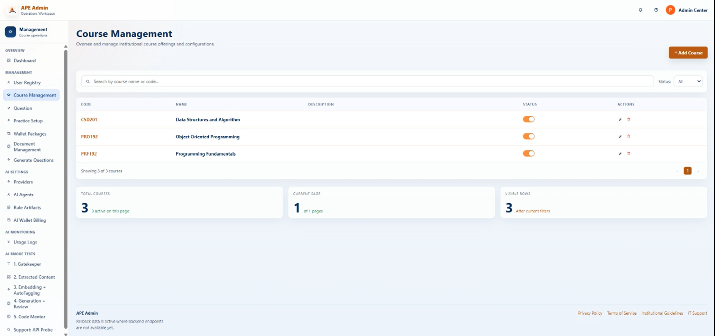
Figure 3-3-1-1 UI Mockup Course Management

3.3.1.2 Description
Full lifecycle management of courses: create a course with its bound programming language, list courses, view detail, update, and delete. A Duplicate action is provided as a UI shortcut over UC-14 Create Course (it opens the Create modal with the source course’s code and name prefilled). Realizes: UC-14 Create Course · UC-15 View Course List · UC-16 View Course Detail · UC-17 Update Course · UC-18 Delete Course.

3.3.1.3 Field Specification
Field Name | Description
Page Actions | Field Group
Add Course | Action (button); disabled when the user is not an admin; opens the Create modal.
Filters | Field Group
Search | Text input; placeholder "Search by course name or code...".
Status | Select; enum { All, Active, Inactive }; default "all".
More Filters | Action (button); opens the extended filter panel.
Course Table | Field Group
Code | Table column; the course code.
Name | Table column; the course display name.
Description | Table column; the course description.
Status | Toggle; calls PATCH /api/admin/courses/{id}/status { status: "Active" | "Inactive" }; disabled when the user is not an admin.
Edit | Action (button); disabled when the user is not an admin; opens the Edit modal and loads data via GET /api/admin/courses/{id}.
Duplicate | Action (button); disabled when the user is not an admin; opens the Create modal with code = "{code}-COPY" and name = "{name} Copy" prefilled (UI shortcut over UC-14).
Delete | Action (button); disabled when the user is not an admin; opens the Confirm modal, then calls DELETE /api/admin/courses/{id}.
Pagination | Field Group
Previous / Next / Page Numbers | Action (button); at most 5 page buttons rendered, with an ellipsis when totalPages > 5.
Summary Cards | Field Group
Total Courses | Display; total course count.
Current Page | Display; the current page index.
Visible Rows | Display; the number of rows on the current page.
Modal: Add / Edit Course | Field Group
Course Code | Text input; disabled when editing; FE-required (both code and name required); BE constraint Required, MaxLength(20); FE forces uppercase; placeholder "PRJ301".
Course Name | Text input; FE-required; BE constraint Required (create), MaxLength(200); placeholder "Software Architecture".
Description | Textarea; BE constraint MaxLength(1000); placeholder "Briefly describe the course outcomes and scope."
Cancel | Action (button); closes the modal.
Create Course / Save Changes | Action (button); calls POST /api/admin/courses (create) or PUT /api/admin/courses/{id} (edit).
Modal: Delete Confirm | Field Group
Message | Display; format "Delete {code} - {name}?".
Cancel | Action (button); closes the modal.
Delete | Action (button); calls DELETE /api/admin/courses/{id}.

3.4 Document Management
Feature scope: system and personal (BYOS) documents — upload that triggers the AI ingest pipeline, listing, detail, delete, download, and review of ingest results. The ingest-pipeline steps (UC-34→46) run in the backend; their status/output is surfaced on the preview/review screens.
Use cases: UC-24→46.
Roles: Student, Super Admin.3.4.1 System Documents (Admin) — Role: Super Admin

3.4.1.1 UI Layout (Mockup)
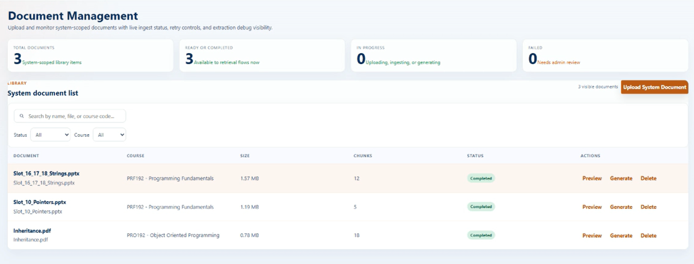
Figure 3-4-1-1 UI Mockup Document Management

3.4.1.2 Description
Lets the Super Admin upload system-wide learning documents (triggering the ingest pipeline), and list, view, delete, and download the original files, with filters for search, status, and course.
Realizes: UC-24 Upload System Document · UC-26 View System Document List · UC-28 View Document Detail · UC-32 Delete Document · UC-33 Download Original Document.

3.4.1.3 Field Specification
Field Name | Description
Stats Cards | Field Group
Total Documents | Display; total document count.
Ready or Completed | Display; count of documents ready or completed.
In Progress | Display; count of documents currently ingesting or generating.
Failed | Display; count of failed documents.
Filters | Field Group
Search | Text input; placeholder "Search by name, file, or course code...".
Status | Select; enum { All, Uploading, Ingesting, Ready, Generating, Completed, Failed }; default "all".
Course | Select; enum { All } + dynamic course list (by course.code); default "all".
Visible Documents Count | Display; number of documents shown after filtering.
Document Table | Field Group
Document | Table column; shows name, fileName, and any warnings.
Course | Table column; format "{courseCode} – {courseName}".
Size | Table column; format "X.XX MB".
Chunks | Table column; number of extracted knowledge chunks.
Status | Table column; badge; enum { Uploading, Ingesting, Ready, Generating, Completed, Failed }.
Preview | Action (button); opens the Detail modal via GET /api/admin/documents/{id}/preview.
Generate | Action (button); disabled when the document is not Ready; navigates to /admin/document-operations/{id}/generate/.
Delete | Action (button); opens the Delete Confirm modal.
Actions | Field Group
Upload System Document | Action (button); opens the Upload modal.
Modal: Upload | Field Group
Course | Select; required; dynamic course list; format "{code} – {name}".
File | File uploader; accept = ".txt,.doc,.docx,.pptx,.pdf,.md"; FE-enforced size limit 2 MB .
Selected Course Display | Display; "{code} – {name}" or "No course selected".
Selected File Display | Display; "{name} – {size}" or "No file selected yet."
Upload System Document | Action (button); calls POST /api/admin/documents/upload (multipart: file + courseId).
Modal: Document Detail | Field Group
Document Name / Status Badge / Document ID / File Name / File Type / Source / Subject Code | Display; read-only metadata.
Gatekeeper Verdict | Display; the domain-validation verdict from UC-35.
Ingestion Status | Display; the current ingest stage.
Chunk Count / Topic Tag Count / Ready for Generation | Display; ingest output summary.
Preview Text | Display; excerpt of the extracted text.
Cleanup Warnings | Display; list of extraction/cleanup warnings (conditional).
Topic Summary (tags) | Display; chip list of assigned topic tags.
Chapter Scope (chapters) | Display; card list — each shows chapterTitle, overviewShort, chunkCount, topic count.
Generate From This Document | Action (button); disabled when not Ready; navigates to /admin/document-operations/{id}/generate/.
Open Extraction Draft | Action (button); opens the draft review view.
Download Original | Action (button); calls GET /api/admin/documents/{id}/download.
Delete Document | Action (button); opens the Delete Confirm modal.
Modal: Delete Confirm | Field Group
Message | Display; format 'Soft-delete "{name}"? Its chunks will be removed...'.
Cancel | Action (button); closes the modal.
Delete | Action (button); calls DELETE /api/admin/documents/{id}.

3.4.2 Personal Documents (My Documents) — Role: Student

3.4.2.1 UI Layout (Mockup)
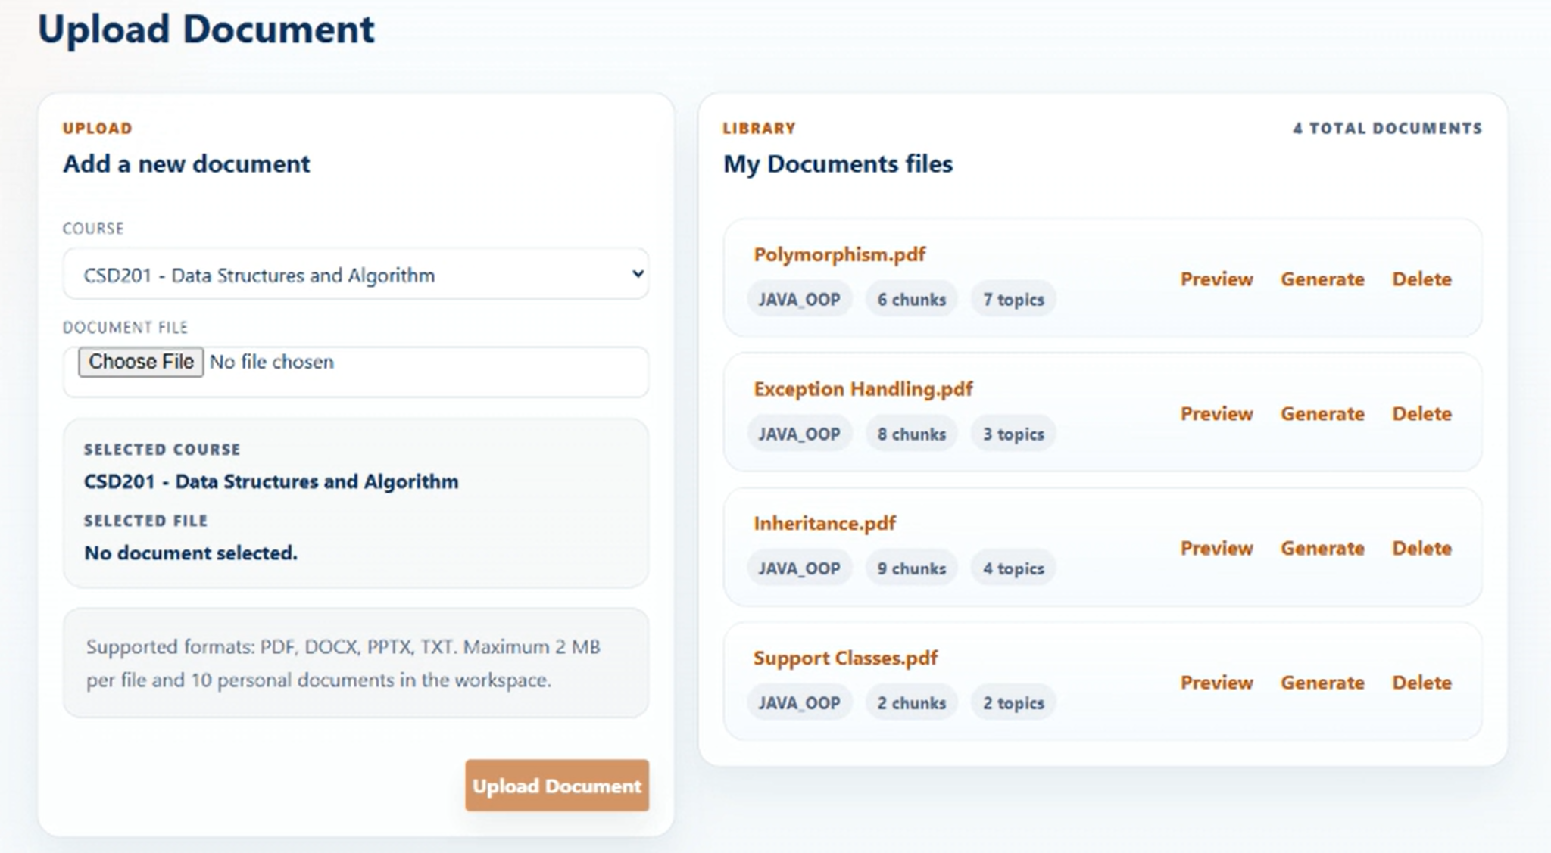
Figure 3-4-2-1 UI Mockup Personal Documents

3.4.2.2 Description
Lets the Student upload a personal document (which triggers the ingest pipeline) and browse their library of uploaded documents with preview, extraction-draft review, generation entry, and delete/download actions. A wallet balance ≥ 1,000 VND is required before an upload is permitted. BE constraints: maximum file size 2 MB, maximum 10 personal documents per Student, allowed file types PDF / DOCX / PPTX / TXT.
Realizes: UC-25 Upload Personal Document (BYOS) · UC-27 View Personal Document List · UC-28 View Document Detail · UC-32 Delete Document · UC-33 Download Original Document.

3.4.2.3 Field Specification
Field Name | Description
Upload Section | Field Group
Course | Select; required; dynamic course list; format "{code} – {name}"; first option "Select course".
Document File | File uploader; accept = ".pdf,.docx,.txt,.pptx"; BE constraints: max 2 MB, max 10 personal documents per Student, allowed types PDF / DOCX / PPTX / TXT.
Selected Course Display | Display; the currently selected course.
Selected File Display | Display; "{name} – {size}" or "No document selected."
Upload Document | Action (button); disabled while uploading or when no file/course is selected; calls POST /api/student/documents/byos (multipart: file + courseId).
Library: My Documents | Field Group
Total Documents Count | Display; total number of personal documents.
Document Card (per document) | Sub-group
File Name | Action (button); calls GET /api/student/documents/{id}/download (triggers file download).
Subject Code | Display; the bound course code.
Chunk Count | Display; format "{n} chunks".
Tag Count | Display; format "{n} topics".
Duplicate Message | Display; conditional; based on duplicateMatchType.
Preview | Action (button); navigates to §3.4.3 Personal Document Preview.
Draft | Action (button); shown when hasExtractionDraft and not readyForGeneration; navigates to §3.4.4 Extraction Draft Review.
Generate | Action (button); shown when isReadyForGeneration; navigates to §3.5.2 Generate from BYOS.
Delete | Action (button); opens the Delete Confirm modal.
Modal: Delete Confirm | Field Group
Message | Display; format 'Delete "{fileName}"? This will remove the file from storage and delete all extracted chunks.'.
Cancel | Action (button); closes the modal.
Delete | Action (button); calls DELETE /api/student/documents/{id}.

3.4.3 Personal Document Preview — Role: Student

3.4.3.1 UI Layout (Mockup)
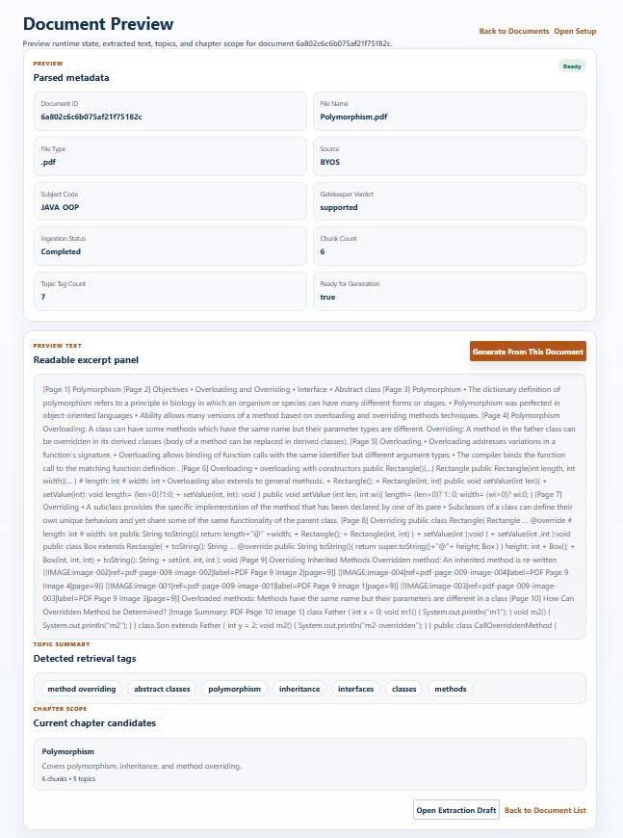
Figure 3-4-3-1 UI Mockup Personal Document Preview

3.4.3.2 Description
Presents the detail of an ingested personal document — parsed metadata, extracted preview text, cleanup warnings, topic summary, and chapter scope — for retrieval-scope browsing before generation.
Realizes: UC-28 View Document Detail · UC-65 View Document Chapters · UC-66 View Chapter Topics · UC-68 View Document Topic Summary.

3.4.3.3 Field Specification
Field Name | Description
Parsed Metadata | Field Group
Ingestion Stage Badge | Display; enum { Ready, Reused, Normalized, Gatekeeper Passed, Embedded, Processing, Failed }.
Document ID / File Name / File Type / Source | Display; read-only. Source default "BYOS".
Subject Code | Display; the bound course code.
Gatekeeper Verdict | Display; the domain-validation verdict.
Ingestion Status | Display; current ingest state.
Chunk Count / Topic Tag Count / Ready for Generation | Display; ingest output summary.
Preview Text | Field Group
Extracted Text Excerpt | Display; short excerpt of the extracted content.
Cleanup Warnings | Display; list (conditional).
Topic Summary (tags) | Display; chip list; sourced from GET /api/student/documents/{id}/topics.
Chapter Scope (chapters) | Display; card list — each shows chapterTitle, overviewShort, chunkCount, topic count; sourced from GET /api/student/documents/{id}/chapters.
Actions | Field Group
Generate From This Document | Action (button); disabled when not isReadyForGeneration; navigates to §3.5.2 Generate from BYOS.
Open Extraction Draft | Action (button); navigates to §3.4.4 Extraction Draft Review.
Back to Document List | Action (button); navigates back to §3.4.2 Personal Documents.
Open Setup | Action (button); navigates to §3.11.4 Student Journey / Setup Guide.

3.4.4 Extraction Draft Review — Role: Student

3.4.4.1 UI Layout (Mockup)
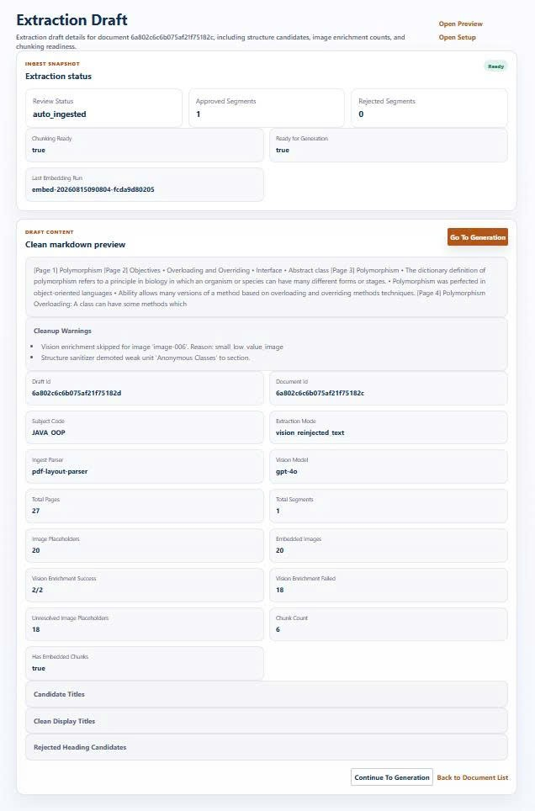
Figure 3-4-4-1 UI Mockup Extraction Draft Review

3.4.4.2 Description
Displays the output of the extraction pipeline — the ingest snapshot, cleaned markdown content, vision enrichment stats, chunking output, and heading candidates — for the Student to review before generation.
Realizes (as displayed results): UC-38 Extract Full Content · UC-39 Normalize Extracted Content · UC-40 Reinject Vision Content · UC-42 Chunk Knowledge Content.

3.4.4.3 Field Specification
Field Name | Description
Ingest Snapshot | Field Group
Ingestion Stage Badge | Display; enum { Ready, Reused, Normalized, Gatekeeper Passed, Embedded, Processing, Failed }.
Review Status | Display; the current draft review state.
Approved Segments / Rejected Segments | Display; counts.
Chunking Ready | Display; boolean.
Ready for Generation | Display; boolean.
Last Embedding Run | Display; timestamp of the most recent embedding run.
Draft Content | Field Group
Clean Markdown Preview | Display; the normalized markdown output.
Cleanup Warnings | Display; list (conditional).
Draft ID / Document ID / Subject Code | Display; read-only identifiers.
Extraction Mode / Ingest Parser / Vision Model | Display; pipeline configuration used for this draft.
Total Pages / Total Segments | Display; counts.
Image Placeholders / Embedded Images | Display; counts.
Vision Enrichment Success | Display; format "{succeeded}/{attempted}".
Vision Enrichment Failed | Display; count of vision-enrichment failures.
Unresolved Image Placeholders | Display; count.
Chunk Count | Display; count of knowledge chunks produced.
Has Embedded Chunks | Display; boolean.
Candidate Titles | Display; chip list (conditional).
Candidate Chapter Markers | Display; chip list (conditional).
Clean Display Titles | Display; chip list (conditional).
Rejected Heading Candidates | Display; chip list (conditional).
Actions | Field Group
Go To Generation / Continue To Generation | Action (button); navigates to §3.5.2 Generate from BYOS.
Back to Document List | Action (button); navigates back to §3.4.2 Personal Documents.
Open Preview | Action (button); navigates to §3.4.3 Personal Document Preview.
Open Setup | Action (button); navigates to §3.11.4 Student Journey / Setup Guide.

3.5 AI Question Generation
Feature scope: configuring and running the synchronous generation + review pipeline from the system knowledge bank or from a personal (BYOS) document. The pipeline internals (UC-48→63) run in the backend; each Generate screen exposes a Generation Result Panel that lets the Student/Super Admin review the produced draft questions and publish or delete them inline — the panel realizes UC-70/71/73/74 (there is no separate “Review Draft Questions” screen).
Use cases: UC-47→64 · UC-70/71/73/74 (via Result Panel).
Roles: Student, Super Admin.

3.5.1 Generate from BYOS (Personal Doc) — Role: Student

3.5.1.1 UI Layout (Mockup)
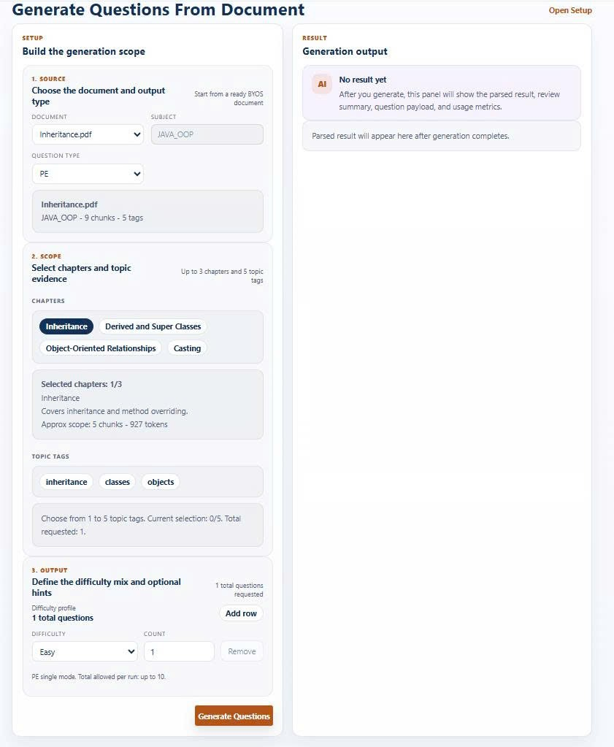
Figure 3-5-1-1 UI Mockup Generate from BYOS

3.5.1.2 Description
The same generation flow scoped to a personal (BYOS) document — only documents that are isReadyForGeneration are selectable. Shows a document-info panel with approximate scope size (chunks/tokens). On success, the generation and review cost is deducted from the Student’s wallet in VND (no result → no charge). The Generation Result Panel is identical to §3.5.1 and realizes UC-70/71/73/74 inline.
Realizes: UC-47 … UC-63 (pipeline) · UC-64 Deduct Generation Fee (VND) (backend effect) · UC-70 / UC-71 / UC-73 / UC-74 (via Result Panel).

3.5.1.3 Field Specification
Field Name | Description
Source Selection | Field Group
Document | Select; required; only documents where isReadyForGeneration = true.
Subject | Text input; read-only; auto-filled from the API.
Question Type | Select; enum { PE, FE }; default PE.
Scope | Field Group
Chapters | Toggle chips (button group); max 3 selected.
Topic Tags | Toggle chips (button group); min 1, max 5 selected.
Output Config | Field Group
Difficulty (per row) | Select; enum { Easy, Medium, Hard }; no duplicate rows allowed.
Count (per row) | Number input; min 1; max 50 (FE) or max 10 (PE).
Add Row | Action (button); max 3 rows.
Remove Row | Action (button); min 1 row must remain.
Document Info Display | Field Group
File Name / Subject Code / Chunk Count / Tag Count | Display; document metadata.
Selected Chapters Count | Display; format "n / 3".
Approx Scope Chunks / Approx Scope Tokens | Display; estimated scope size.
Actions | Field Group
Generate Questions | Action (button); calls the generateReviewFromByos API.
Open Setup | Action (button); navigates to §3.11.4 Student Journey.
Generation Result Panel | Field Group
(same fields as §3.5.1 Result Panel) | Realizes UC-70 / UC-71 / UC-73 / UC-74 inline.
Confirm Remaining Questions | Action (button); calls the publishGeneratedQuestion API; shown only if drafts exist.
Open Practice Config | Action (button); navigates to §3.7.1 FE Exam Config.

3.5.2 Generate System Bank (Admin) — Role: Super Admin

3.5.2.1 UI Layout (Mockup)
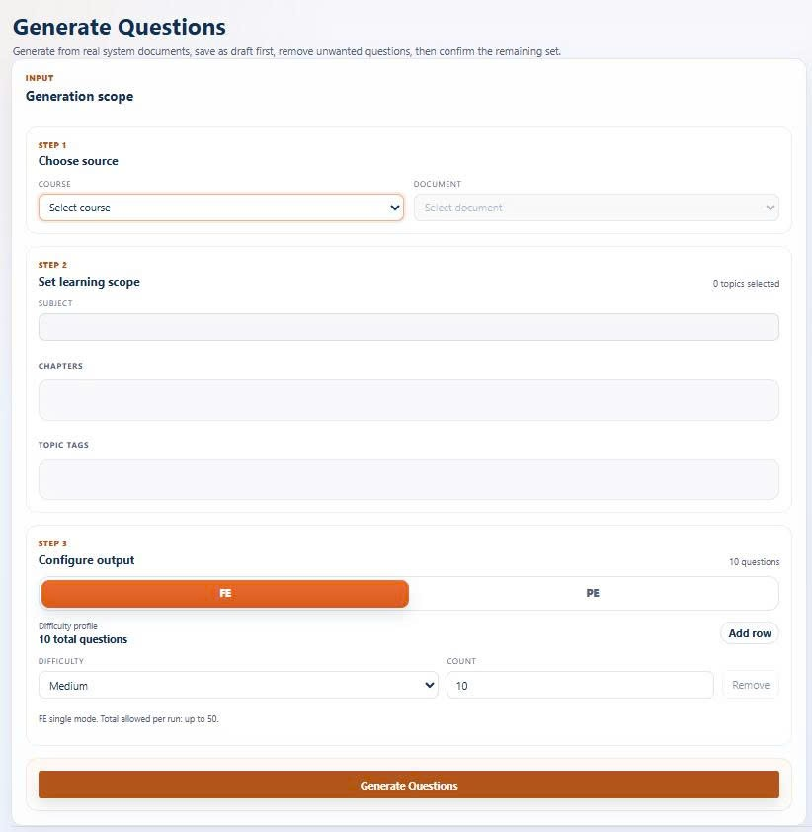
Figure 3-5-2-1 UI Mockup Generate System Bank (Admin)

3.5.2.2 Description
Lets the Super Admin run the same generation + review pipeline to populate the system question bank with Draft questions (isPublic: true). Unlike the Student flows, chapter selection is unbounded. The Generation Result Panel realizes UC-70/71/73/74 inline.
Realizes: UC-47 … UC-63 (pipeline, backend) · UC-70 / UC-71 / UC-73 / UC-74 (via Result Panel, system bank scope).

3.5.2.3 Field Specification
Field Name | Description
Source Selection | Field Group
Course | Select; required.
Document | Select; required; options depend on the selected Course.
Learning Scope | Field Group
Subject | Text input; read-only; auto-filled from the API.
Chapters | Toggle chips (button group); no upper bound (unlike Student flows capped at 3).
Topic Tags | Toggle chips (button group); min 1 selected.
Output Config | Field Group
Question Type | Segmented (button group); enum { FE, PE }; default FE.
Difficulty (per row) | Select; enum { Easy, Medium, Hard }; no duplicate rows allowed.
Count (per row) | Number input; min 1; max 50 (FE) or max 10 (PE).
Add Row | Action (button); max 3 rows.
Remove Row | Action (button); min 1 row must remain.
Actions | Field Group
Generate Questions | Action (button); calls the generateReviewFromAdminSystem API (isPublic: true).
Generation Result Panel | Field Group
(same fields as §3.5.1 Result Panel) | Realizes UC-70 / UC-71 / UC-73 / UC-74 inline.
Remove This Draft | Action (button); calls the deleteGeneratedQuestion API.
Confirm Remaining Questions | Action (button); calls the publishGeneratedQuestion API.

3.6 Question Bank
Feature scope: browsing and searching the shared active bank, admin moderation (publish, reject, edit, disable/enable, delete), and bulk import. Reviewing and publishing generated drafts happens inline in the Generation Result Panel of §3.5 (not a separate screen).
Use cases: UC-70 · UC-71 · UC-72 · UC-74 · UC-75 · UC-76→79.
Roles: Student, Super Admin.

3.6.1 Question Bank Browse (Student) — Role: Student

3.6.1.1 UI Layout (Mockup)
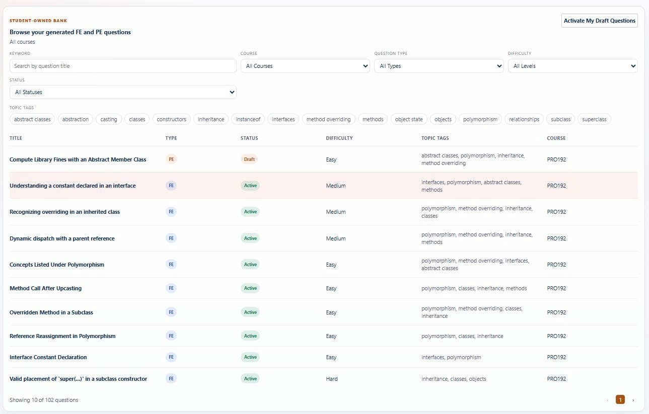
Figure 3-6-1-1 UI Mockup Question Bank Browse (Student)

3.6.1.2 Description
Lets the Student browse the shared question bank with filtering (course, question type, difficulty, status, topic tags), keyword search, and paginated listing. Selecting a row opens the detail panel described in §3.6.2.
Realizes: UC-76 Browse Question Bank · UC-77 Filter Questions · UC-78 Search Questions by Keyword · UC-79 Preview Question, UC-73.

3.6.1.3 Field Specification
Field Name | Description
Filters | Field Group
Keyword | Text input; placeholder "Search by question title".
Course | Select; enum { All Courses } + dynamic course list.
Question Type | Select; enum { All Types, FE, PE }.
Difficulty | Select; enum { All Levels, Easy, Medium, Hard }.
Status | Select; enum { All Statuses, Active, Draft }.
Topic Tags | Toggle chips (button group); dynamic per selected course.
Question Table | Field Group
Title | Table column; the question title.
Type | Table column; badge { FE, PE }.
Status | Table column; badge { Active, Draft }.
Difficulty | Table column; { Easy, Medium, Hard }.
Topic Tags | Table column; comma-joined topic tags.
Course | Table column; the bound course.
Pagination | Field Group
Showing X of Y | Display; page counter.
Previous Page / Next Page | Action (button); page navigation.
Current Page | Display; the active page index.

3.6.2 Question Detail (Student) — Role: Student

3.6.2.1 UI Layout (Mockup)
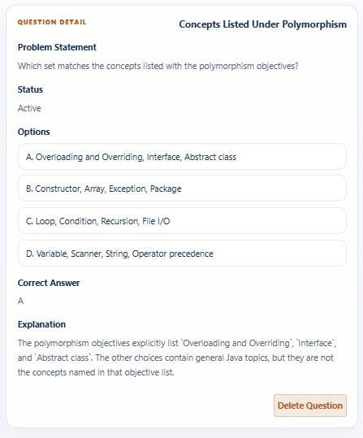
Figure 3-6-2-1 UI Mockup Question Detail (Student)

3.6.2.2 Description
Detail panel (inline in §3.6.1) showing the full detail of a selected question — MCQ shown in full; coding problems hide the hidden test cases. If the question is a personal draft that can be activated (canPublish), the Student may Activate or Delete it.
Realizes: UC-75 View Question Detail · UC-71 Publish Question (personal draft, canPublish only) · UC-74 Delete Question.

3.6.2.3 Field Specification
Field Name | Description
Detail Panel (inline in §3.6.1) | Field Group
Title | Display; the question title.
Problem Statement (description) | Display; the question body.
Status | Display; the current status.
FE-specific | Field Group
Options | Display; list of option strings.
Correct Answer | Display; the correct option.
Explanation | Display; the answer explanation.
PE-specific | Field Group
Skeleton Code | Display; per file — filename + content.
Sample Test Cases | Display; per case — input + expectedOutput (hidden test cases excluded).
Actions | Field Group
Active Question | Action (button); calls the publishStudentQuestion API; shown only when canPublish.
Delete Question | Action (button); opens the Delete Confirm modal.
Modal: Delete Confirm | Field Group
Title | Display; "Delete question".
Message | Display; format "Delete {title}? Deleted questions cannot be activated again."
Delete | Action (button); calls the deleteStudentQuestion API.
Cancel | Action (button); closes the modal.

3.6.3 System Question Bank & Moderation (Admin) — Role: Super Admin

3.6.3.1 UI Layout (Mockup)

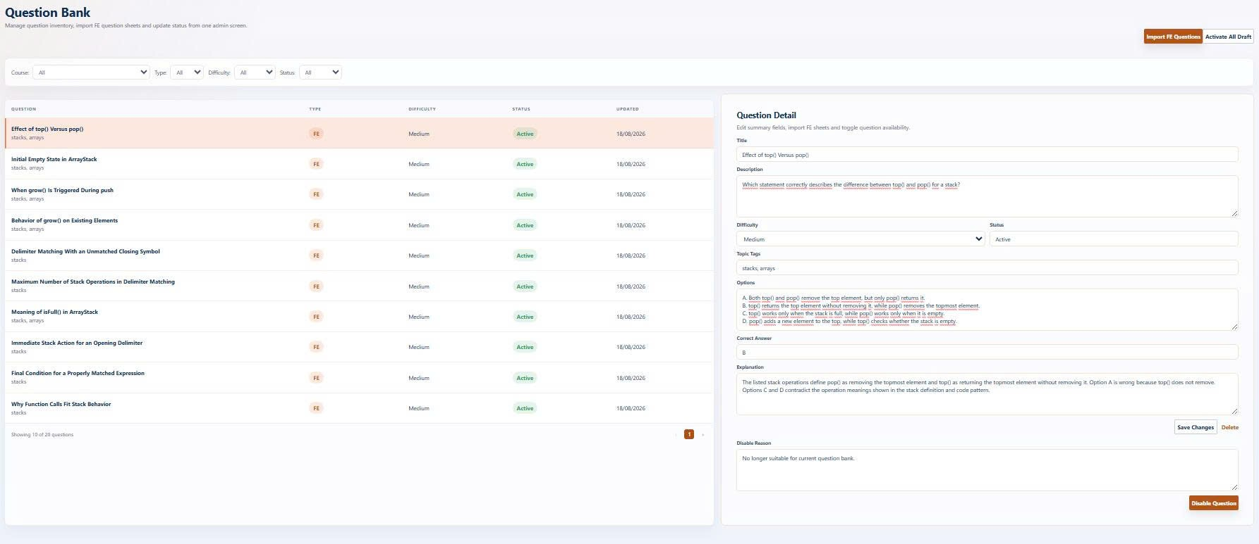
Figure 3-6-3-1 UI Mockup System Question Bank & Moderation (Admin)

3.6.3.2 Description
Lets the Super Admin view system questions with filtering, moderate drafts (publish / reject), edit any question (title, description, difficulty, tags, options, correct answer, skeleton code, test cases as JSON), disable or enable Active questions with a required reason, delete questions, and open the bulk-import modal (§3.6.4). Note: this contradicts the earlier SRS rule “questions are never editable” — that rule is superseded by this screen’s Edit panel. Disable / Enable is treated as a moderation utility over UC-72 (no separate UC).
Realizes: UC-70 View Draft Questions · UC-71 Publish Question · UC-72 Reject Draft Question · UC-74 Delete Question · UC-75 View Question Detail (+ Edit + Disable/Enable utility).

3.6.3.3 Field Specification
Field Name | Description
Filters | Field Group
Course | Select; enum { All } + dynamic course list.
Type | Select; enum { All, FE, PE }.
Difficulty | Select; enum { All, Easy, Medium, Hard }.
Status | Select; enum { All, Active, Draft, Disabled }.
Question Table | Field Group
Question | Table column; shows title + topicTags.
Type | Table column; badge { FE, PE }.
Difficulty | Table column; { Easy, Medium, Hard }.
Status | Table column; badge { Active, Draft, Disabled }.
Updated | Table column; format dd/MM/yyyy.
Pagination | Field Group
Showing X of Y / Previous / Next / Current | Standard paging controls.
Toolbar | Field Group
Import FE Questions | Action (button); opens the Import modal (see §3.6.4).
Detail / Edit Panel | Field Group
Title | Text input.
Description | Textarea.
Difficulty | Select; enum { Easy, Medium, Hard }.
Status | Text input; read-only.
Topic Tags | Text input; comma-separated.
FE-specific Edit | Field Group
Options | Textarea; one option per line.
Correct Answer | Text input; comma-separated.
Explanation | Textarea; read-only.
PE-specific Edit | Field Group
Skeleton Code | Textarea; must be a valid JSON array.
Test Cases | Textarea; must be a valid JSON array.
Solution Code | Textarea; read-only.
Edit Actions | Field Group
Save Changes | Action (button); calls the updateQuestion API.
Active Question | Action (button); calls the publishQuestion API; shown for Draft status only.
Delete | Action (button); calls the deleteQuestion API.
Moderation | Field Group
Disable Reason | Textarea; required for the disable action.
Disable Question / Enable Question | Action (button); calls the toggleQuestionDisabled API (utility, no dedicated UC).
Import Result Display | Field Group
Imported Rows | Display; format "{successCount} / {totalRows}".
Failed | Display; failCount.
Row Errors | Display; up to 5 errors — row number + error message.

3.6.4 Question Import (Admin) — Role: Super Admin

3.6.4.1 UI Layout (Mockup)

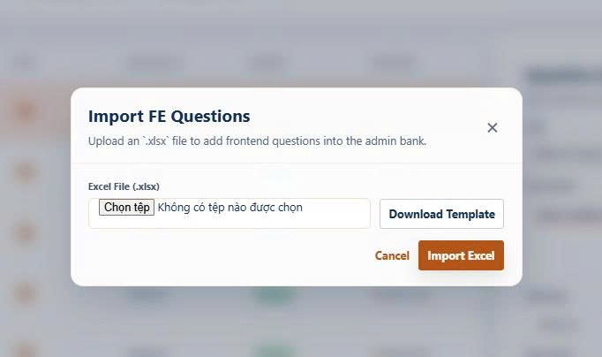
Figure 3-6-4-1 UI Mockup Question Import (Admin)

3.6.4.2 Description
Modal (embedded in §3.6.3) that lets the Super Admin bulk-import questions from an Excel file into the system bank. Supports: UC-70 / UC-71 (batch entry into the bank).

3.6.4.3 Field Specification
Field Name | Description
Import Modal (inside §3.6.3) | Field Group
Excel File (.xlsx) | File uploader; accept = ".xlsx".
Cancel | Action (button); closes the modal.
Import Excel | Action (button); calls the importQuestionsExcel API (POST FormData).

3.7 Practice Setup
Feature scope: assembling practice sets — MCQ/Flashcard by per-difficulty counts, and Coding by manual problem selection — from the system or personal bank, plus admin template setup. Use cases: UC-80→83.
Roles: Student, Super Admin. Note: StudentPeExamConfigPage.jsx is exported but has no active route — excluded from this SRS as planned.

3.7.1 Practice Configuration - Role: Student

3.7.1.1 UI Layout (Mockup)

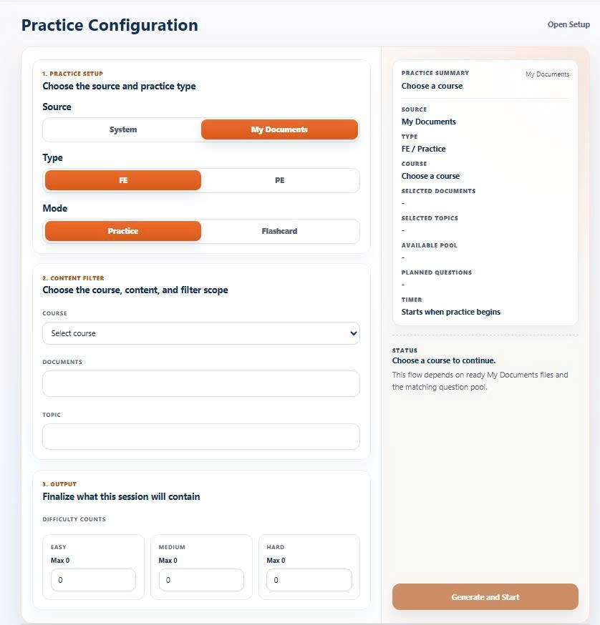
Figure 3-7-1-1 UI Mockup Practice Configuration

3.7.1.2 Description
Lets the Student configure and start a new practice session from either the system or personal (BYOS) bank. A Source segmented control switches between System and My Documents; type (FE/PE) selects the practice mode; for FE the Student sets per-difficulty counts (Easy/Medium/Hard) while for PE the Student manually picks up to 5 coding problems from the filtered pool. A summary sidebar shows the resulting pool and readiness before the session starts. Realizes: UC-80 Configure Practice from System Bank · UC-81 Configure Practice from Personal Bank · UC-82 Manually Select Coding Problems · UC-83 Assemble MCQ Practice Set by Difficulty.

3.7.1.3 Field Specification
Field Name | Description
Practice Setup | Field Group
Source | Segmented (button group); enum { System, My Documents (BYOS) }.
Type | Segmented (button group); enum { FE, PE }; enabled after Source is selected.
Mode | Segmented (button group); enum { Practice, Flashcard }; shown for Type = FE only.
Content Filter | Field Group
Course | Select; required.
Documents | Checkbox list; shown for Source = BYOS only; multi-select.
Topic | Checkbox list; dynamic from the question pool.
Difficulty Filter (PE only) | Checkbox; enum { Easy, Medium, Hard }.
Output | Field Group
Pick Questions (PE) | Checkbox list; per question from the filtered pool.
Easy Count (FE) | Number input; min 0; max = dynamic available pool; step 1.
Medium Count (FE) | Number input; min 0; max = dynamic available pool; step 1.
Hard Count (FE) | Number input; min 0; max = dynamic available pool; step 1.
Summary Sidebar | Field Group
Source / Type / Course | Display; the selected configuration.
Selected Documents | Display; shown for Source = BYOS only.
Selected Topics | Display; count of topics selected.
Available Pool | Display; count of questions matching the filter.
Planned Questions | Display; count + type of the planned session.
Timer | Display; "Starts when practice begins".
Status | Display; readiness text.
Actions | Field Group
Generate and Start | Action (button); calls the startConfiguredExam API, then navigates to the exam / flashcard / coding screen.
Open Setup | Action (button); navigates to §3.11.4 Student Journey.

3.7.2 Personal Practice Library — Role: Student

3.7.2.1 UI Layout (Mockup)

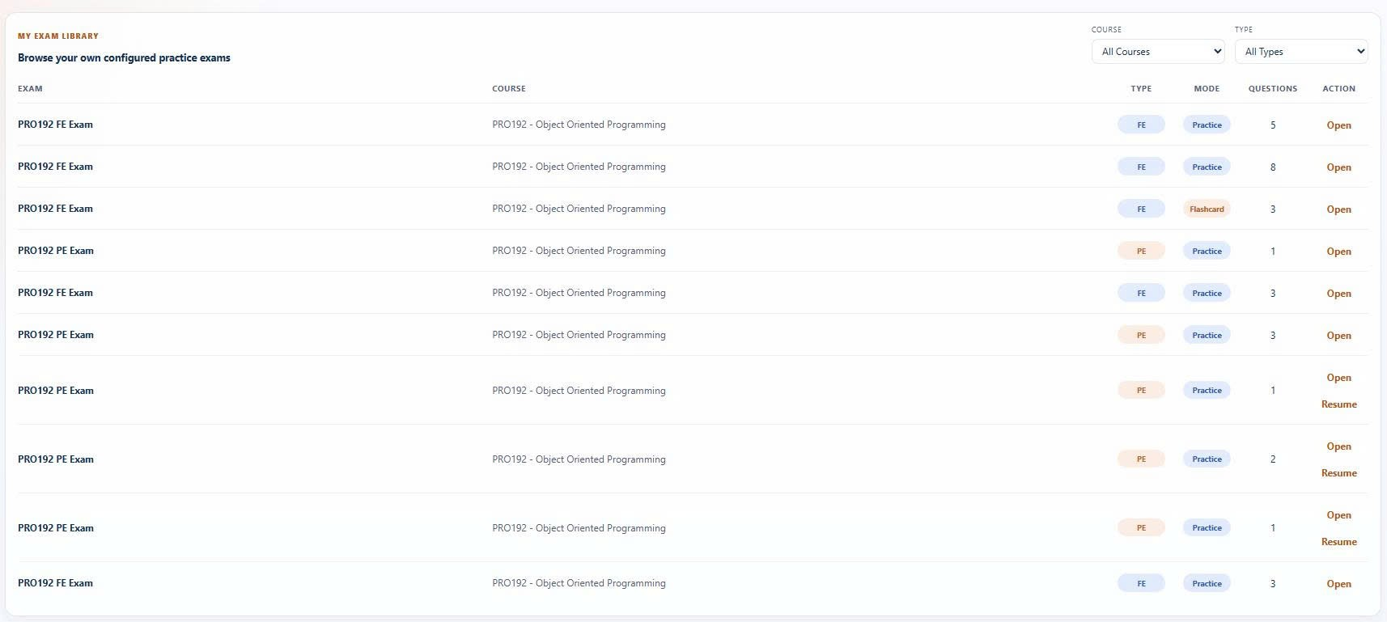
Figure 3-7-2-2 UI Mockup Personal Practice Library

3.7.2.2 Description
Lists practice sessions previously configured from the Student’s personal bank, filterable by course and type. Each row exposes Open (to start a new session) and Resume (for a PE session with active state).
Realizes: UC-81 Configure Practice from Personal Bank (entry to saved sets).

3.7.2.3 Field Specification
Field Name | Description
Filters | Field Group
Course | Select; enum { All Courses } + dynamic course list.
Type | Select; enum { All Types, fe, pe, mixed }.
Exam Table | Field Group
Exam | Table column; the exam title.
Course | Table column; format "{courseCode} – {courseName}".
Type | Table column; badge { FE, PE, Mixed }.
Mode | Table column; badge { Practice, Flashcard }.
Questions | Table column; totalQuestions count.
Action | Table column; row actions (see below).
Row Actions | Field Group
Open | Action (button); calls createFeExamSession / createFlashcardSession / createPePracticeSession depending on type, then navigates to the session screen.
Resume | Action (button); calls resumePePracticeSession; shown for PE with an active session only.

3.7.3 System Exam Library — Role: Student

3.7.3.1 UI Layout (Mockup)

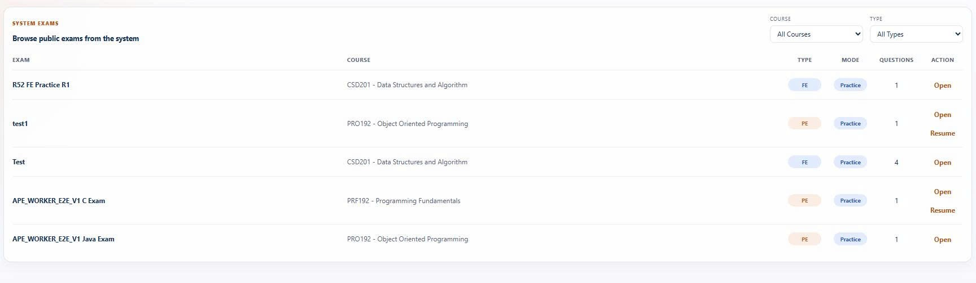
Figure 3-7-3-1 UI Mockup System Exam Library

3.7.3.2 Description
Lists practice sessions available from the system bank, filterable by course and type. Each row exposes Open (to start a new session) and Resume (for a PE session with active state).
Realizes: UC-80 Configure Practice from System Bank (entry to saved sets).

3.7.3.3 Field Specification
Field Name | Description
Filters | Field Group
Course | Select; enum { All Courses } + dynamic course list.
Type | Select; enum { All Types, fe, pe, mixed }.
Exam Table | Field Group
Exam | Table column; the exam title.
Course | Table column; format "{courseCode} – {courseName}".
Type | Table column; badge { FE, PE, Mixed }.
Mode | Table column; badge { Practice, Flashcard }.
Questions | Table column; totalQuestions count.
Action | Table column; row actions (see below).
Row Actions | Field Group
Open | Action (button); calls createFeExamSession / createFlashcardSession / createPePracticeSession depending on type, then navigates to the session screen.
Resume | Action (button); calls resumePePracticeSession; shown for PE with an active session only.

3.7.4 Admin Practice Setup — Role: Super Admin

3.7.4.1 UI Layout (Mockup)

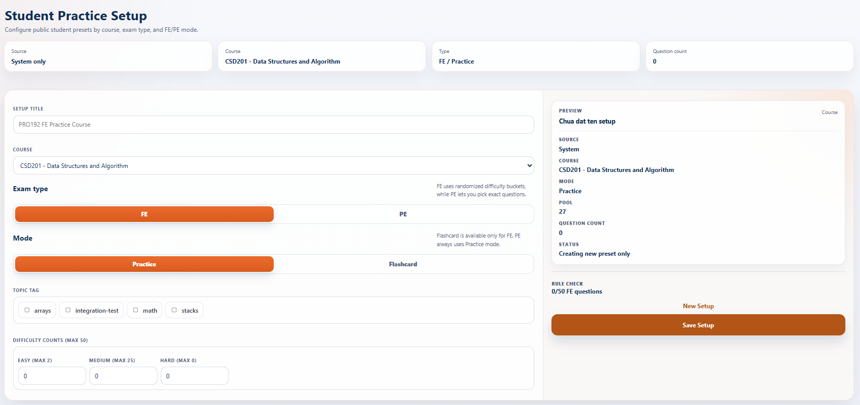
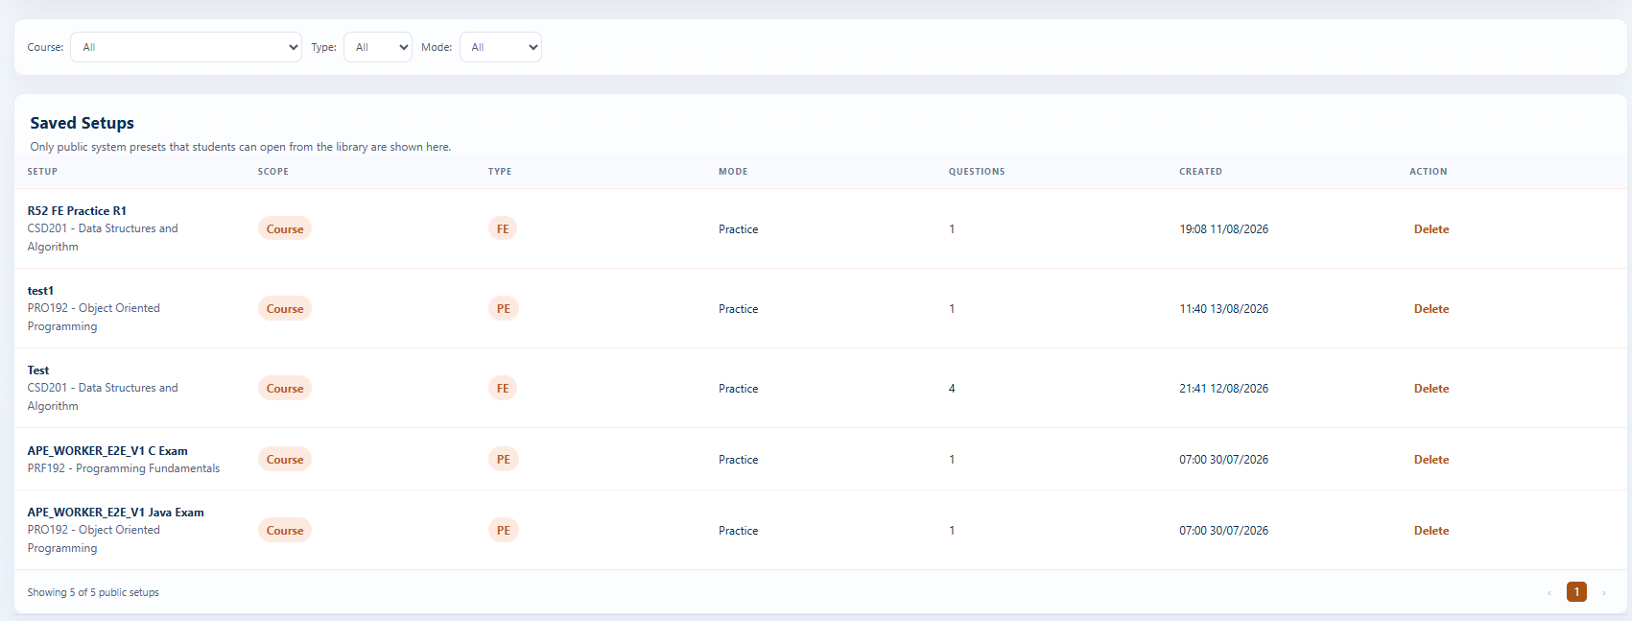
Figure 3-7-4-1 UI Mockup Admin Practice Setup

3.7.4.2 Description
Lets the Super Admin configure and save reusable practice presets for the system bank — a preset captures the course, type (FE/PE), mode (Practice/Flashcard), topic tags, and either per-difficulty counts (FE) or manually picked problems (PE, max 5). Saved presets are listed with filters and populate the System Exam Library (§3.7.3). Save/List of presets is a UI utility supporting UC-80 / UC-81 — no dedicated UC. Supports: UC-80 · UC-81 · UC-82 · UC-83.

3.7.4.3 Field Specification
Field Name | Description
Hero Display | Field Group
Source | Display; "System only".
Course | Display; the selected course label.
Type | Display; examType + mode.
Question Count | Display; totalQuestionCount.
Setup Form | Field Group
Setup Title | Text input; required; placeholder "PRO192 FE Practice Course".
Course | Select; required; only Active courses.
Exam Type | Segmented (button group); enum { FE, PE }; default FE.
Mode | Segmented (button group); enum { Practice, Flashcard }; shown for Exam Type = FE only.
Topic Tag | Checkbox list; dynamic from the question pool.
PE-specific | Field Group
Difficulty | Checkbox; enum { Easy, Medium, Hard }.
Pick Questions (max 5) | Checkbox list; max 5 selected.
FE-specific | Field Group
Easy Count | Number input; min 0; max = min(50, available); step 1.
Medium Count | Number input; min 0; max = min(50, available); step 1.
Hard Count | Number input; min 0; max = min(50, available); step 1.
Preview Sidebar | Field Group
Source | Display; "System".
Course / Mode | Display; the current configuration.
Pool | Display; matching-question count.
Question Count | Display; planned count.
Status | Display; "Creating new preset only".
Rule Check | Display; "n/50" for FE, "n/5" for PE.
Actions | Field Group
New Setup | Action (button); resets the form.
Save Setup | Action (button); calls the createAdminPracticeSetup API.
Saved Setups — Filters | Field Group
Course | Select; enum { All } + dynamic course list.
Type | Select; enum { All, FE, PE }.
Mode | Select; enum { All, Practice, Flashcard }.
Saved Setups Table | Field Group
Setup | Table column; title + course.
Scope | Table column; badge.
Type | Table column; badge.
Mode | Table column; { Practice, Flashcard }.
Questions | Table column; count.
Updated | Table column; format dd/MM/yyyy HH:mm.
Pagination | Field Group
Showing X of Y / Previous / Next / Current | Standard paging controls.

3.8 MCQ & Flashcard Practice
Feature scope: timed MCQ sessions with in-place scoring/review, and study flashcard sessions with self-marking.
Use cases: UC-84→91 (UC-87 realized in §3.11.3).
Role: Student.

3.8.1 MCQ Session — Role: Student

3.8.1.1 UI Layout (Mockup)

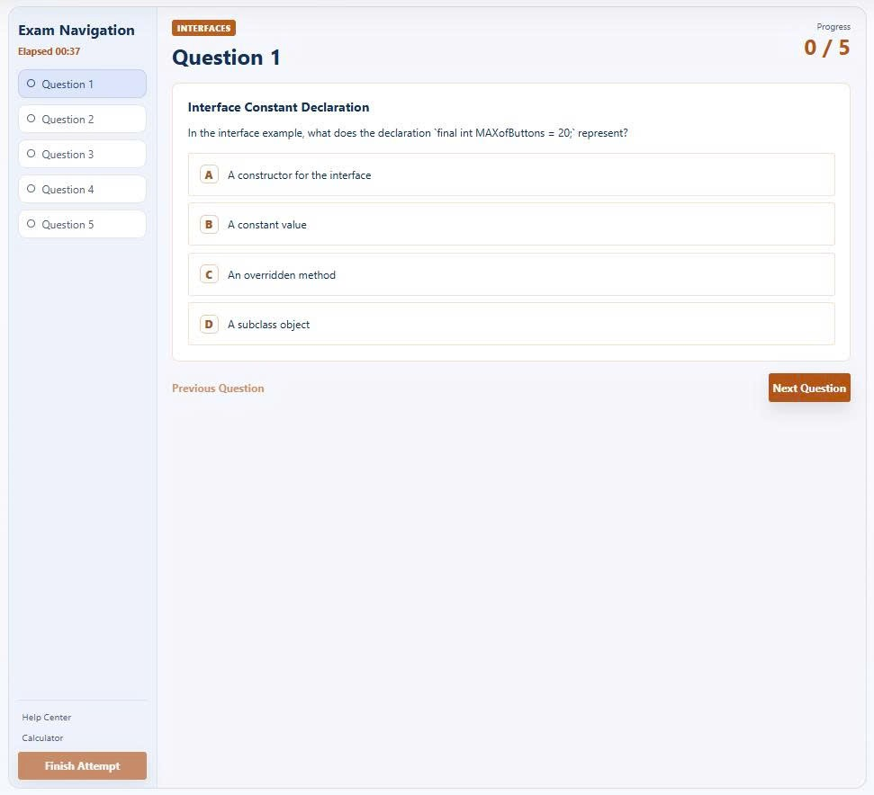
Figure 3-8-1-1 UI Mockup MCQ Session

3.8.1.2 Description
Runs a timed, single-choice MCQ session and, after submission, flips in place to a per-question review state (chosen vs correct option, explanation, and score summary); unanswered items are counted incorrect, and an in-progress session can be resumed. Includes Help Center and Calculator utilities. Realizes: UC-84 Start MCQ Practice Session · UC-85 Submit MCQ Answers · UC-86 View MCQ Result (embedded review state) · UC-89 Resume In-Progress Session.

3.8.1.3 Field Specification
Field Name | Description
Exam Navigation | Field Group
Elapsed Timer | Display; running session stopwatch.
Question Item (1…n) | Button; jumps to the selected question.
Help Center | Button; opens contextual help (utility).
Calculator | Button; opens an in-session calculator (utility).
Finish Attempt | Button; submits answered questions via POST /api/student/submissions/fe, then ends the session via POST /api/student/practice/sessions/{sessionId}/end.
Question Header | Field Group
Topic / Session Badge | Display; topic tag and session title.
Question Title | Display; current question label.
Progress | Display; answered/total indicator.
Question Content | Field Group
Question Text | Display; question title and description.
Option A…n | Button (single-select); disabled while submitting or after the session is finished.
Your Answer Badge | Display; marks the Student's chosen option (review state).
Correct Answer Badge | Display; marks the correct option (review state).
Correct Marker | Display; per-option correctness indicator (review state).
Status & Review | Field Group
Error Message | Display; inline submission error.
Explanation Toggle | Button; shows/hides the answer explanation (review state).
Explanation Text | Display; rationale for the correct answer (review state).
Score Summary | Display; correct count and percentage (review state).
Footer Actions | Field Group
Previous / Next Question | Buttons; navigate between questions.

3.8.2 Flashcard Session — Role: Student

3.8.2.1 UI Layout (Mockup)

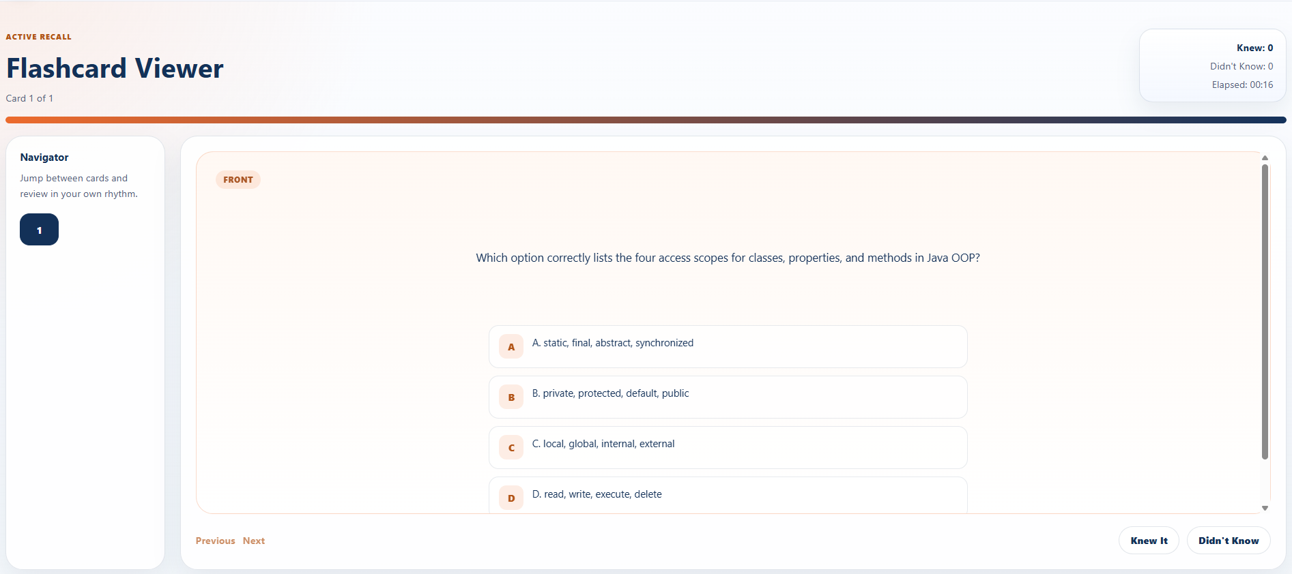
Figure 3-8-2-1 UI Mockup Flashcard Session

3.8.2.2 Description
Runs a study flashcard session in which the Student flips cards (front: question and options; back: correct answer and explanation) and self-marks each card as Knew It or Didn't Know for personal tracking; no graded scoring is applied.
Realizes: UC-90 Start Flashcard Session · UC-91 Review Flashcards.

3.8.2.3 Field Specification
Field Name | Description
Header | Field Group
Card Progress | Display; current card index over total.
Knew Count | Display; cards self-marked "Knew It".
Didn't-Know Count | Display; cards self-marked "Didn't Know".
Elapsed Timer | Display; session stopwatch.
Progress Bar | Display; visual completion of the deck.
Navigator | Field Group
Card Item (1…n) | Button; jumps to the selected card.
Flashcard | Field Group
Card Surface | Button; flips the card between front and back.
Front / Back Tag | Display; current face indicator.
Question / Description | Display; card prompt (front).
Option A…n | Display; answer options (front).
Flip Hint | Display; "Click to flip the card".
Correct Answer | Display; correct option (back).
Explanation | Display; answer rationale (back).
Actions | Field Group
Previous / Next | Buttons; navigate the deck.
Knew It / Didn't Know | Buttons; self-mark the current card for personal tracking.

3.9 Coding Practice
Feature scope: coding sessions executed against Judge0, with auto-save/resume, unlimited test runs, and a one-shot final submission.
Use cases: UC-92→98.
Role: Student (+ Judge0).

3.9.1 Coding Session — Role: Student

3.9.1.1 UI Layout (Mockup)

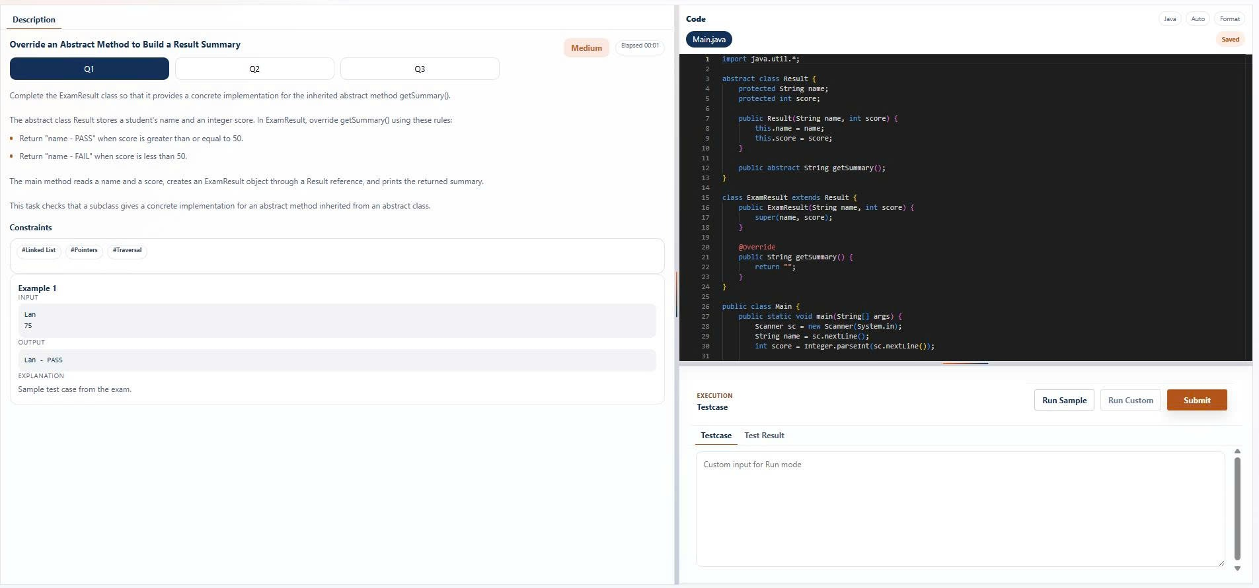
Figure 3-9-1-1 UI Mockup Coding Session

3.9.1.2 Description
Runs a coding session in the course-bound language with a Monaco code editor and a stopwatch; auto-saves draft code for resume, runs sample/visible test cases via Judge0 with unlimited attempts, and accepts a single final submission per problem. A session may contain multiple problems (Q1…n). Realizes: UC-92 Start Coding Practice Session · UC-93 Save Draft Code · UC-94 Run Test Cases · UC-95 Submit Coding Solution · UC-97 Resume Coding Session · UC-98 Start New Coding Attempt.

3.9.1.3 Field Specification
Field Name | Description
Workspace Actions | Field Group
Back to Configuration | Button; returns to /exams/.
Last Result | Button; opens the latest result at /practice/result/.
Problem | Field Group
Description Tab | Button; selects the problem-description view.
Question Title | Display; current problem title.
Difficulty Badge | Display; problem difficulty.
Elapsed Timer | Display; session stopwatch.
Question Item (Q1…n) | Button; switches between problems in the session.
Problem Description | Display; statement body.
Constraint Item | Display; problem constraints.
Topic Tag | Display; associated topic(s).
Sample Input / Output / Explanation | Display; worked example.
Discussion Hint | Display; discussion pointer.
Editor | Field Group
Language Pill | Button; shows the active language.
Auto / Format | Buttons; editor utilities (auto-behavior, code formatting).
File Tab | Button; switches the editor file.
Read-only Lock | Display; indicates a read-only file.
Save State | Display; draft auto-save status.
Code Editor | Text input (Monaco); read-only when the active file is locked.
Execution | Field Group
Run Sample | Button; runs sample cases via POST /api/student/submissions/pe/run.
Run Custom | Button; runs custom input via POST /api/student/submissions/pe/run.
Submit | Button; final submission via POST /api/student/submissions/pe.
Custom Input | Text input; placeholder "Custom input for Run mode".
Error Message | Display; execution error.
Testcase / Test Result Tabs | Buttons; switch between the case list and results.
Console Output | Display; run output.

3.9.2 Submission Result — Role: Student

3.9.2.1 UI Layout (Mockup)

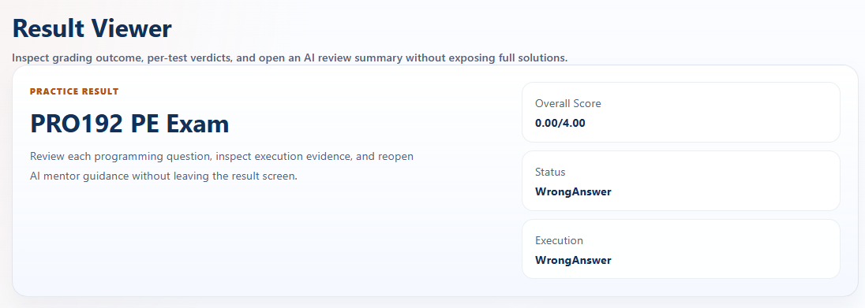
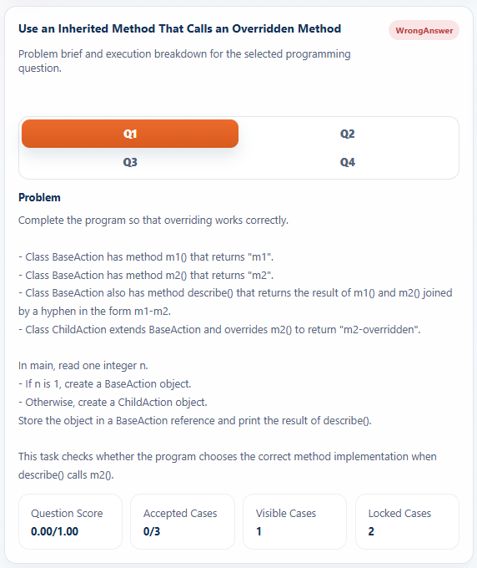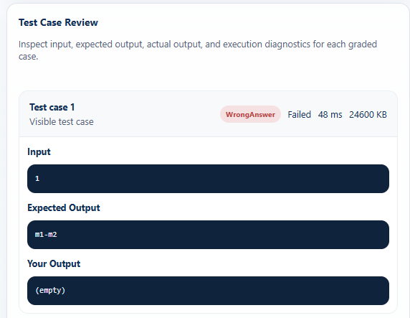
Figure 3-9-2-1 UI Mockup Submission Result

3.9.2.2 Description
Displays the pass/fail result of the submitted coding solution, with per-question verdicts and a per-test-case breakdown (verdict, runtime, memory, I/O). Rendered by the shared result viewer. Realizes: UC-96 View Submission Result.

3.9.2.3 Field Specification
Field Name | Description
Result Header | Field Group
Exam Title | Display; submitted exam name.
Overall Score | Display; aggregate score.
Status | Display; overall pass/fail status.
Execution | Display; execution summary.
Question Overview | Field Group
Selected Question Title | Display; chosen problem.
Verdict Badge | Display; problem verdict.
Diagnostics | Display; problem-level diagnostics.
Difficulty / Topic Tag | Display; problem metadata.
Problem Statement | Display; problem body.
Question Score | Display; per-problem score.
Accepted / Visible / Locked Cases | Display; test-case counts by category.
Test Case Review | Field Group
Test Case Title | Display; case label.
Hidden / Visible Status | Display; case visibility.
Verdict Badge | Display; case verdict.
Execution Status | Display; run state.
Runtime / Memory | Display; resource usage.
Input / Expected Output / Your Output | Display; case I/O.
Standard Error / Compile Output | Display; execution logs.
Diagnostics | Display; case diagnostics.

3.10 AI Code Mentor
Feature scope: post-submission AI feedback on coding solutions, quota-limited and charged in VND. Use cases: UC-99→103. Role: Student.

3.10.1 AI Mentor Feedback — Role: Student

3.10.1.1 UI Layout (Mockup)

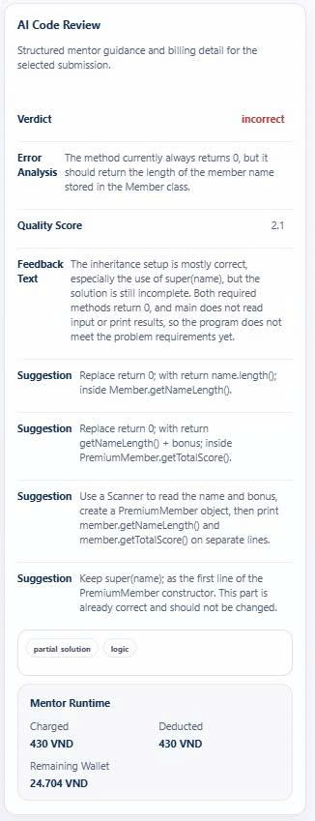
Figure 3-10-1-1 UI Mockup AI Mentor Feedback

3.10.1.2 Description
Lets the Student request AI feedback on a submitted solution (post-submission only, once per coding problem per attempt, requires a wallet ≥ 1,000 VND) and view the latest AI code review together with the run's charge, deduction, and remaining wallet balance. Static analysis, quota enforcement, and fee deduction run in the backend. Realizes: UC-99 Request AI Mentor Feedback · UC-103 View Latest Mentor Feedback · UC-100/101/102 (backend: analyze, enforce quota, deduct fee).

3.10.1.3 Field Specification
Field Name | Description
Mentor Request | Field Group
Error Message | Display; request error.
In-flight Notice | Display; title and description shown while a request is pending.
Ask AI Mentor | Button; requests feedback via POST /api/student/submissions/{submissionId}/mentor.
AI Code Review | Field Group
Verdict | Display; review verdict.
Error Analysis | Display; detected issues.
Quality Score | Display; solution-quality rating.
Feedback Text | Display; narrative feedback.
Suggestion | Display; improvement suggestions.
Issue Category Tag | Button; navigates to /exams/ .
Mentor Runtime | Field Group
Charged | Display; VND charged for the run.
Deducted | Display; amount deducted from the wallet.
Remaining Wallet | Display; post-charge balance.

3.11 Progress & Analytics
Feature scope: the Student dashboard, knowledge analytics, practice history, onboarding guide, and admin dashboards/statistics. Use cases: UC-105→114, plus UC-87 (§3.11.3) and UC-143 & UC-152 (Admin). Roles: Student, Super Admin.

3.11.1 Student Home — Role: Student

3.11.1.1 UI Layout (Mockup)

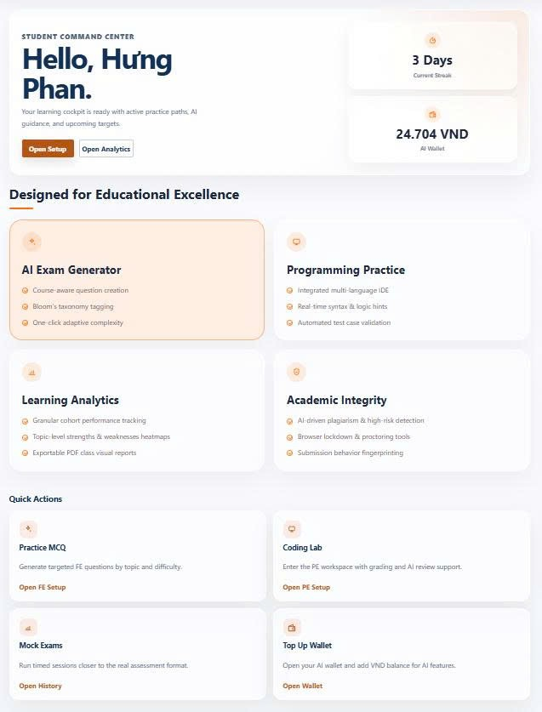

Figure 3-11-1-1 UI Mockup Student Home

3.11.1.2 Description
The Student's post-login landing page, showing key learning metrics and quick actions into the main functional areas. Realizes: UC-105 View Personal Dashboard.

3.11.1.3 Field Specification
Field Name | Description
Hero | Field Group
Student Name | Display; signed-in Student.
Open Setup | Button; navigates to /student/setup/.
Open Analytics | Button; navigates to /analytics/.
Metric Cards | Field Group
Current Streak | Display; consecutive active days.
AI Wallet | Display; current wallet balance.
Quick Actions | Field Group
Practice MCQ | Button; navigates to /exams/.
Coding Lab | Button; navigates to /exams/.
Mock Exams | Button; navigates to /practicehistory/.
Top Up Wallet | Button; navigates to /wallet/.

3.11.2 Knowledge Analytics — Role: Student

3.11.2.1 UI Layout (Mockup)

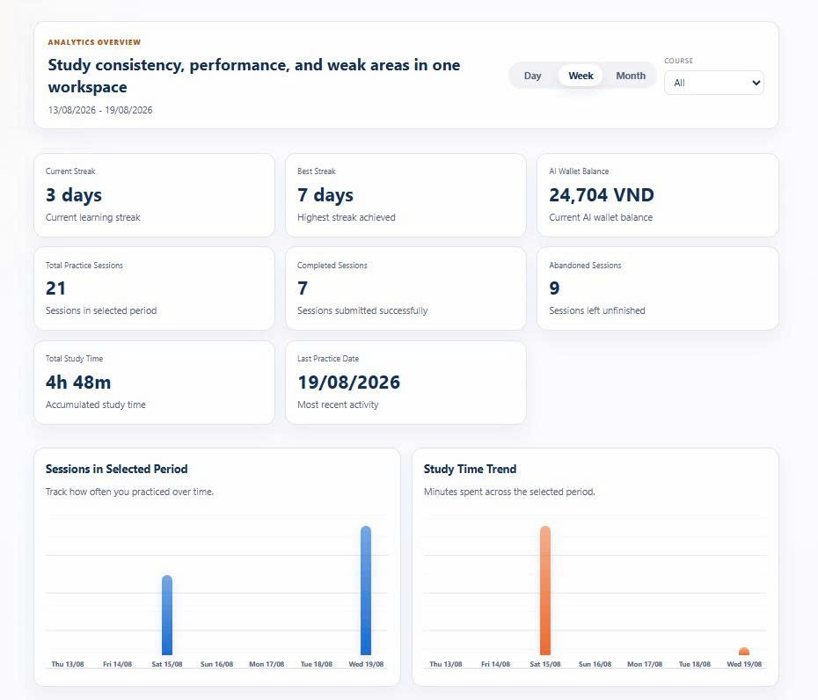

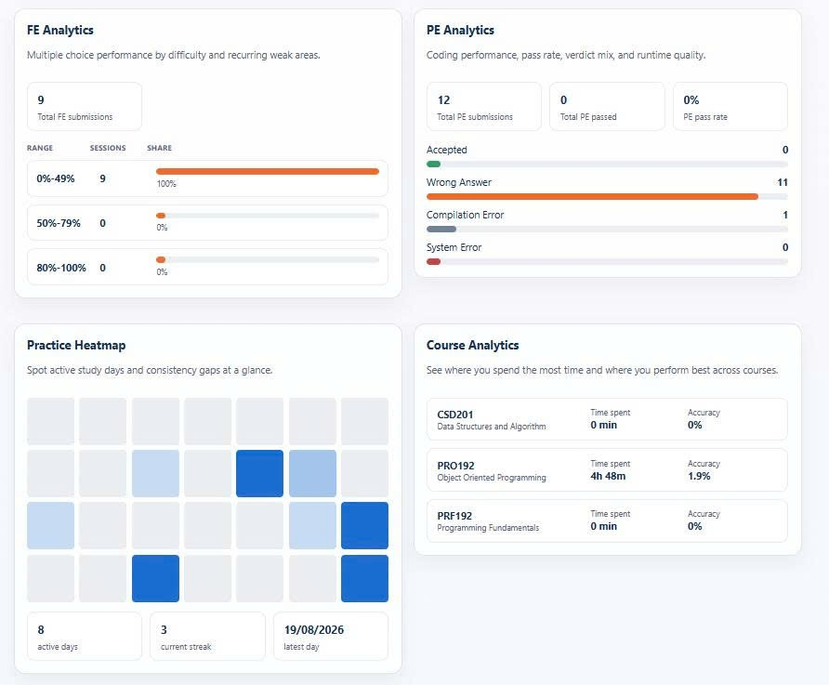
Figure 3-11-2-1 UI Mockup Knowledge Analytics

3.11.2.2 Description
Presents the Student's learning analytics under period (Day/Week/Month) and course filters: accuracy and time spent per course, session and study-time trends, an FE/PE submission breakdown, a practice heatmap, and streak/wallet overview cards. Realizes: UC-106 View Accuracy by Course · UC-108 View Progress Chart.

3.11.2.3 Field Specification
Field Name | Description
Toolbar | Field Group
Period (Day / Week / Month) | Buttons; select the reporting window.
Course | Select; filters by course.
Overview Cards | Field Group
Current / Best Streak | Display; streak metrics.
AI Wallet Balance | Display; wallet balance.
Total / Completed / Abandoned Sessions | Display; session counts.
Total Study Time | Display; cumulative practice time.
Last Practice Date | Display; most recent activity.
Trend Charts | Field Group
Sessions in Period | Display; session-count trend.
Study Time Trend | Display; study-time trend.
FE Analytics | Field Group
Total FE Submissions | Display; MCQ submission count.
Range / Sessions / Share | Display; distribution metrics.
PE Analytics | Field Group
Total PE Submissions / Passed | Display; coding submission counts.
PE Pass Rate | Display; pass percentage.
Verdict Label / Value | Display; verdict distribution.
Practice Heatmap | Field Group
Day Cell | Display; per-day activity intensity.
Active Days / Current Streak / Latest Day | Display; heatmap summary.
Course Analytics | Field Group
Course Code / Name | Display; course identity.
Time Spent | Display; time per course.
Accuracy | Display; accuracy per course.

3.11.3 Practice History — Role: Student

3.11.3.1 UI Layout (Mockup)

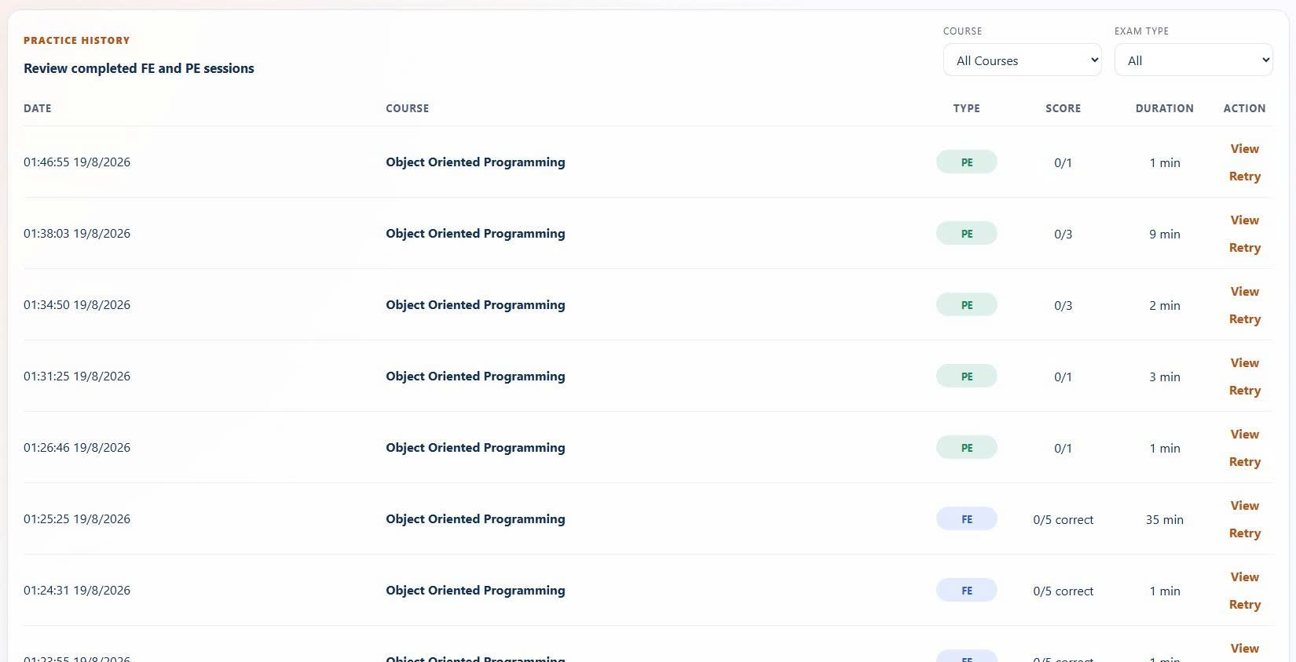
Figure 3-11-3-1 UI Mockup Practice History

3.11.3.2 Description
Lists the Student's past practice sessions under course/type filters, opens the detail of a single session, and retries a session as a new attempt. Realizes: UC-109 View Practice History · UC-110 View Practice Session Detail · UC-87 Retry All Questions (Retry action).

3.11.3.3 Field Specification
Field Name | Description
Filters | Field Group
Course | Select; default "all".
Exam Type | Select; enum { All, FE, PE }.
History Table | Field Group
Date / Course / Type / Score / Duration | Columns; session summary.
Action | Column; per-row actions.
Row Actions | Field Group
View | Button; opens the FE session (/exams/fe/live/) or PE result (/practice/result/) for review.
Retry | Button; creates a new FE or PE session from the same exam and navigates to the live session.
Page Action | Field Group
Open Exams | Button; navigates to /exams/.

3.11.4 Setup Guide — Role: Student

3.11.4.1 UI Layout (Mockup)

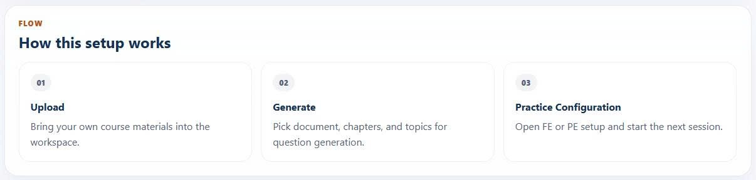
Figure 3-11-4-1 UI Mockup Setup Guide

3.11.4.2 Description
Guided onboarding that walks a new Student through the core track (Upload → Generate → Practice). Realizes: — (onboarding utility, no dedicated UC).

3.11.4.3 Field Specification
Field Name | Description
Hero | Field Group
Open My Documents | Button; navigates to /documents/byos/.
Open Practice | Button; navigates to /exams/.
Documents / Ready | Display; onboarding status counters.
Flow | Field Group
Step Index / Title / Detail | Display; guided-step content.
Tracks | Field Group
Upload Documents | Button; navigates to /documents/byos/.
Generate Questions from Document | Button; navigates to /documents/byos/generate/.
Open Practice Configuration | Button; navigates to /exams/.
Track Meta Item | Display; per-track descriptor.

3.11.5 Admin Dashboard — Role: Super Admin

3.11.5.1 UI Layout (Mockup)

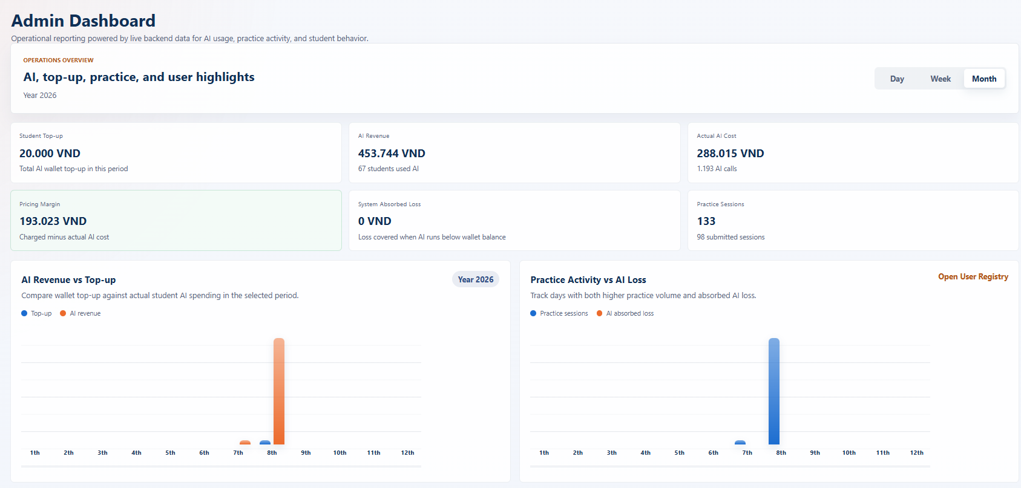
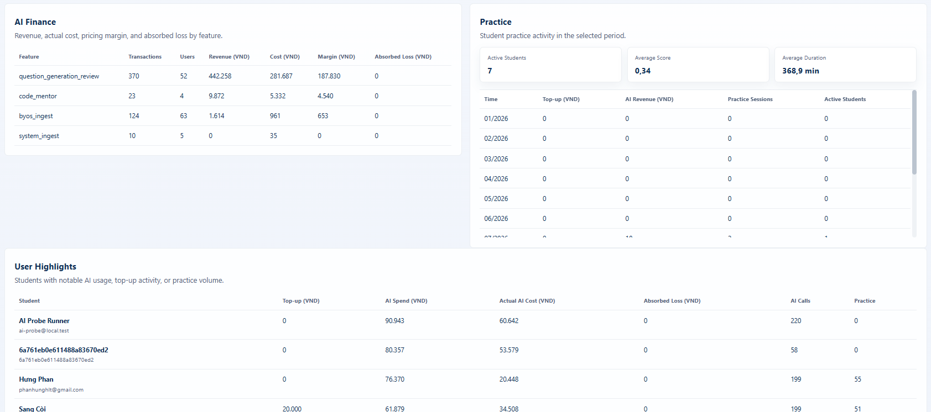
Figure 3-11-5-1 UI Mockup Admin Dashboard

3.11.5.2 Description
The Super Admin's system-wide dashboard under a period filter: AI-finance KPIs (Student top-up, AI revenue, actual AI cost, pricing margin, system-absorbed loss) and practice KPIs, a per-feature AI finance table, per-student highlights, and a link into the user registry. This screen is also the viewer for AI billing and system-absorbed loss. Realizes: UC-111 View System Dashboard · UC-112 View All Students Statistics (User Highlights) · UC-143 View AI Billing & Absorbed Loss (Absorbed-Loss KPIs & AI Finance table).

3.11.5.3 Field Specification
Field Name | Description
Period | Field Group
Day / Week / Month | Buttons; select the reporting window.
KPI Cards | Field Group
Student Top-up | Display; total top-up.
AI Revenue | Display; revenue from AI charges.
Actual AI Cost | Display; provider cost.
Pricing Margin | Display; revenue-over-cost margin.
System Absorbed Loss | Display; loss absorbed by the system.
Practice Sessions | Display; session count.
Charts | Field Group
AI Revenue vs Top-up | Display; period comparison.
Practice Activity vs AI Loss | Display; combined trend.
Open User Registry | Button; navigates to /admin/user-registry/ .
AI Finance Table | Field Group
Feature / Transactions / Users / Revenue / Cost / Margin / Absorbed Loss | Columns; per-feature AI finance.
Practice Summary | Field Group
Active Students / Average Score / Average Duration | Display; practice aggregates.
Practice Table | Field Group
Time / Top-up / AI Revenue / Practice Sessions / Active Students | Columns; per-period practice and finance.
User Highlights Table | Field Group
Student / Top-up / AI Spend / Actual AI Cost / Absorbed Loss / AI Calls / Practice | Columns; per-student usage and cost.

3.12 AI Configuration
Feature scope: Super-Admin configuration of AI providers, agents, rule artifacts (prompts / policies / rubrics / ground-truth / taxonomy), billing parameters, usage logs and summary, and diagnostic smoke tests. Use cases: UC-115→144 (adds UC-119, UC-140; UC-143 moved to §3.11.5). Role: Super Admin.

3.12.1 Provider Credentials — Role: Super Admin

3.12.1.1 UI Layout (Mockup)

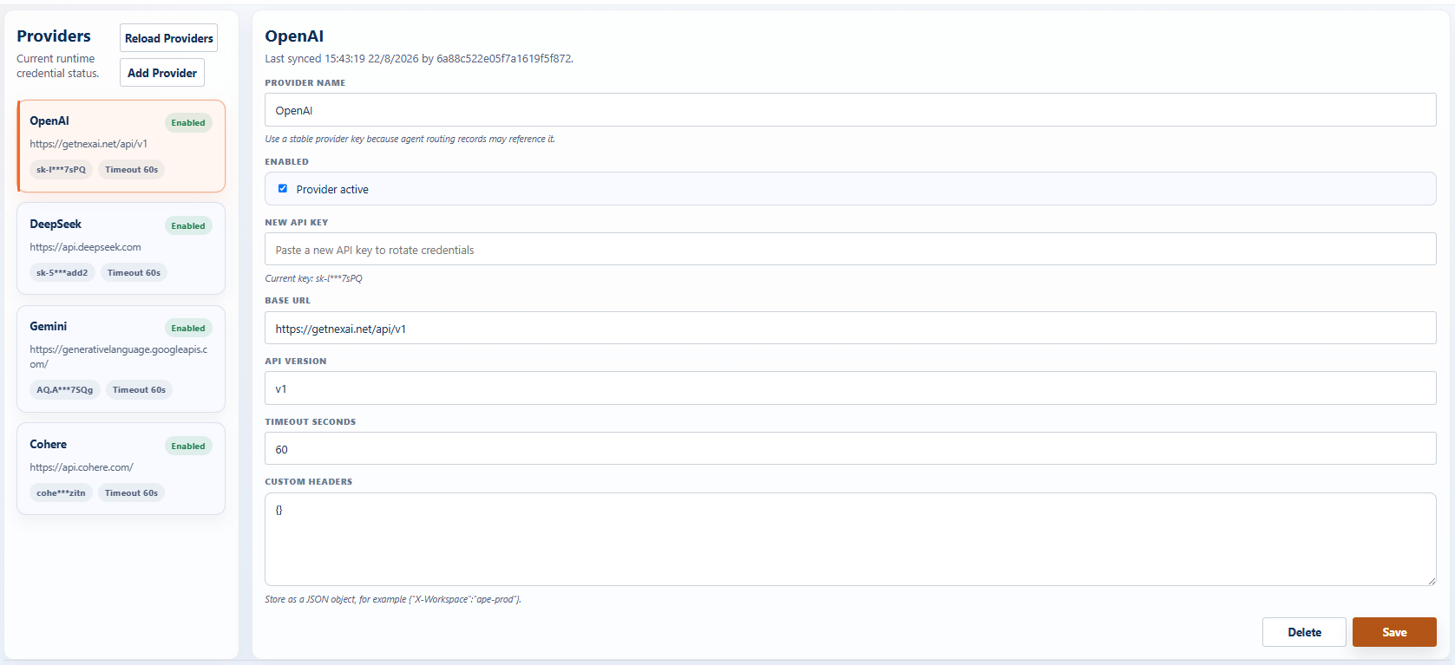
Figure 3-12-1-1 UI Mockup Provider Credentials

3.12.1.2 Description
Lets the Super Admin create, list, update, and delete AI provider credentials, with a Reload utility to refresh the list. Realizes: UC-115 Create · UC-116 View List · UC-117 Update · UC-118 Delete Provider Credential.

3.12.1.3 Field Specification
Field Name | Description
Providers List | Field Group
Reload Providers | Button; refreshes the provider list (utility).
Add Provider | Button; opens the create form.
Provider Card | Button (selectable); shows name, enabled badge, base URL, masked API key, timeout.
Provider Detail Form | Field Group
Provider Name | Text input; editable only when creating; placeholder "OpenAI".
Enabled | Checkbox; toggles the provider on/off.
New API Key | Password input; paste to rotate credentials.
Base URL | Text input; provider endpoint.
API Version | Text input; placeholder "v1beta".
Timeout Seconds | Number input; min 1; default 45.
Custom Headers | Textarea; JSON object.
Detail Meta | Field Group
Last Synced / Updated By | Display; audit metadata.
Actions | Field Group
Delete | Button; opens the delete-confirmation modal.
Create / Save | Button; calls createProviderCredentials or updateProviderCredentials.
Delete Confirmation | Field Group
Confirm Delete | Modal ("Delete provider"); Delete calls deleteProviderCredentials, Cancel closes.

3.12.2 AI Agents — Role: Super Admin

3.12.2.1 UI Layout (Mockup)
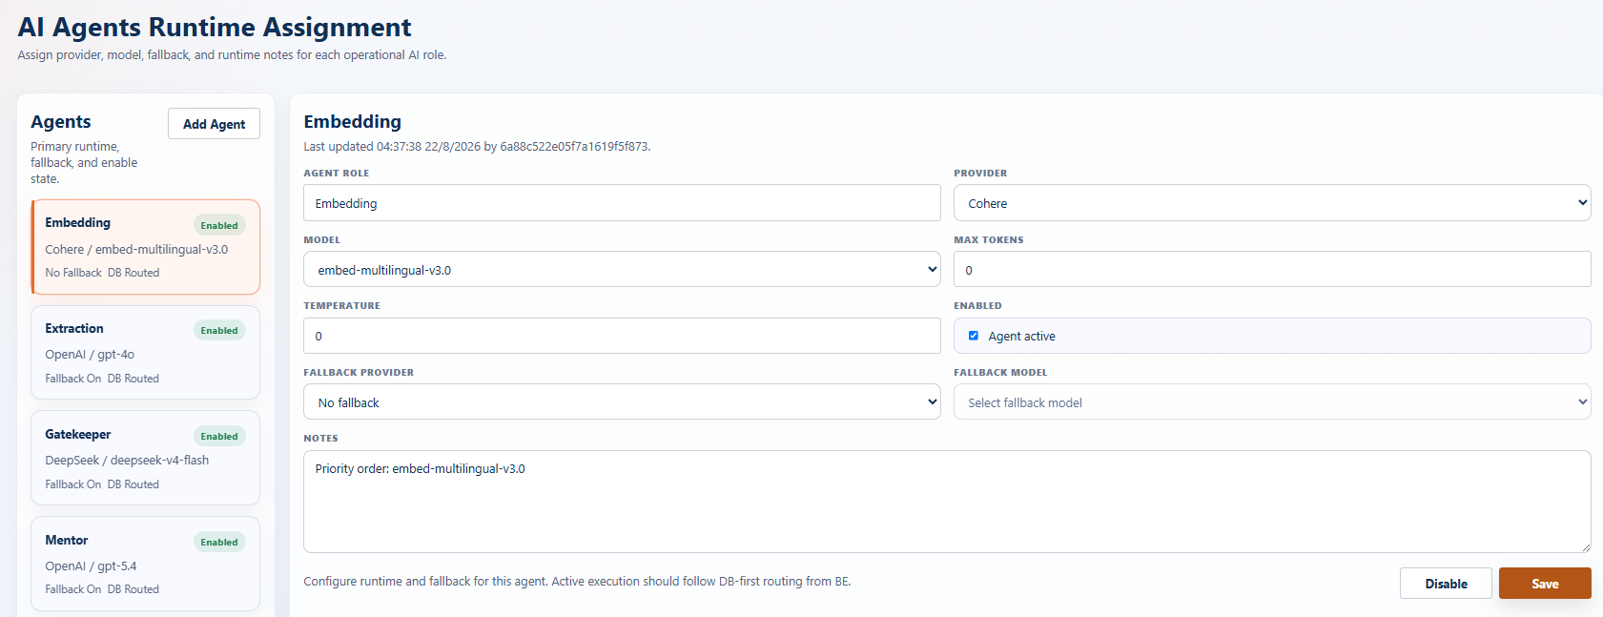
Figure 3-12-2-1 UI Mockup AI Agent

3.12.2.2 Description
Lets the Super Admin create an agent, view the configured AI agents and their detail, and configure each agent's model settings (provider, model, max tokens, temperature), enable flag, and fallback provider/model. A Disable shortcut soft-disables an agent (is_enabled = false). Realizes: UC-119 Create AI Agent (proposed) · UC-120 View AI Agent List · UC-121 View AI Agent Detail · UC-122 Configure Agent Model Settings.

3.12.2.3 Field Specification
Field Name | Description
Agents List | Field Group
Add Agent | Button; opens the create form.
Agent Card | Button (selectable); shows agent role, enabled badge, provider/model, fallback status.
Agent Detail Form | Field Group
Agent Role | Text input; required; editable only when creating.
Provider | Select; required; dynamic provider options.
Model | Select; required; dynamic model options per provider.
Max Tokens | Number input; min 0; default 3200.
Temperature | Number input; min 0, max 1, step 0.05; default 0.3.
Enabled | Checkbox; agent on/off.
Fallback Provider | Select; "No fallback" or a provider.
Fallback Model | Select; required when a fallback provider is set.
Notes | Textarea; free notes.
Detail Meta | Field Group
Last Updated / Updated By | Display; audit metadata.
Actions | Field Group
Disable | Button; opens the disable confirmation (soft-disable utility).
Save | Button; calls createAiAgent or updateAiAgent.
Disable Confirmation | Field Group
Confirm Disable | Modal; Disable calls updateAiAgent with is_enabled = false, Cancel closes.

3.12.3 Rule Artifacts (Policy / Rubric / GroundTruth / Prompt / Taxonomy) — Role: Super Admin

3.12.3.1 UI Layout (Mockup)
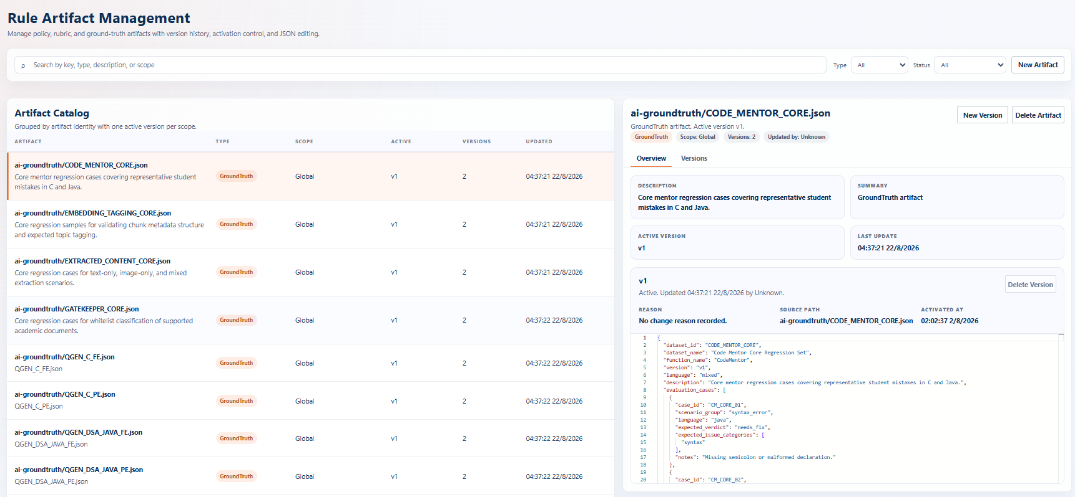
Figure 3-12-3-1 UI Mockup Rule Artifacts

3.12.3.2 Description
Lets the Super Admin manage versioned rule artifacts and prompts: list and search, view detail with a JSON version viewer, create a new artifact or version, activate a version, and delete — with one active version per key. The create modal restricts creatable types to { Policy, Rubric, GroundTruth }; Realizes: · UC-134→139 (Rule Artifact CRUD / activate).

3.12.3.3 Field Specification
Field Name | Description
Filters | Field Group
Search | Text input; matches key, type, description, or scope.
Type | Select; "all" or { Policy, Rubric, GroundTruth, Prompt, Taxonomy }.
Status | Select; { all, active, draft }.
New Artifact | Button; opens the create-artifact modal.
Artifact Table | Field Group
Artifact (Key + Description) | Column; artifact identity.
Type | Column; type badge.
Scope | Column; subject code / question type / language.
Active | Column; active version name.
Versions | Column; total version count.
Updated | Column; last-updated datetime.
Detail Header | Field Group
New Version | Button; opens the create-version modal.
Delete Artifact | Button; opens the delete-artifact confirmation.
Detail Meta | Field Group
Type Badge / Scope / Versions Count / Updated By | Display; artifact metadata.
Tabs | Field Group
Overview / Versions | Buttons; switch detail tabs.
Overview Tab | Field Group
Description / Summary | Display; artifact text.
Active Version / Last Update | Display; active-version metadata.
Version Viewer (JSON) | Display; read-only Monaco editor of the version content.
Activate | Button; opens the activate-version confirmation (inactive versions only).
Delete Version | Button; opens delete-version confirmation; disabled for the active version.
Reason / Source Path / Activated At | Display; version provenance.
Versions Tab | Field Group
Version / Status / Reason / Updated | Columns; version list.
Actions (Activate / Delete) | Column; per-version actions.
Create / Version Modal | Field Group
Artifact Type | Select; { Policy, Rubric, GroundTruth }; create-artifact mode only.
Artifact Key / Description / Summary | Text inputs; create-artifact mode only.
Base Version | Select; create-version mode only.
Subject Code / Question Type / Language | Text inputs; scope; create-artifact mode only.
Change Reason | Text input; version reason.
Change Notes | Textarea; one note per line.
Activation | Checkbox; default on ("Activate immediately" / "Save as inactive version").
Content (JSON) | Textarea (Monaco); must be valid JSON.
Format JSON | Button; reformats the content.
Create Artifact / Create Version | Button; calls createRuleArtifact or createRuleArtifactVersion.
Close / Cancel | Buttons; dismiss the modal.
Confirmation Modal | Field Group
Activate / Delete | Button; calls activateRuleArtifactVersion / deleteRuleArtifactVersion / deleteRuleArtifact, Cancel closes.

3.12.4 AI Billing Configuration — Role: Super Admin

3.12.4.1 UI Layout (Mockup)
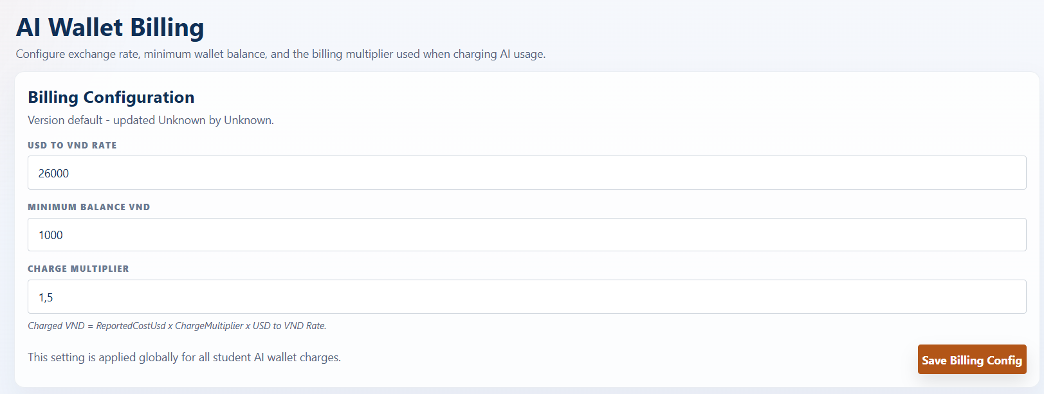
Figure 3-12-4-1 UI Mockup AI Billing Configuration

3.12.4.2 Description
Lets the Super Admin configure the AI billing parameters: the USD→VND conversion rate, the minimum wallet balance required to use paid AI features, and the charge multiplier applied over provider cost. The billing-records and system-absorbed-loss view lives on the Admin Dashboard (§3.11.5). Realizes: UC-140 Configure AI Billing Settings (proposed).

3.12.4.3 Field Specification
Field Name | Description
Billing Config Form | Field Group
USD to VND Rate | Number input; min 1, step 1; default 26000.
Minimum Balance (VND) | Number input; min 0, step 1000; default 1000.
Charge Multiplier | Number input; min 0.01, step 0.01; default 1.5.
Meta | Field Group
Version / Last Updated / Updated By | Display; audit metadata.
Actions | Field Group
Save Billing Config | Button; calls updateBillingConfig.

3.12.5 AI Usage Logs — Role: Super Admin

3.12.5.1 UI Layout (Mockup)
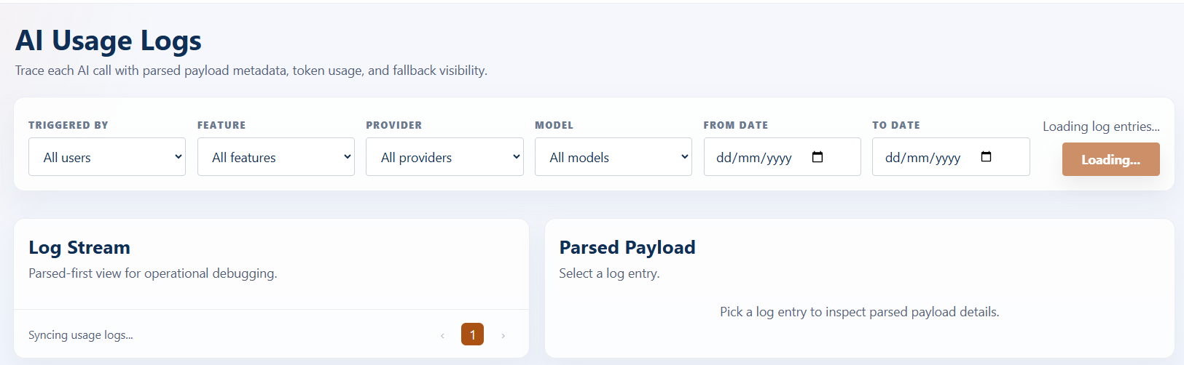
Figure 3-12-5-1 UI Mockup AI Usage Logs

3.12.5.2 Description
Lets the Super Admin view detailed AI usage logs with filtering and a per-entry parsed-payload drill-down. Realizes: UC-141 View AI Usage Logs.

3.12.5.3 Field Specification
Field Name | Description
Filters | Field Group
Triggered By | Select; a user or "All users".
Feature | Select; a feature or "All features".
Provider | Select; a provider or "All providers".
Model | Select; a model or "All models".
From / To Date | Date inputs; range bounds.
Apply Date Filter | Button; re-applies the local filter over pre-fetched logs.
Log Count | Field Group
Entry Count | Display; number of matching log entries.
Log Stream | Field Group
Log Row | Button; shows agent role/id, triggered-by, timestamp, tokens used, cost (USD), charged/actual (VND).
Parsed Payload Detail | Field Group
Feature / Step / Provider / Effective Model | Display; call metadata.
Fallback Used | Display; Yes/No.
Total Tokens | Display; token count.
Parsed Payload (JSON) | Display; raw payload block.

3.12.6 Smoke Test Suite — Role: Super Admin

Description
A suite of diagnostic smoke tests the Super Admin can run against individual AI components; smoke runs are not charged. Panels 3.12.7.1–.5 share a common run/result shell (Run, Reset, Copy Request/Response, a Provider / Effective Model / Fallback header, and a raw-response / error / fallback-debug block) but differ in their input form and parsed-result sections; 3.12.7.6 API Probe uses a distinct low-level request/response form. Pre-filled inputs are intentional test seeds. Realizes: UC-144 Run AI Smoke Test.
The suite comprises:
- 3.12.6.1 Smoke — Question Generation Review — diagnostic run of the question-generation review path.
- 3.12.6.2 Smoke — Code Mentor — diagnostic run of the AI code-mentor path.
- 3.12.6.3 Smoke — Embedding — diagnostic run of the embedding-generation path.
- 3.12.6.4 Smoke — Gatekeeper — diagnostic run of the document domain-validation (Gatekeeper) path.
- 3.12.6.5 Smoke — Extracted Content — diagnostic run of the content-extraction/normalization path.
- 3.12.6.6 API Probe — low-level connectivity probe against a configured provider endpoint.

Field Specification
(A) Shared shell (panels 3.12.6.1–.5)
Field Name | Description
Actions | Field Group
Run | Button; calls runSmokeTest(<component>) for the panel.
Reset | Button; resets the input form.
Copy Request | Button; copies the request payload to the clipboard.
Copy Response | Button; copies the result; disabled until a result exists.
Simulate Fallback Error | Checkbox; forces a fallback-chain failure; default off.
Result Header | Field Group
Provider / Effective Model / Fallback | Display; resolved provider, model, and fallback usage.
Debug | Field Group
Raw Response | Display; JSON block.
Error | Display; message, error code, trace id (on error).
Fallback Debug | Display; primary and fallback provider+model (on fallback error).

(B) Per-panel input & result

3.12.6.1 Question Generation Review
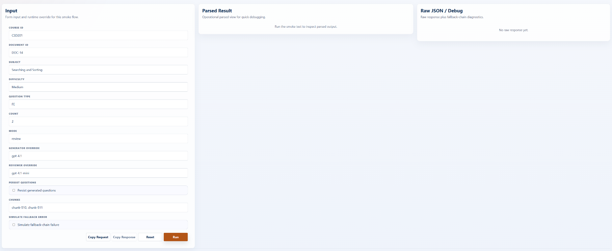
Figure 3-12-6-1 UI Mockup AI Smock test Question Generation Review
Field Name | Description
Input | Field Group
Course Id / Document Id / Subject / Difficulty / Question Type | Text inputs; defaults CSD201 / DOC-14 / Searching and Sorting / Medium / FE.
Count | Number input; default 2.
Mode | Text input; default "review".
Generator / Reviewer Override | Text inputs; defaults gpt-4.1 / gpt-4.1-mini.
Persist Questions | Checkbox; default off.
Chunks | Text input; default "chunk-510, chunk-511".
Result | Field Group
Run Summary | Display; subject, question type, difficulty, mode, attempts used.
Models / Review | Display; generator model, reviewer model, review, questions.
Persistence / Metrics | Display; persistence, context pack, retrieval plan, metrics.

3.12.6.2 Code Mentor
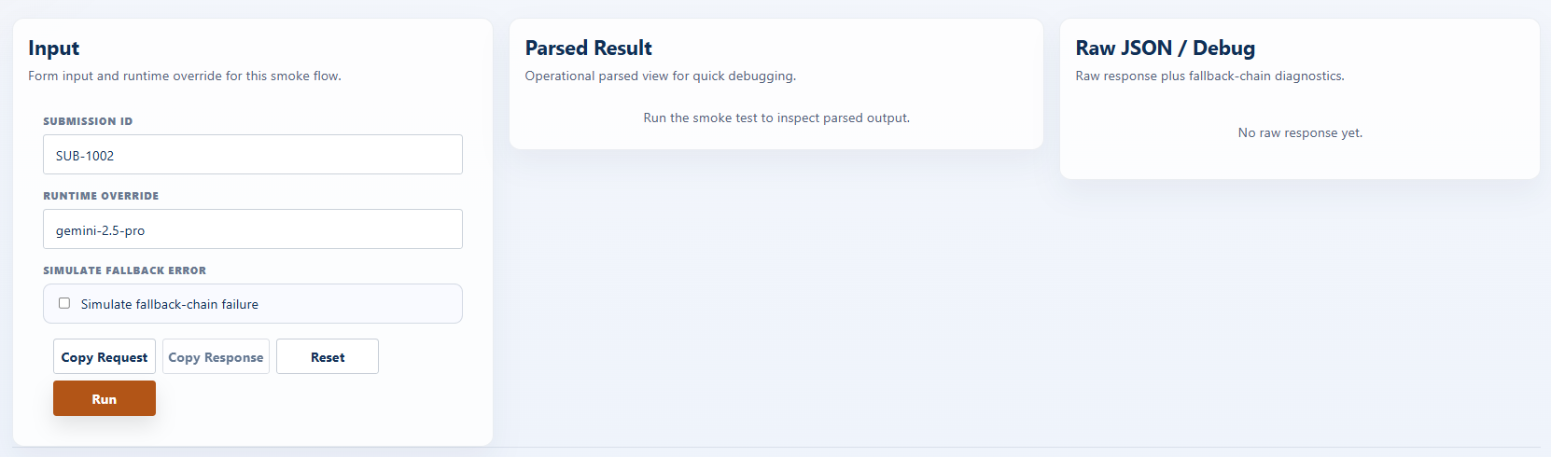

Figure 3-12-6-2 UI Mockup Smock test Code Mentor

Field Name | Description
Input | Field Group
Submission Id | Text input; default "SUB-1002".
Runtime Override | Text input; default "gemini-2.5-pro".
Result | Field Group
Submission | Display; submission id, feedback.
Runtime Usage | Display; configured/effective model, total tokens, cost (USD), credits deducted.
Credit State | Display; remaining free/paid credit, created-at, fallback used.

3.12.6.3 Embedding
Field Name | Description
Input | Field Group
Document Id / Course Id / Source Type | Text inputs; defaults DOC-14 / CSD201 / SYSTEM.
Embedding / Tagging Override | Text inputs; defaults text-embedding-3-large / gemini-2.5-flash.
Content | Textarea; sample text.
Result | Field Group
Chunks | Display; produced chunks.
Embedding Usage / Tagging Usage | Display; per-step usage.

3.12.6.4 Gatekeeper
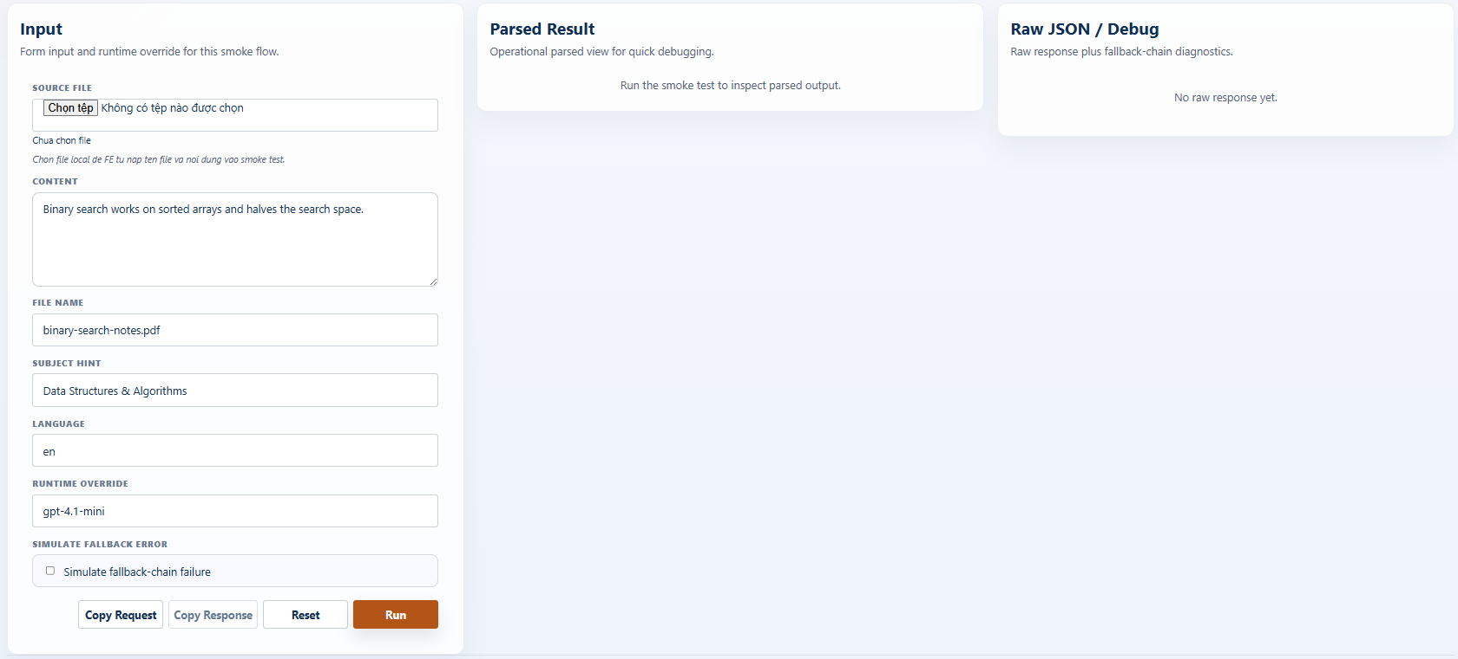
Figure 3-12-6-2 UI Mockup Smock test Gatekeeper
Field Name | Description
Input | Field Group
Source File | File; accepts common text/code types (.txt, .md, .json, source files, …).
Content | Textarea; sample text.
File Name / Subject Hint / Language | Text inputs; defaults binary-search-notes.pdf / Data Structures & Algorithms / en.
Runtime Override | Text input; default "gpt-4.1-mini".
Result | Field Group
Verdict | Display; verdict, reason, confidence, primary domain.
Topic Detection | Display; matched subjects, detected topics, is-supported.
Usage | Display; configured/effective model, tokens, cost (USD), fallback used.

3.12.6.5 Extracted Content
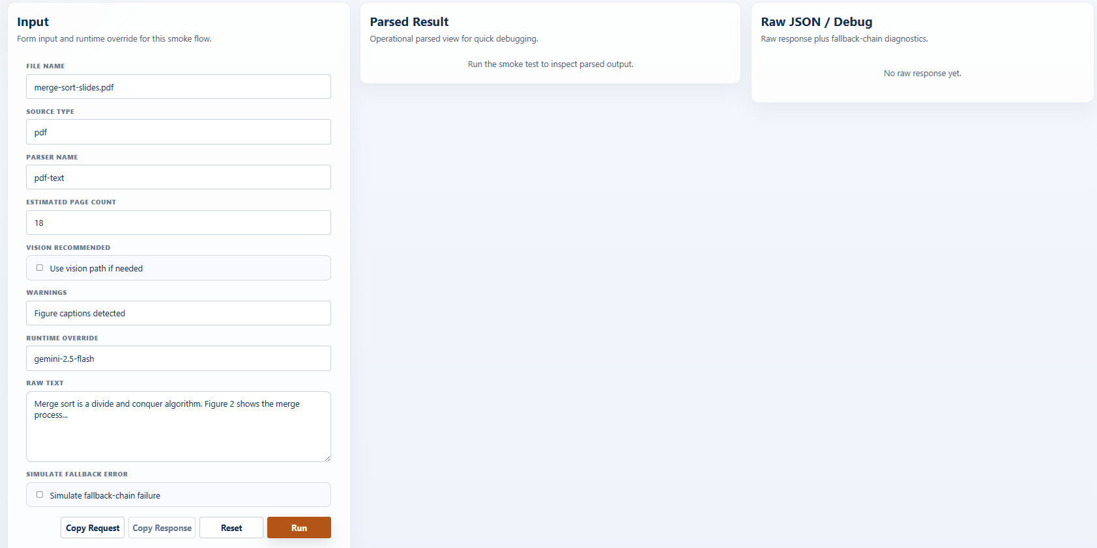
Figure 3-12-6-2 UI Mockup Smock test Extracted Content

Field Name | Description
Input | Field Group
File Name / Source Type / Parser Name | Text inputs; defaults merge-sort-slides.pdf / pdf / pdf-text.
Estimated Page Count | Number input; default 18.
Vision Recommended | Checkbox; default off.
Warnings | Text input; default "Figure captions detected".
Runtime Override | Text input; default "gemini-2.5-flash".
Raw Text | Textarea; sample content.
Result | Field Group
Normalization | Display; normalized markdown, used-AI-normalization, extraction mode.
Parser Metadata | Display; parser name, vision model, word count, image references, warnings.
Usage | Display; configured/effective model, tokens, cost (USD), fallback used.

4. Non-Functional Requirements

4.1 External Interfaces

System | Provider | Purpose | Protocol | Auth / Notes
Judge0 API | Judge0 | Code execution sandbox for PE grading. APE sends source code + inputs, receives stdout/stderr per test case. | HTTPS / REST | API Key in header. Hard timeout 30s/call. Supports: C, C++, Java, Python.
LLM Cloud Service (Tier 1) | Google Gemini 1.5 Flash / GPT-4o-mini | AI Gatekeeper classification, Auto-Tagging, FE MCQ generation (Actor-Critic). Fast & cost-efficient. | HTTPS / REST | Bearer token (API Key). Managed via AI Configurator. BYOK supported.
LLM Cloud Service (Tier 2) | Google Gemini 1.5 Pro / GPT-4o | PE Generator (Generator+Critic Agents), AI Code Mentor (AST/Semantic analysis). Deep reasoning tasks. | HTTPS / REST | Bearer token (API Key). Token budget enforced. BYOK supported.
OCR Cloud Service | Google Cloud Vision / Azure OCR | Extracts plain text from uploaded raw documents (PDF/DOCX/scanned images) before AI processing. | HTTPS / REST | Service Account / API Key. Returns structured text strings.
Payment API | VNPay / MoMo | Handles Premium Tier purchase and Top-up wallet transactions. APE sends QR generation requests; receives payment status webhook. | HTTPS / REST + Webhook | HMAC-SHA512 signature verification on webhook. Idempotency key on each transaction.
Google SSO | Google OAuth 2.0 | User authentication. APE redirects to Google Login, receives ID Token, verifies via Google public keys, creates/updates User record. | OAuth 2.0 / OIDC | ID Token verified with Google public keys. JWT issued by APE after verification.
Vector Database | Pinecone / Qdrant | Stores and queries vector embeddings of text chunks for RAG-based exam generation. | HTTPS / gRPC | API Key. Namespace isolation: system vs. per-user (BYOS).

4.2 Quality Attributes

4.2.1 Usability

Attribute | Requirement
Learnability | A new student user with no prior APE experience must be able to complete their first practice exam (FE type) within 5 minutes of first login, without requiring any documentation.
Responsive Design | All screens must be fully functional on desktop (1920×1080), laptop (1366×768), and tablet (768×1024) viewports. Mobile (< 480px) is supported in read-only mode.
Language | The system interface is in English. AI-generated content (questions, hints, advice) is generated based on the language of the source syllabus document.
Accessibility | Color contrast ratio ≥ 4.5:1 (WCAG AA). All interactive elements have ARIA labels. Keyboard navigation supported on all core screens.
Error Feedback | All form validation errors are displayed inline next to the relevant field within 200ms. System errors (AI timeout, Judge0 failure) display user-friendly messages with retry guidance, never raw stack traces.
Loading States | All AI generation operations (FE/PE exam, AI Mentor, Study Advice) display a loading indicator with estimated wait time. Operations exceeding 15s display a progress message.
Onboarding | First-time users are guided through a 3-step onboarding flow: (1) Select subscription tier, (2) Choose a course, (3) Generate first practice exam.

4.2.2 Performance

Metric | Target / Constraint
Page Load Time | Initial page load ≤ 2 seconds (FCP) on a 10 Mbps connection. Subsequent navigation ≤ 500ms (SPA routing).
FE Exam Generation | AI-generated MCQ exam (10 questions) must be returned to the user within 20 seconds under normal load.
PE Problem Generation | Full PE generation pipeline (Generator + Critic + Judge0 validation) must complete within 60 seconds. Each individual AI call hard timeout: 30 seconds.
Code Execution (Run) | Judge0 single-run response (custom test input) ≤ 10 seconds. Compilation timeout: 5 seconds. Execution timeout: 10 seconds per test case.
Code Execution (Submit) | Judge0 batch submission (all test cases) ≤ 30 seconds total. Results streamed per test case as they complete.
AI Code Mentor | AST/Semantic analysis response from LLM Tier 2 ≤ 30 seconds.
Knowledge Analytics | Competency chart computation and page render ≤ 3 seconds for up to 500 historical submissions.
Concurrent Users | System must support ≥ 100 concurrent active users without degradation. Judge0 and LLM calls are queued with backpressure if capacity is exceeded.
Database Query | MongoDB Atlas read operations ≤ 100ms (p95). Write operations ≤ 200ms (p95). Index coverage required on all queried fields.
API Rate Limit | APE Backend enforces 60 requests/minute per user token. Burst allowance: 10 requests/5 seconds.

4.2.3 Security

Security Domain | Requirement
Authentication | All users authenticate via Google OAuth 2.0 / OIDC. APE issues a signed JWT (RS256) with 1-hour expiry after verifying the Google ID Token. Refresh token stored in HttpOnly cookie.
Authorization | Role-Based Access Control (RBAC): Student vs. Super Admin. All API endpoints verify JWT and role claim before processing. Unauthorized requests return HTTP 403 immediately.
Transport Security | All traffic over HTTPS (TLS 1.2+). HSTS enforced. No sensitive data in URL query parameters.
BYOK API Key Storage | User-provided API keys (BYOK) are encrypted at rest using AES-256 before storage in MongoDB. Keys are never logged or returned in API responses after initial save.
Code Execution Sandbox | All student-submitted code runs in Judge0’s isolated container with no network access, restricted filesystem, and hard CPU/memory limits. APE never executes code directly on its own servers.
Input Validation | All user inputs (file uploads, form fields, code) are validated and sanitized server-side. File uploads are virus-scanned via OCR Cloud Service pipeline before processing. Max file size: 20MB.
AI Prompt Injection | System prompts are separated from user-provided content. User inputs in AI prompts are wrapped in explicit delimiters to prevent prompt injection attacks.
Payment Security | Payment webhook callbacks verified via HMAC-SHA512 signature. Wallet balance updates use MongoDB transactions to prevent race conditions. No card data stored by APE.
Data Privacy | Personal documents (BYOS) are stored in user-namespaced Vector DB partitions. One user cannot query another user’s private content. Admin cannot access student personal documents.
Audit Logging | All Admin actions (ban user, delete question, change AI config) are logged with actor, timestamp, and change description. Logs are append-only.

4.2.4 Scalability

Component | Scalability Strategy
Backend (.NET 8) | Deployed on Azure App Service with auto-scaling rules: scale out when CPU > 70% for 5 minutes. Horizontal scaling to max 5 instances. Stateless design – session state in Redis, not in-process.
Frontend (ReactJS) | Deployed on Vercel Edge Network (CDN). Static assets cached globally. No server-side rendering required. Zero cold start.
Database (MongoDB Atlas) | MongoDB Atlas M10+ cluster with auto-scaling storage. Connection pooling via .NET MongoDB driver. Read preference: primaryPreferred for analytics queries to reduce primary load.
Cache (Redis) | Redis used for: JWT blacklist, session data, recent AI generation results (TTL 1 hour), rate limiting counters. Azure Cache for Redis with 1GB tier.
Vector DB (Pinecone/Qdrant) | Pinecone Serverless or Qdrant Cloud – auto-scales index replicas based on query load. Namespace isolation ensures per-user BYOS queries do not impact system-level performance.
AI Call Throughput | LLM API calls managed via LangChain .NET with async/await and configurable concurrency limits. Model Routing reduces Tier 2 (expensive) calls to only PE Generator and Code Mentor tasks.
Judge0 Throughput | Judge0 API calls are async. Multiple test case submissions are batched per job. Retry with exponential backoff on 429/503 responses.
CI/CD | GitHub Actions pipeline: build → unit test → integration test → deploy to staging → smoke test → promote to production. Zero-downtime deployment via Azure deployment slots.

4.2.5 Reliability

Reliability Aspect | Requirement / Mechanism
Availability Target | System uptime ≥ 99.5% per month (excluding planned maintenance windows announced 24 hours in advance). Core exam functionality must degrade gracefully if AI services are unavailable.
Circuit Breaker | Circuit breaker pattern implemented for LLM Cloud Services and Judge0 API. After 3 consecutive failures within 30 seconds: circuit opens, requests fail fast with user-friendly error. Circuit retries after 60 seconds.
LLM Failover (Model Routing) | If primary LLM provider (e.g., OpenAI) returns 5xx or timeout: automatically retry with backup provider (Google Gemini) within same Tier. Failover is transparent to the user.
Judge0 Resilience | If Judge0 API is unavailable: queue submission request, notify user "Grading in progress, results will appear shortly." Retry queue with max 3 attempts over 5 minutes before returning error.
Graceful Degradation | If AI services are fully unavailable: Students can still browse existing question banks, view past results, and access analytics. AI generation features display "AI temporarily unavailable" with ETA.
Data Integrity | MongoDB write operations for Submissions use Optimistic Locking to prevent overwrite race conditions. Financial transactions (Payments, wallet top-up) use MongoDB multi-document transactions.
Backup & Recovery | MongoDB Atlas automated daily backups with 7-day retention. Point-in-time recovery to any minute within the retention window. RTO ≤ 4 hours, RPO ≤ 24 hours.
Error Monitoring | All unhandled exceptions logged to Azure Application Insights with stack trace, request context, and user ID (anonymized). Alerts triggered on error rate > 1% over 5-minute window.

5. Requirement Appendix

5.1 Business Rules
The business rules the system must follow, grouped by domain. Conventions:
- ID scheme: BR-<DOMAIN>-nn. IDs BR-PAY-01→BR-PAY-11, BR-GEN-01, and BR-SET-01 are fixed — they are already referenced by Section 3 (Functional Requirements) and must not be renumbered.
- marker: a rule tagged ⚠ depends on an assumption still pending team confirmation (see FR Appendix B — Open Items); the referenced T-item is noted.
- Stable IDs: removed rules leave their IDs vacant (gaps are intentional); a contiguous renumber is deferred to a final pass across all documents.

Authentication & Account (BR-AUTH)
ID | Rule Definition
BR-AUTH-01 | Both roles authenticate exclusively via Google OAuth 2.0 (SSO); there is no email/password registration, login, or password reset.
BR-AUTH-02 | On the first successful Google authentication, the system auto-provisions a user account from the Google profile (subject id, email, name, avatar), defaulting the role to Student.
BR-AUTH-03 | Super Admin accounts are pre-designated (seeded/configured) out-of-band; there is no in-app role-management screen. ⚠ (N1)
BR-AUTH-04 | The Google subject id is the unique account identifier used to match returning users.

AI Wallet & Payment (BR-PAY)
ID | Rule Definition
BR-PAY-01 | The AI wallet is denominated directly in VND.
BR-PAY-02 | No credit/token is used as the wallet unit on the user side.
BR-PAY-03 | A user may send an AI request only when the wallet balance is ≥ 1,000 VND.
BR-PAY-04 | If the balance is < 1,000 VND, the request is blocked immediately, no pipeline runs, and the user is prompted to top up.
BR-PAY-05 | If a permitted request runs and its cost exceeds the balance, the full result is still delivered.
BR-PAY-06 | When cost exceeds balance, the wallet is deducted only down to 0 — never negative.
BR-PAY-07 | The cost portion exceeding the balance is recorded as system Absorbed Loss.
BR-PAY-08 | Every successful AI request must produce a billing log / usage log entry.
BR-PAY-09 | Top-up denominations are fixed at 10,000 / 20,000 / 50,000 / 100,000 VND, with 10,000 VND the minimum.
BR-PAY-10 | No trial or complimentary balance is granted to any account.
BR-PAY-11 | There is no refund path; the wallet is charged only after a successful result, so a technical failure (no result) is never charged.
BR-PAY-12 | Super Admin actions (system ingest/generation) and diagnostic actions (smoke test) are not charged.
BR-PAY-13 | Pricing is hardcoded in the backend; there is no price-configuration screen for the Super Admin, and cost is hidden from the user.
BR-PAY-14 | The transaction history shows top-up entries only; deduction/usage entries are never shown.
BR-PAY-15 | Absorbed Loss is visible only to the Super Admin in analytics; the Student sees only the wallet reaching 0, with no cost-confirmation modal.

Course (BR-CRS)
ID | Rule Definition
BR-CRS-01 | A Course maps to exactly one programming language and has no category.
BR-CRS-02 | A Document belongs to exactly one Course.
BR-CRS-03 | Courses are openly accessible; there is no enrollment.
BR-CRS-04 | The programming language is fixed at Course creation; changing it once Documents exist is restricted.
BR-CRS-05 | Deleting a Course is blocked while dependent Documents/Questions exist. ⚠ (N2)

Topic Tag (BR-TAG)
ID | Rule Definition
BR-TAG-01 | Topic Tag taxonomies are seeded by the Super Admin per Course.
BR-TAG-02 | AI Auto-Tag selects only from the Course’s seeded tags.
BR-TAG-03 | Re-tagging applies only to newly ingested Documents; existing Documents’ tags are unchanged.
BR-TAG-04 | Students see Topic Tags as read-only filters.

Document & Ingest (BR-DOC)
ID | Rule Definition
BR-DOC-01 | Accepted upload formats are txt, doc, docx, pptx, pdf, md; maximum file size 20 MB.
BR-DOC-02 | PDFs must contain a text layer; scanned-only PDFs are warned (original file recommended). No full OCR is performed.
BR-DOC-03 | The Gatekeeper validates the document’s domain against the selected Course; on reject no Document is persisted and no override is allowed. Applies to both system and BYOS uploads.
BR-DOC-04 | Duplicate detection uses file_checksum + normalized_content_checksum; system-scoped per Course, BYOS-scoped per User. A duplicate reuses the existing Document, notifies the UI, and is not charged if AI has not run.
BR-DOC-05 | Vision reinjection is phase-1 (embedded-image description) only, not full OCR.
BR-DOC-06 | Chapter detection is rule-based (structural, not semantic); on 0 chapters it falls back to “Untitled Section N”, and detected chapters are not manually editable.
BR-DOC-07 | Ingest and generation are two separate steps: uploading a document runs ingest synchronously within the request; generation is initiated separately as its own synchronous request. Neither step persists a processing status.
BR-DOC-08 | The BYOS ingest fee is deducted once on successful completion of the synchronous ingest; Super Admin uploads are not charged.
BR-DOC-09 | Deleting a Document soft-deletes it and removes its KnowledgeChunks from retrieval; already-generated questions (both Active and Draft) are retained as independent entities. (T7 resolved)
BR-DOC-11 | Ingest and generation run synchronously in the foreground with no background job, persisted status, or progress streaming: the action should be confirmed before running (it incurs cost/time), cannot be cancelled once started, and closing the tab loses the in-flight run (the user simply re-runs it).

Question Generation (BR-GEN)
ID | Rule Definition
BR-GEN-01 | The difficulty allocation of a generated question set follows the mix — target Easy → 60/30/10, Medium → 30/50/20, Hard → 10/30/60 (Easy/Medium/Hard). (Applies to AI question generation only; Practice Setup uses direct per-difficulty counts.)
BR-GEN-02 | A generation request must specify a Chapter (hard scope) and a Topic (selects the primary context); a narrow scope is allowed and produces no warning.
BR-GEN-03 | Chapter is the retrieval scope (hard filter), Topic selects the primary context, and the relevance score ranks candidates within the scope.
BR-GEN-04 | Duplicate generation is prevented via question_fingerprint — scoped per Course for system and per owner for BYOS (unique index per scope).
BR-GEN-05 | Every generated question undergoes mandatory Rule-based Review (schema, grounding to source_chunk_ids, tag overlap, duplicate, PE low-value guard); LLM Cross-Review is optional and does not require a different model.
BR-GEN-06 | A generated question’s tags must overlap with its source chunk tags (grounding preserved) before being persisted.
BR-GEN-07 | MCQ (FE) is single-choice and includes an explanation; Coding (PE) includes a problem statement and test cases, including hidden ones.
BR-GEN-08 | The BYOS generation fee is charged after generation + review completes, including a needs_revision outcome; a technical failure before a result is not charged.
BR-GEN-09 | Retrieval is heuristic and chapter-aware, with no AI reranker.

Question Bank & Draft (BR-QBK)
ID | Rule Definition
BR-QBK-01 | Draft, Active, and Disabled questions share one collection, distinguished by status.
BR-QBK-02 | Questions are never editable; they can only be soft-deleted.
BR-QBK-03 | System-generated questions pass review → Draft → Super Admin Publish (Active) / Reject (Disabled).
BR-QBK-04 | BYOS questions pass review → Draft → Student “Publish all” (no Super Admin approval); there is no public bank.
BR-QBK-05 | A BYOS question with a bad AI test case is removed via “Delete Question” with no refund.
BR-QBK-06 | The Question entity does not store chapter metadata; therefore Chapter is not a direct filter of the question bank.

Practice Setup (BR-SET)
ID | Rule Definition
BR-SET-01 | For MCQ/Flashcard practice, Practice Setup uses no length preset and no fixed difficulty allocation; the Student enters the exact number of Easy/Medium/Hard questions, and each difficulty is capped at the number of Active questions available in scope (requesting more is not an error). For Coding practice, the Student manually selects the specific problems to include.
BR-SET-02 | A practice set can be built from the System (shared) bank or the Personal (BYOS) bank.
BR-SET-03 | A practice set (both System and Personal sources) is scoped by a Course, a Document, and one or more Topics derived from that Document; for MCQ the Student specifies the exact number of Easy/Medium/Hard questions, while for Coding the Student manually selects specific problems.
BR-SET-04 | In “Browse Question Bank” Topic is a primary filter; in “Practice Setup” Topic is multi-select and optional, chosen from the selected Document’s topic list — an empty selection means all topics of the Document.
BR-SET-05 | Only published (Active) questions are used for practice; Draft questions are not.
BR-SET-06 | Every question stores a source Document reference (documentId) so that document-scoped practice works for both the System and Personal sources.

MCQ & Flashcard Practice (BR-PRC)
ID | Rule Definition
BR-PRC-01 | The practice timer is a count-up stopwatch, not a countdown.
BR-PRC-02 | An in-progress session (InProgress) is preserved; closing the tab does not lose progress.
BR-PRC-03 | On MCQ submit, an unanswered question is counted incorrect. ⚠ (T10)
BR-PRC-04 | Each retry (Retry All / Retry Wrong) creates a new, independent PracticeSession; Retry Wrong repeats until no wrong answers remain.
BR-PRC-05 | Flashcards are a render mode of MCQ filtered by difficulty (distractors hidden, flip reveals the answer) and are study-only — no submit, no score. ⚠ (T11)

Coding Practice (BR-COD)
ID | Rule Definition
BR-COD-01 | The coding language is bound to the Course.
BR-COD-02 | Run Test executes on Judge0 with no limit on the number of runs.
BR-COD-03 | Submit executes on Judge0 exactly once per attempt.
BR-COD-04 | A solution is graded passed only if 100% of tests pass.
BR-COD-05 | Time/memory limits are configured by the Super Admin per problem and enforced by Judge0.
BR-COD-06 | After a failed attempt a new independent attempt can be started; a new attempt after a PASS is allowed and does not overwrite the passing result. ⚠ (T13)
BR-COD-07 | If Judge0 is unavailable at submit, the submission is not finalized as graded and the submit attempt is not consumed. ⚠ (T12)
BR-COD-08 | Judge0 runs self-hosted.

AI Code Mentor (BR-MTR)
ID | Rule Definition
BR-MTR-01 | The mentor is PE-only, on-demand, and available only post-submission (both pass and fail); it is not a hint tool.
BR-MTR-02 | The mentor performs static analysis only (no compile/run); read-code complexity may not be exact.
BR-MTR-03 | The mentor response is structured (correctness, timeComplexity, spaceComplexity, codeStyle, suggestions[]) and contains no code snippet; a parse failure triggers one retry.
BR-MTR-04 | The mentor input is problem + code + pass/fail + up to 3 failed tests (input/expected/actual); no hidden tests and no passed tests are included. An all-pass submission uses an optimization-focused prompt variant.
BR-MTR-05 | The mentor quota is one request per problem per attempt (reset on a new attempt), counting technical failures, enforced via mentorCallsUsed.
BR-MTR-06 | The mentor fee is charged when a usable feedback is produced.

Progress & Analytics (BR-PRG)
ID | Rule Definition
BR-PRG-01 | Practice history is retained and cannot be reset or deleted by the Student.
BR-PRG-02 | There is no leaderboard.

AI Configuration (BR-CFG)
ID | Rule Definition
BR-CFG-01 | Each agent embeds its own model configuration (provider, model, maxTokens, temperature, capability flags) directly; there are no reusable model presets. Model configuration contains no artifacts (no prompt/rubric/policy/ground-truth).
BR-CFG-02 | There are 6 agents (Gatekeeper, ExtractedContent, Embedding, QuestionGenerator, QuestionReviewer, CodeMentor); each agent carries its own model configuration and N independent Artifacts, and is configured independently.
BR-CFG-03 | Prompts and Rule Artifacts are versioned, with exactly one active version each.
BR-CFG-04 | Structured/JSON artifact content is edited via the Monaco Editor; thresholds live inside the rubric/policy ContentJson, not as shared top-level fields.
BR-CFG-05 | An agent whose model configuration lacks a required capability is hard-blocked on save (e.g., a text-only model on the Embedding agent). ⚠ (T14)

Data Retention (BR-RET)
ID | Rule Definition
BR-RET-01 | PracticeSession records are retained indefinitely.
BR-RET-02 | MCQ answer records are retained 12 months. ⚠ (T5)
BR-RET-03 | Coding submission source is retained 6 months (metadata indefinitely).
BR-RET-04 | Mentor feedback is retained 6 months.
BR-RET-05 | AI billing and top-up transactions are retained indefinitely.
BR-RET-08 | Usage/generation logs are retained 90 days.
BR-RET-09 | Documents and questions are retained indefinitely while Active and are hard-deleted 30 days after soft-delete.

Total: 92 business rules across 14 domains. IDs BR-PAY-01→11, BR-GEN-01, BR-SET-01, BR-SET-04, BR-SET-06 are referenced by Section 3; all other IDs are newly assigned here. Rules marked ⚠ depend on assumptions pending confirmation (FR Appendix B). The Notification domain (BR-NOT), the Extraction Draft rule (BR-DOC-10), the real-time/background-job rule (folded into the synchronous BR-DOC-11), and the notification/extraction-draft retention rules (BR-RET-06/07) have been removed; the vacated IDs are left as intentional gaps.

5.2 System Messages
User-facing messages, grouped by feature with continuous codes. Conventions:
- ID scheme: flat MSGnn; the Feature column groups them. Placeholders use {...} (e.g., {amount}, {name}, {max_length}).
- Type: In line (inline text / empty state) · Inline (red) (field validation) · Toast (transient success/info) · Modal (confirmation dialog) · Banner (persistent warning/status).
- FR link: messages referenced from Section 3 by → §5.2 are marked in Context — MSG10 ← FR-AUTH-06, MSG11 ← FR-PAY-04.
- ⚠ marker: message tied to an assumption pending confirmation (see FR Appendix B); T-item noted.
MSG Code | Feature | Type | Context | Content
MSG01 | Common | Inline (red) | A required field is empty on submit | This field is required.
MSG02 | Common | Inline (red) | Input length exceeds the maximum | Exceeds the maximum length of {max_length}.
MSG03 | Common | In line | A list/search returns no items | No results found.
MSG04 | Common | Toast | A create/update succeeds | Saved successfully.
MSG05 | Common | Toast | A delete succeeds | Deleted successfully.
MSG06 | Common | Modal | Confirm a delete action | Are you sure you want to delete this item? This cannot be undone.
MSG07 | Common | In line | An unexpected server error occurs | Something went wrong. Please try again.
MSG08 | Common | Modal | Navigating away with unsaved edits | You have unsaved changes. Leave without saving?
MSG09 | Common | Modal | The session has expired | Your session has expired. Please sign in again.
MSG10 | Authentication | In line | Google authentication fails or is denied (FR-AUTH-06) | Sign-in failed. Please try again.
MSG11 | Payment | Modal | Wallet balance < 1,000 VND when starting an AI action (FR-PAY-04) | Insufficient balance. You need at least 1,000 VND to use AI features. Please top up.
MSG12 | Payment | In line | Redirecting to the PayOS checkout | Redirecting to the payment gateway…
MSG13 | Payment | Toast | A top-up is confirmed by the PayOS webhook | Top-up successful. {amount} VND has been added to your wallet.
MSG14 | Payment | Toast | The user cancels payment at PayOS | Payment was cancelled. Your balance is unchanged.
MSG15 | Payment | In line | The payment link expires | The payment link has expired. Please try again.
MSG16 | Payment | In line | Payment verification fails | Payment could not be completed. Please try again.
MSG17 | Course | Inline (red) | Creating a course with a duplicate name | A course with this name already exists.
MSG18 | Course | Modal | Deleting a course that has documents/questions ⚠ (N2) | This course cannot be deleted while it still has documents or questions.
MSG19 | Topic Tag | Toast | A taxonomy import completes | Imported {count} topic tags.
MSG20 | Topic Tag | Inline (red) | Importing an invalid taxonomy file | Invalid taxonomy file. Please upload a valid JSON file.
MSG21 | Topic Tag | Inline (red) | Creating a duplicate tag in a course | This tag already exists in the course.
MSG22 | Document | Inline (red) | Uploading an unsupported file type | Unsupported file type. Allowed: txt, doc, docx, pptx, pdf, md.
MSG23 | Document | Inline (red) | Uploading a file larger than 20 MB | The file exceeds the 20 MB limit.
MSG24 | Document | Modal | The Gatekeeper rejects a document (not saved) | This document does not match the selected course and was not saved.
MSG25 | Document | In line | A duplicate document is detected and reused | This document already exists and has been reused.
MSG26 | Document | Banner | A PDF has no text layer (scanned) | This PDF appears to be scanned. For best results, upload a file with a text layer.
MSG27 | Document | In line | While a document is being ingested (synchronous) | Processing your document…
MSG28 | Document | Toast | A synchronous ingest completes successfully | Document “{name}” has been added.
MSG29 | Document | In line | A synchronous ingest fails (nothing saved) | Processing failed. Nothing was saved — please try uploading again.
MSG30 | Document | Banner | Chapter detection finds 0 chapters | No chapters were detected; content was grouped under “Untitled Section”.
MSG31 | Document | Modal | Deleting a document (questions retained) (T7) | Delete this document? Questions already generated from it will be kept.
MSG32 | Generation | Inline (red) | Submitting generation without chapter/topic | Please select a chapter and a topic.
MSG33 | Generation | In line | While questions are being generated (synchronous) | Generating questions…
MSG34 | Generation | Toast | A synchronous generation completes | Question generation complete. Draft questions are ready for review.
MSG35 | Generation | In line | Generation fails before a result (not charged) | Question generation failed. You were not charged.
MSG36 | Generation | In line | Fewer questions than requested were produced | Only {n} questions could be generated. You can generate more.
MSG37 | Question Bank | Toast | A Student publishes all BYOS drafts | All draft questions have been published.
MSG38 | Question Bank | Toast | A Super Admin publishes a question | Question published.
MSG39 | Question Bank | Toast | A Super Admin rejects a draft question | Question rejected.
MSG40 | Question Bank | Modal | Deleting a question (soft delete) | Delete this question? This cannot be undone.
MSG41 | Question Bank | In line | Deleting a BYOS question with a bad AI test case | Question deleted. No refund is issued for AI-generated content.
MSG42 | Practice Setup | In line | The requested count for a difficulty exceeds the number available (auto-capped) | Only {n} {difficulty} questions are available.
MSG43 | Practice Setup | Inline (red) | All three difficulty counts are 0 on submit (MCQ) | Please request at least one question.
MSG44 | MCQ & Flashcard | Modal | Submitting an MCQ session with unanswered items ⚠ (T10) | You have {n} unanswered questions. Submit anyway? Unanswered questions are marked incorrect.
MSG45 | MCQ & Flashcard | In line | Resuming an in-progress session | Resumed your in-progress session.
MSG46 | Coding | Modal | Submitting a coding solution (one-shot) | Submit your solution? You can submit only once per attempt.
MSG47 | Coding | In line | Judge0 is unavailable at submit ⚠ (T12) | The code execution service is temporarily unavailable. Please try again — this attempt was not used.
MSG48 | Coding | Modal | Starting a new coding attempt | Start a new attempt?
MSG49 | AI Code Mentor | In line | A mentor analysis is running | Analyzing your code…
MSG50 | AI Code Mentor | In line | The mentor request for this problem attempt is already used | You have already used your mentor request for this attempt.
MSG51 | AI Code Mentor | In line | Mentor feedback cannot be produced | Mentor feedback could not be generated. Please try again.
MSG52 | AI Configuration | Toast | A provider connection test succeeds | Connection successful.
MSG53 | AI Configuration | In line | A provider connection test fails | Connection failed. Please check the credentials.
MSG54 | AI Configuration | Modal | Saving agent model settings that lack a required capability ⚠ (T14) | This model lacks a required capability for the {agent} agent and cannot be saved.
MSG55 | AI Configuration | Toast | A prompt/artifact version is activated | Version activated.
MSG56 | AI Configuration | Inline (red) | Saving invalid JSON in the Monaco editor | Invalid JSON. Please fix the highlighted errors.
MSG57 | AI Configuration | Toast | A smoke test finishes | Smoke test completed.

Total: 57 messages across 13 feature groups (Common + 12 features). MSG10 and MSG11 resolve the two → §5.2 references in Section 3. Messages marked ⚠ depend on assumptions pending confirmation (FR Appendix B). The former away-completion/failure notifications (MSG28/29 for Document, MSG34 for Generation) are now synchronous inline/toast messages, and the mentor-quota and preset-capability messages have been updated to the one-request-per-attempt and agent-model-settings models respectively.

5.3 Other Requirements

5.3.1 Glossary
Domain and technical terms used throughout this SRS, listed alphabetically.
Term | Definition
Absorbed Loss | The portion of an AI request’s cost that exceeds the user’s wallet balance and is borne by the system rather than the user (visible to the Super Admin only).
Agent | One of the six runtime AI agents (Gatekeeper, ExtractedContent, Embedding, QuestionGenerator, QuestionReviewer, CodeMentor); each embeds its own model configuration and is bound to N Rule Artifacts.
AI Code Mentor | An on-demand, post-submission static analysis of a coding solution (PE-only) that returns structured feedback without a code snippet.
AI Wallet | The user’s balance for AI usage, denominated directly in VND.
APE | The central system described by this document — the online practice platform providing coding and multiple-choice practice with AI-generated questions.
Attempt | An independent practice run; each retry (MCQ) or new coding attempt creates a separate PracticeSession.
Auto-Tag | The ingest/generation step in which AI assigns topic tags, selected only from the Course’s seeded taxonomy.
BYOS (Bring Your Own Source) | The mode in which a Student uploads their own documents and generates a private, personal question bank (charged in VND).
Chapter | A structural scope unit within a document (document → chapter → topic); the hard scope for retrieval.
Chapter Detection | The rule-based, structural (non-semantic) ingest stage that identifies chapters, falling back to “Untitled Section” when none are found.
Charge Point | The moment a fee is deducted: BYOS ingest on successful completion, generation after review, and mentor when a usable feedback is produced.
Context Pack | The assembled set of retrieved chunks (with Primary/Support/Optional roles) supplied to the generator.
Course | The top-level container mapped to exactly one programming language; owns documents, topic tags, and questions.
Draft / Active / Disabled | The three status states of a question within the shared question collection.
Duplicate Check | The checksum-based ingest stage that reuses an existing document on a match instead of re-ingesting.
Embedding | The vector representation of a KnowledgeChunk used for retrieval.
FEQuestion / PEQuestion | Internal entities for the two question types — FE (multiple-choice) and PE (coding).
Gatekeeper | The ingest stage that validates a document belongs to the selected Course; rejection prevents the document from being saved (no override).
Ground-truth | A type of Rule Artifact holding reference data used during review.
Ingest (Ingest Pipeline) | The synchronous (foreground) process that turns an uploaded document into retrievable chunks (Preview → Gatekeeper → Duplicate → Extract → Normalize → Vision → Chapter Detection → Chunk → Embed → Auto-Tag); on success the document appears in its list.
Judge0 | The self-hosted engine that compiles and runs code for the coding practice.
KnowledgeChunk (Chunk) | A segment of a normalized document produced by chunking and embedded for retrieval.
Minimum-balance guard | The rule that an AI action requires a wallet balance of at least 1,000 VND.
Monaco Editor | The in-app code/JSON editor used to edit prompts and rule artifacts.
needs_revision | A review outcome indicating a generated question needs revision; it is still charged (BYOS).
PayOS | The external payment gateway used for wallet top-ups.
Practice Set | A set assembled for a practice session: for MCQ, a specified number of Easy/Medium/Hard questions from a chosen Document and its Topics (each difficulty capped at availability); for Coding, a set of manually selected problems.
PracticeSession | An instance of a practice attempt (InProgress → Submitted), preserved across tab close.
Primary / Support / Optional | The three roles assigned to chunks within a Context Pack, from most to least central to the generated question.
Prompt (versioned) | A system/user prompt template with variables; exactly one version is active per prompt key.
Provider Credential | The stored credential for an LLM cloud provider, referenced by an agent’s model configuration.
question_fingerprint | The semantic + scope key used to prevent duplicate questions (scoped per Course for system, per owner for BYOS).
RAG (Retrieval-Augmented Generation) | The heuristic, chapter-aware retrieval approach (no AI reranker) that grounds question generation in document chunks.
Rule Artifact | A versioned policy, rubric, or ground-truth artifact (JSON) consumed by an agent; exactly one version is active.
Rule-based Review / LLM Cross-Review | The two-tier question review — a mandatory rule-based pass and an optional LLM cross-review pass.
Soft-delete / Hard-delete | Deletion lifecycle in which an item is first flagged deleted (soft) and permanently removed 30 days later (hard).
source_chunk_ids | The identifiers of the chunks a generated question is grounded on.
Top-up | Adding balance to the AI Wallet via PayOS, in fixed VND denominations.
Topic / Topic Tag | A thematic label seeded per Course, used for AI tagging and for filtering questions.
Vision Reinjection | The phase-1 ingest step that describes embedded images (not full OCR).

5.3.2 Abbreviations & Acronyms
Abbreviation | Expansion
APE | (Product name — the system in this document)
BR | Business Rule
BYOS | Bring Your Own Source
CRUD | Create, Read, Update, Delete
FE | Front-End question type (multiple-choice), internal naming
FR | Functional Requirement
JSON | JavaScript Object Notation
LLM | Large Language Model
MCQ | Multiple-Choice Question
MSG | System Message
OAuth | Open Authorization
PE | Programming Exercise question type (coding), internal naming
RAG | Retrieval-Augmented Generation
RTM | Requirement Traceability Matrix
SA | Super Admin
SRS | Software Requirement Specification
SSO | Single Sign-On
ST | Student
UC | Use Case
UI | User Interface
VND | Vietnamese Dong

5.3.3 Assumptions & Open Items
A number of design points apply a recommended default that is still pending team confirmation. To avoid duplication, these are *maintained in a single place — FR Appendix B (Open Items & Assumptions)*** — and are not repeated here. That appendix records:
- Resolved: T7 (deleting a document retains both Active and Draft questions — see BR-DOC-09). Ingest & generation are synchronous (foreground) — no background job, persisted status, real-time streaming, or notification.
- Assumptions pending confirmation: N1 (Super Admin provisioning), N2 (course-delete cascade), T4 (LLM provider list), T5 (MCQ-record retention), T9 (“Publish all” scope), T10 (unanswered MCQ), T11 (flashcard scoring), T12 (Judge0 unavailable at submit), T13 (new attempt after pass), T14 (agent model-capability mismatch).
- Proposed Business-Rule IDs newly assigned in §5.1 from documented rules: BR-PAY-09, BR-PAY-10, BR-PAY-11, BR-GEN-01, BR-SET-01, BR-SET-06.
The business rules and system messages that depend on these items are marked with ⚠ in §5.1 and §5.2 respectively.
§5.3 provides a glossary, an abbreviations list (21 entries), and a single-source reference to the assumptions tracked in FR Appendix B.

